Team Kinetic Frequently Asked Questions
We have developed this FAQ’s guide to help you navigate using the system and help you to begin using it to record your volunteering activities and have access to your volunteer record.
This document is being updated on a regular basis so please keep checking back here to see if it has an answer to your question. If you can’t find what you are looking for and need further assistance, please contact the Volunteering Support Team by email volunteering@ywt.org.uk or phone 01904 659570 and select option 2.

Q. Why do I need a pin emailed to me to sign in?
We have set up Multi Factor Authentication (MFA). MFA is used to significantly enhance security by requiring multiple forms of verification, making it much harder for cyber criminals to access your account even if your password is compromised.

Q. I’m having issues logging in to the Team Kinetic Portal
If you’re experiencing login issues with the Team Kinetic portal, please follow these steps to resolve them.

Step 1: Verify Your Email Address
- Ensure you are using the correct email address associated with your Team Kinetic portal account.
  - Double-check for typos, such as missing characters or incorrect domains (e.g., “.co.uk” instead of “.com”).
  - Ensure you are entering the whole email address and not a shortened version, Team Kinetic uses your full email address as your login credential.
  - If unsure which email is registered, refer to any previous emails received from Team Kinetic, as they will be sent to the registered address.
- Try logging in again using the correct email address.

Step 2: Reset Your Password
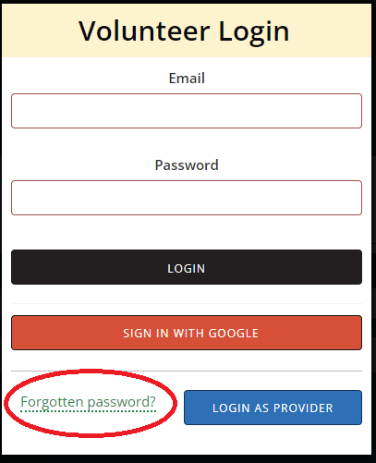
- Select “Forgotten Password?” circled, on the TeamKinetic login page.

- Enter your registered email address when prompted. A reset link will be sent to this email.
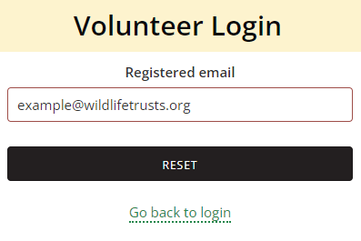
  - Note: The email may take a few minutes to arrive. Check your Spam or Junk folder if you don’t see it within 5 minutes.
  - Click the reset link only once. Multiple clicks may delay the process, so please wait for the reset page to load.

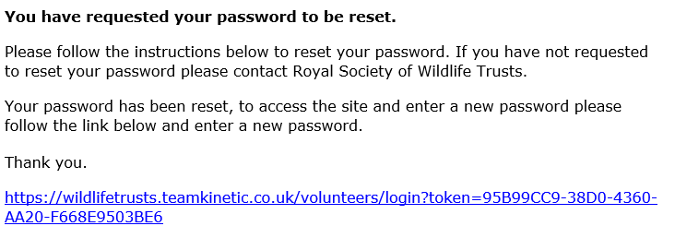
- Follow the link in the email to reset your password. You will be provided with a new token to complete the reset process.

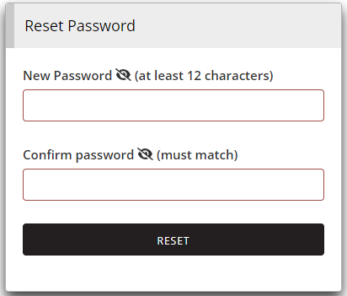
- Once you have entered a new password that meets the criteria, you will be logged in to your volunteer profile.

- If you are still unable to log in, please contact your Trust System Administrator for further assistance.

Additional Tips for Users
- Ensure your internet connection is stable, and use a compatible browser (we recommend Chrome, Firefox, or Edge).
- Clear your browser cache or try logging in using a private/incognito browsing window.

How can I find out what task days are happening?
All the task days we have details for are currently listed on Team Kinetic and new ones as they are planned will be added to the system. You'll see new opportunities appear on your own home page or you can search for them on the search page – see the screen shots below.
View of new opportunities suggestions on your home page:
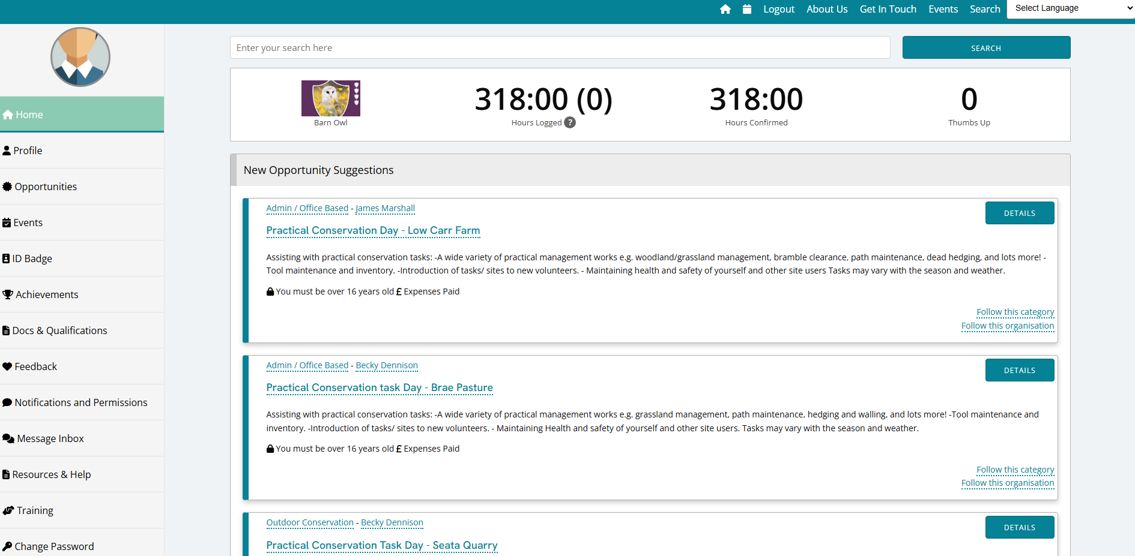
View of search page:
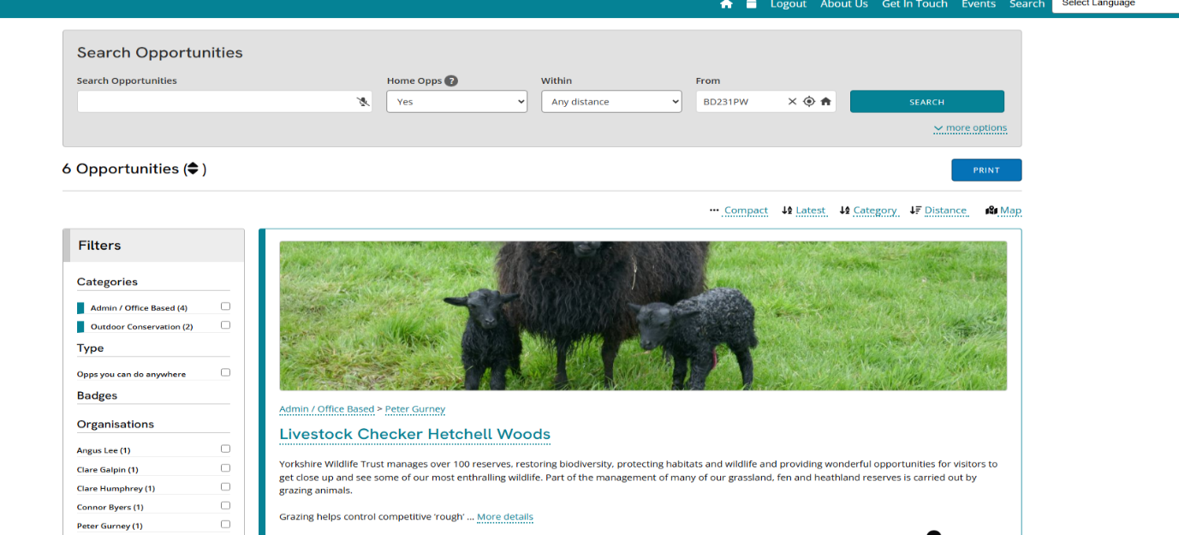
You can also follow a Provider or click on a Providers name to see what volunteering opportunities they have available. This is particularly useful when you attend task days run by the same member of staff.
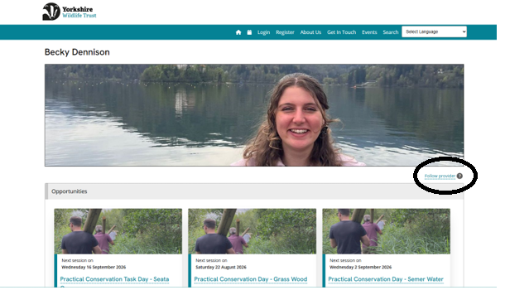

Q. Can I add additional volunteer hours that are outside my normal role or task day?
Yes – if you do some ad hoc additional volunteering, you can add these hours to your record. Please note if this is something you are regularly doing, it’s likely that we will need create, or add you to an opportunity.
Go to the Opportunities section, then you’ll see your Current Opportunities and below this Your Extra Volunteering – this is where you can add any ad hoc volunteering.
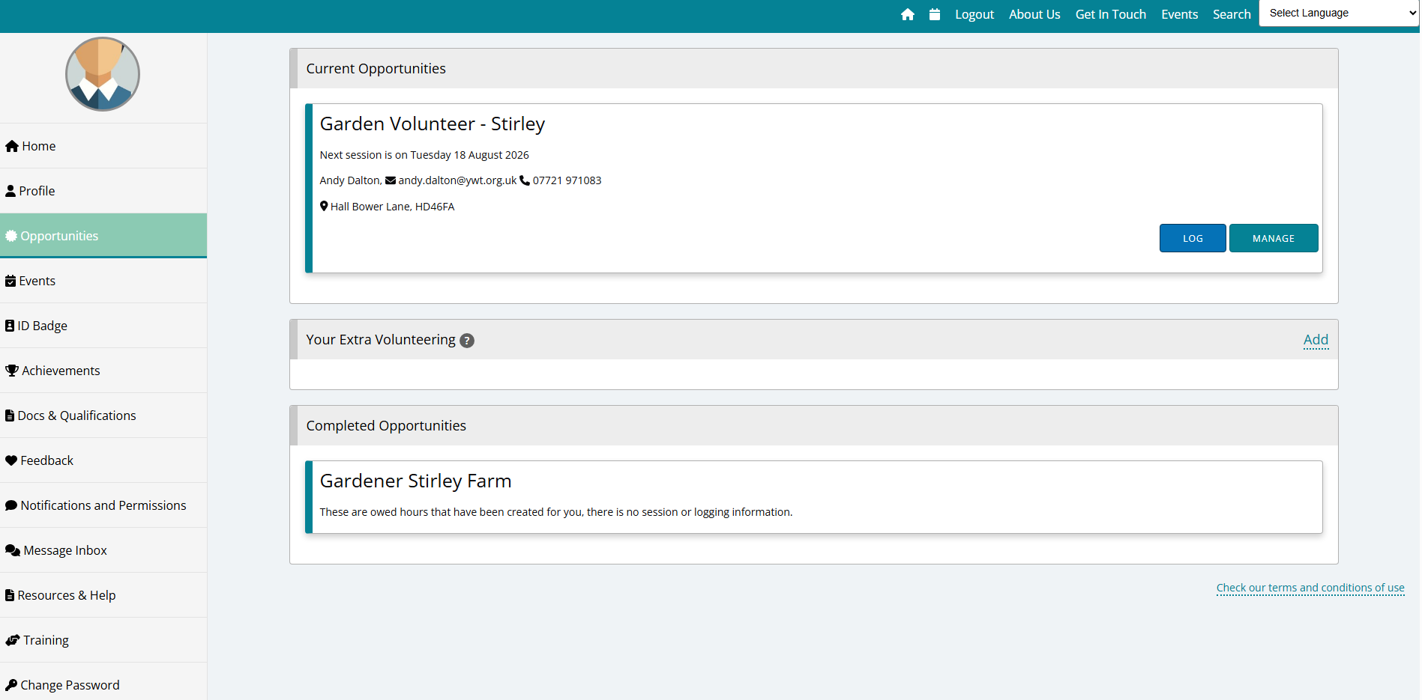

Q. Why do I have sessions or completed volunteering in past appear on my record when we have only just started using Team Kinetic?
There are a few reasons for this:
- If you had any volunteer hours, we needed to bring across there will be a completed opportunity for this
- To link you to your usual volunteering opportunities and volunteer managers we created some dummy task days – you can just ignore anything before went live to you on Tuesday 11th August. You may get notifications about these as we work through them to make them clearer about being part of the admin set up.

Q. Why do I have a lump sum of hours against one opportunity when I have volunteered in different roles?
We could only migrate a lump sum in one of your usual volunteering roles. To have separated them out would have been a huge administration project and not within our capacity to manage.

Q. There’s lots of information about my opportunities – start date, end date, number of volunteer hours available to log. What does this all mean?
We’ve always had this information on record but not for you to see. There are settings that are mandatory and must be completed when we create opportunities such as start and end date. Many of our volunteering opportunities are ongoing and we have added end dates far in the future, which will be monitored and updated accordingly. There’s nothing for you to do with this.
When we create the opportunities and add the end date, the system automatically assumes how many hours there will be available in that period that could be logged. Again, there is nothing you need to worry about here – just log the hours you do as volunteer and these will be added to your record.

Q. I have tried to book onto my regular volunteering opportunity, and it is saying the session is full. What can I do?
You’ll be added to a waiting list and notified if a place becomes available. You can also email the provider to enquire directly with them about the session as they may be able to accept more volunteers.

Q. I know when my volunteering days are and I am used to just turning up. Can I continue to do this?
You should let us know in advance if you intend to join a task day by booking on to the session. This helps task day leaders to plan and prepare for the day. Having his information gives advance notice to prepare the tasks for the day, to know how many tools to bring, materials and other equipment. Team Kinetic sessions will act as the registers as task leaders will refer to this before and after the task day for recording your hours.

Q. I can’t attend the task day anymore, what should I do?
Plans change; we get that! All you need to do is log on to you account, on your home page you will see your upcoming opportunities, hit manage on the one you want to make changes to which will open up that opportunity where you can hit the leave button of the session you can’t attend.

Q. Do I have to tell you about my health issues and other sensitive information like race or religion in my volunteer profile?
No, these are not mandatory fields of information. It’s helpful to your volunteer manager to know if you have any medical or support needs that may affect your volunteering and only they and the Volunteering Team have access to this data.

Q. I don’t have an email address, and I don’t want to get one. How will Team Kinetic work for me?
That’s ok. We recognise that some people may not have access to digital platforms so easily or want an online presence. As an organisation that involves volunteers, we must have a record of every person who undertakes a volunteering role with us. This is due to insurance and Health and Safety requirements. Team Kinetic is our organisations volunteer management system and where we register and record your volunteering activity – all active volunteers must be recorded in the system. For anyone who can’t access Team Kinetic we can help to manage these records. Please contact us and we will discuss your needs if you cannot access Team Kinetic.

Q. I volunteer in several different places, and I’ve selected one role from my home screen to log hours or view the session, and now I can’t see the details for the other roles.
You can go back to a list of all the roles you volunteer in by clicking the home button (on the teal bar at the top of the page) – this will take you back to your summary page where you can see all your opportunities.

Q. I don’t want to receive any marketing emails (bulk emails), how can I turn this off?
You can change notifications and permissions from your profile on the lefthand bar you will see the option Notifications and Permissions. From here you can opt out of bulk emails, chat notifications and anniversary emails, plus unfollow providers and categories. If you opt out of emails you won’t receive any emails from us that has a marketing element, which does include the monthly Volunteer News. You will still receive emails from your volunteer manager about your volunteering and/or essential administrative emails from the volunteering team.

Q. What is the chat room function for?
Each opportunity has a chat function which allows volunteers to message other volunteers who are on the same session or opportunity. This could be useful to organise lift shares, discuss arrangements or agree who is bringing the biscuits! There’s no requirement to use this, its function is built into Team Kinetic and is designed to promote community and connection. The Volunteering Team will be moderating the opportunity chats and please only discuss appropriate topics pertaining to your volunteering activities and do not share any personal information through the chat please.

Q. I’d like to apply for other types of opportunities, why have I been asked to provide information about my experience and/or references when I am already a volunteer?
That’s great news you’d like to get involved with a new opportunity. We may need further information to assess suitability and experience for some of our volunteering roles. There are roles that require further checks such as reference or DBS checks – this is because they could include working with personal and sensitive data, money, children, young people and/or adults at risk.
Q. There are lots of options on the lefthand bar of my profile – identity badges, training courses, qualifications etc. Do I need to know about these and how to use these?
Team Kinetic is an off the shelf product, it’s been developed to be used by multiple volunteering organisations, therefore it has lots of different functions. We will begin to use more of these in the future and will keep volunteer updated on this.
Q. Do I need to download the Team Kinetic App?

The Team Kinetic App is not a necessity, but you may find it useful to have on your mobile. The app will look a little different as it’s used for all of Team Kinetic customers, so you will be able to see other organisation volunteering opportunities on there.
You can choose to access the system through other devices on a web browser – it’s what works best for you.

