Logging Hours for Attended Opportunities
After completing an opportunity, it’s important to log your hours to keep track of your contributions. Here’s how to log hours, depending on the type of opportunity.

Session-Based Opportunities (e.g., task days)
Session-based opportunities occur on a fixed date and time, so the hours will generally be pre-defined. Volunteer Managers have the ability to bulk add volunteer hours from these sessions too, so don’t worry if you forget to log hours from task days as this will be done by task day leaders.
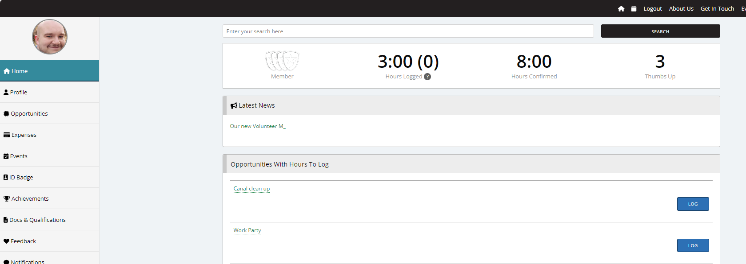
- Locate the relevant Opportunity
Once you have attended a session, return to your volunteering homepage on the TeamKinetic portal. Here, you will see the sessions that you are required to log hours for. As below:

- Click “Log”
For session-based roles, select “Log” next to the opportunity. This will take you to the next page, where you may be asked to leave feedback for the opportunity provider, and where the sessions you can log hours for will appear. These sessions will be in the past and you may have more than one session to log hours for.
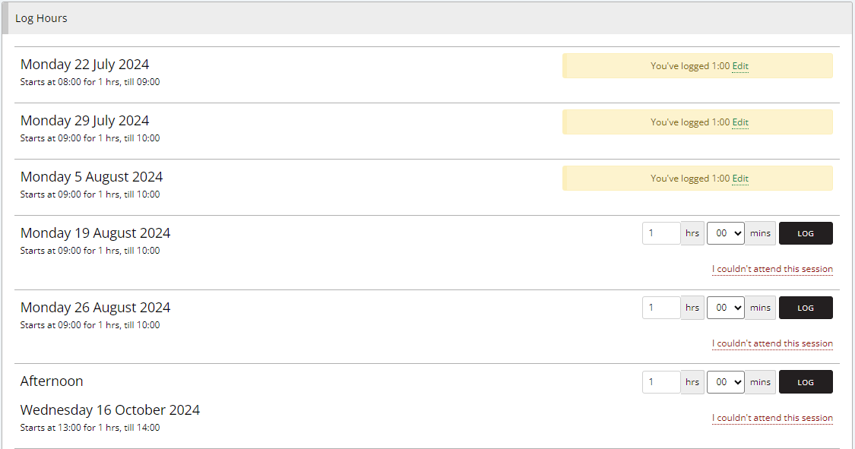
Please note that you can also edit previously submitted hours, if you’ve made a mistake.

- Enter Hours
The hours will automatically populate based on the scheduled session time. Confirm the details, and submit your hours by hitting the ‘Log button’. Once done, your total hours logged will increase in line with the amount logged.
Important:
- You cannot record more hours than the session allows. If the session was scheduled for 3 hours, the system will cap your logged hours accordingly.
- If you attended only part of the session, you can adjust the hours within the session limit.
- You can also find opportunities with hours to log via the opportunities tab on your profile. However, these will be same as on the homepage. See below:
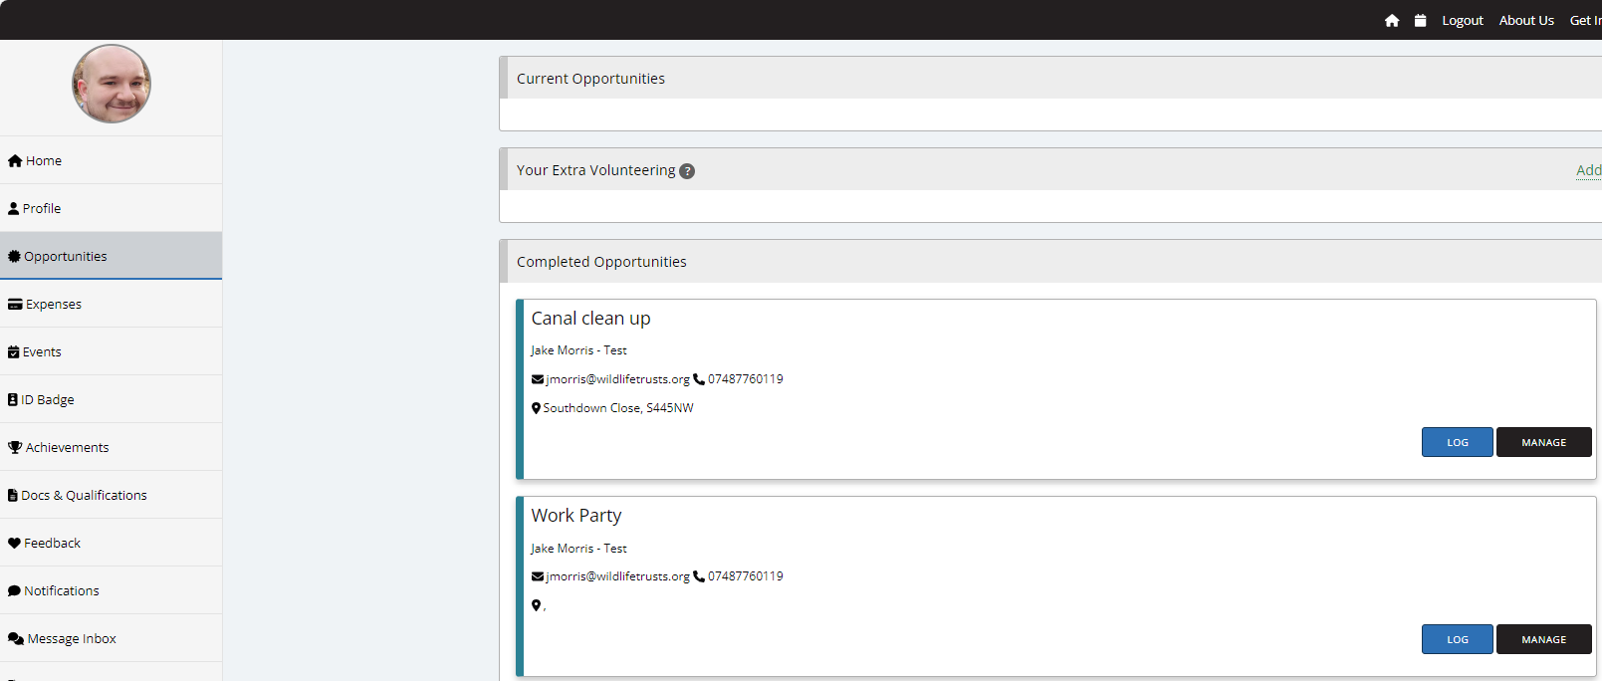

Flexible Opportunities (e.g., Livestock checker, admin roles, surveyors etc.)
Flexible opportunities allow you to volunteer at any time that suits you and log the actual hours you worked.
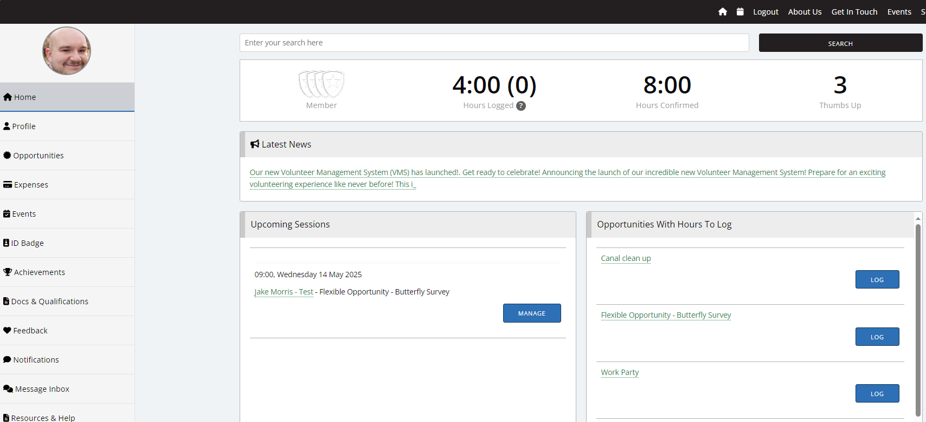
- Locate Your Opportunity
Once you have attended a flexible session, return to your volunteering homepage on the TeamKinetic portal. Here, you will see the sessions that you are required to log hours for. For this example, we’ll record hours against ‘Flexible Opportunity – Butterfly Survey’. As below:

- Click “Log”
Select “Log” next to the opportunity. This will navigate you to the next page where you may be asked to leave feedback for the opportunity provider.

- Enter Actual Hours
Input the number of hours you spent on the activity and the date you attended. Flexible roles allow you to record any amount of time up to 24 hours per entry. Confirm and log your hours.
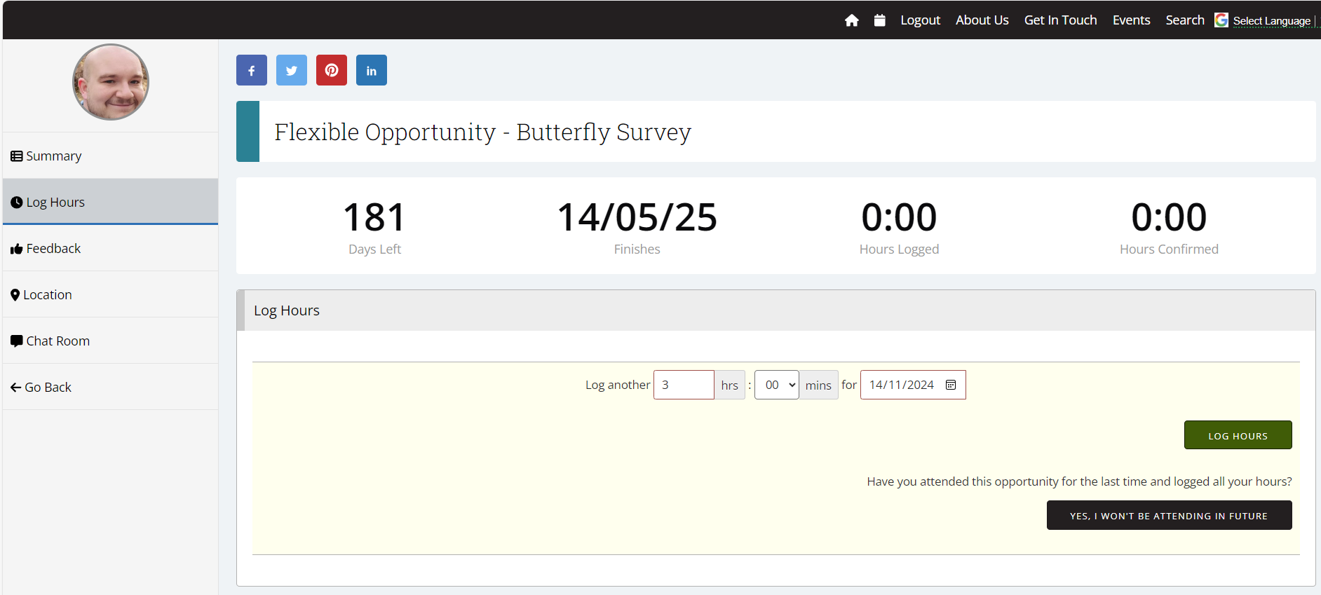

Notes:
- Hours can be recorded in multiple entries if you take part in the opportunity across different days.
- You can’t edit logged hours once submitted, so double-check before submitting. However, you can delete them an re-enter if needed.
- You can log hours retrospectively.

Frequently Asked Questions (FAQ)
1. Can I log more hours than a session allows?
No, for session-based opportunities, you can only log the predefined hours. Flexible opportunities let you log any time up to 24 hours per entry.
2. What if I forget to log my hours immediately?
You can log hours any time after attending. Go to your volunteering homepage or “Opportunities” and select the relevant opportunity to enter your hours.
3. Can I edit my hours after submitting?
Yes, once submitted, you can edit logged hours.
4. How do I view my total hours?
On your volunteering homepage there is a dashboard that displays your total hours.
5. Why are Hours Logged and Total Hours different on my dashboard?
This is because the opportunity provider needs to validate the hours submitted, so you may notice a discrepancy between what you have submitted and what is logged dependant on when the provider confirms these hours.
5. What should I do if I can't log hours for an opportunity?
Ensure you have followed the steps in this guide. If issues persist, reach out to volunteering@ywt.org.uk

