 Volunteer Opportunity

Volunteer Opportunity Title
Welcome Volunteer
Reserve, Project, Team or Area
Potteric Carr Nature Reserve
Volunteer Manager
Jennifer Pass, Nature Discovery Nature Manager
Why do we need you?
Potteric Carr Nature Reserve welcomes thousands of visitors each year, including families, wildlife enthusiasts, school groups and first-time visitors, all coming to explore its wetlands, woodlands and wildlife-rich habitats. Our Welcome Volunteers play an important role in creating a positive first impression and helping visitors make the most out of their day with us.
By supporting the Visitor Services team, volunteers help the Nature Discovery Centre run smoothly during busy periods while providing a warm welcome, answering questions and sharing news of the latest wildlife sightings. Through sharing enthusiasm for nature and conservation, volunteers help people feel connected to the reserve, encourage repeat visits and support our work protecting wildlife.
What will you be doing?
As a Welcome Volunteer, you’ll be based primarily within the Nature Discovery Centre, supporting the Visitor Services team to create a friendly and welcoming experience for everyone visiting Potteric Carr Nature Reserve.
You’ll often be the first person visitors meet, helping them feel welcome and excited about exploring the reserve. Tasks may include:
- Greeting visitors as they arrive and providing a warm, positive welcome
- Sharing information about the reserve, walking routes, wildlife sightings and upcoming events
- Helping visitors make the most of their visit by sharing enthusiasm for Yorkshire’s wildlife and the work of Yorkshire Wildlife Trust
- Supporting with visitor enquiries, membership applications and taking payments for admissions or shop items on our till system
- Assisting in the shop by helping visitors find products and keeping displays tidy and welcoming
- Encouraging visitors to engage with conservation and the work of the reserve – promoting Yorkshire Wildlife Trust membership.
For volunteers with a particular interest in optics and wildlife watching equipment, there may also be opportunities to receive additional training to become a specialist in selling binoculars and spotting scopes.
This is a varied, people-focused role that’s ideal for someone who enjoys meeting new people, working as part of a team and helping visitors connect with nature.

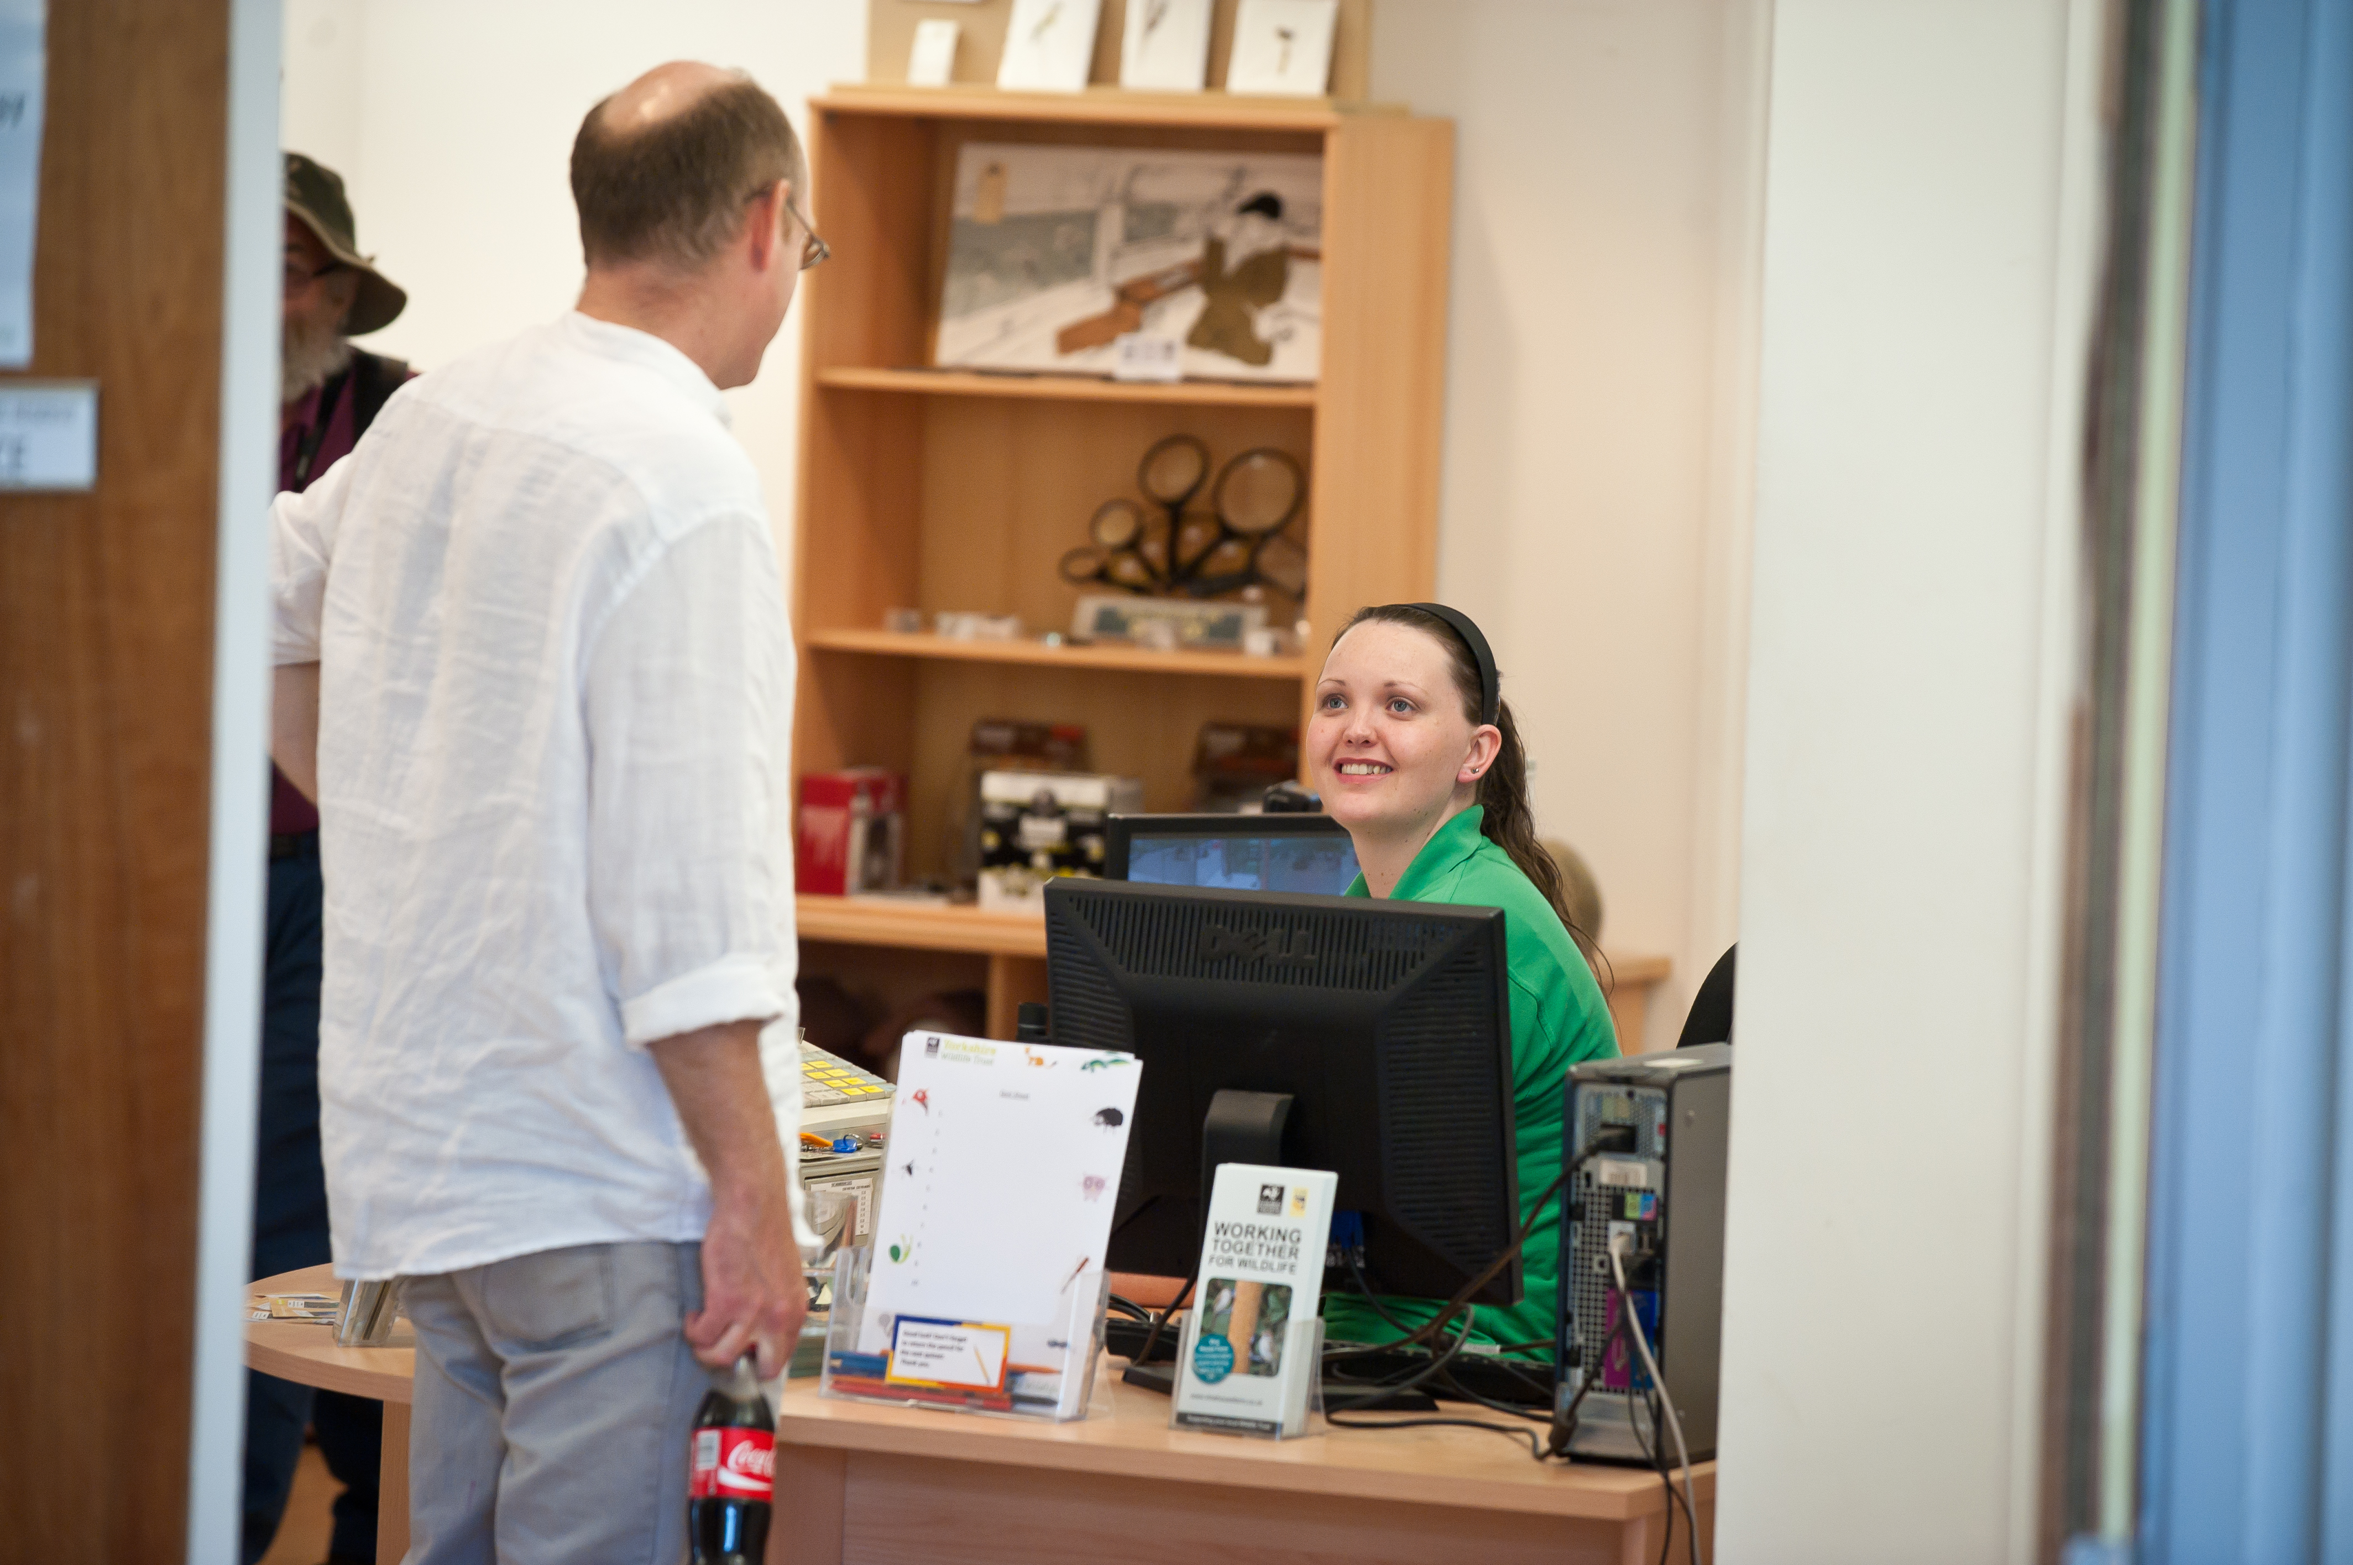
Could you help us engage visitors at Potteric Carr - one of our flag ship visitor sites?
Photo Credit: Matthew Roberts
Experience, knowledge and skills needed for this opportunity
Essential
- Friendly and approachable manner
- Good communication and listening skills
- Confidence speaking to a wide range of people
- Reliable and punctual
- Ability to work as part of a team
- Enthusiasm for wildlife, nature or conservation
Desirable
- Experience in customer service, retail, hospitality or visitor engagement
- Confidence handling basic enquiries or using tills/payment systems
- Experience supporting events or working with families and children

Does the volunteer need a driver’s licence?
No — a driver’s licence is not essential for this role. However, access to transport may be helpful depending on travel arrangements and volunteer shift times.
What’s in it for you?
- Meet new people and become part of a friendly volunteer team
- Gain experience in visitor engagement and customer service
- Develop communication and confidence skills
- Learn more about local wildlife and conservation
- Spend time outdoors in a beautiful natural setting
- Receive training, guidance and ongoing support from reserve staff
- Contribute to protecting wildlife and inspiring others to care for nature
- Opportunities to get involved in events and wider reserve activities

Where is the opportunity based? (be specific)
Potteric Carr Nature Reserve
Nature Discovery Centre and surrounding reserve areas.
Commitment (how often and when? e.g. every Wednesday or once a month)
Flexible opportunities are available. Ideally volunteers would be able to commit to:
- One regular shift per week or fortnight
- Weekday and/or weekend availability welcomed
- Typical shifts may be morning or afternoon sessions of approximately 2–3 hours

Duration (how long will the role last? e.g. ongoing or every week from April-August)
This is an ongoing volunteer opportunity with no fixed end date. We welcome both long-term volunteers and those looking to gain experience over a shorter period.

Is this opportunity accessible? Please provide as much detail as possible.
We are committed to making volunteering as accessible and inclusive as possible.
- Some periods of standing may be required
- Busy visitor areas can occasionally be noisy or fast-paced
- Outdoor areas may include uneven ground and varying weather conditions
- Training and guidance will be provided to ensure volunteers feel safe and supported in the role
- The visitor centre has accessible toilet facilities and step-free access
- Some volunteering tasks can be adapted to suit individual needs and abilities
- Seating can be available during shifts where appropriate
- The reserve includes a mixture of surfaced and uneven outdoor paths which may be affected by weather conditions
- Volunteers are encouraged to discuss any access requirements or support needs before starting so reasonable adjustments can be explored wherever possible
- Full induction and support will be provided by staff and experienced volunteers

For more information and to apply for this volunteer role please send in a completed application to

volunteering@ywt.org.uk

