 Volunteer Opportunity

Volunteer Opportunity Title
Events and Experience Volunteer
Reserve, Project, Team or Area
Potteric Carr Nature Reserve
Volunteer Manager
Lily Lomas-O’Neill, Events and Experiences Officer
Why do we need you?
At Potteric Carr Nature Reserve, we’re growing and developing our events programme to offer a wider range of inspiring experiences for both new and existing visitors. From family-friendly activities to creative workshops and evening events, we want to connect more people with nature in meaningful and memorable ways.

To make this happen, we need a dedicated team of volunteers who can help bring these experiences to life. Events don’t just run themselves; they rely on enthusiastic people who are happy to get involved in every aspect of delivery.
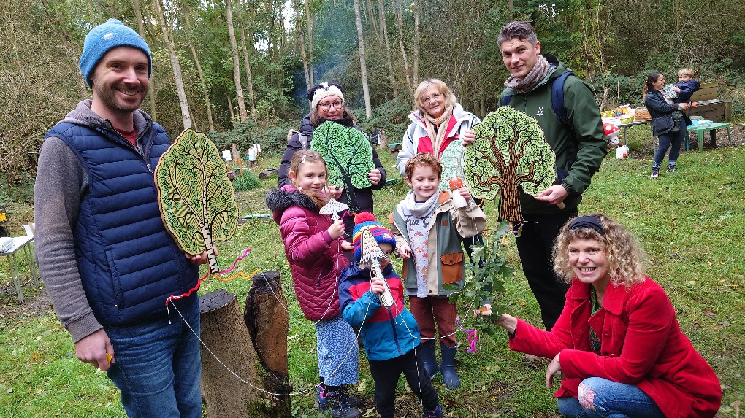

Can you help us bring stories to life for families and school groups?

As an Events and Experience Volunteer, you’ll be part of both the public-facing highlights; welcoming visitors, supporting activities, and creating a great atmosphere. And the behind-the-scenes work that makes it all possible. This might include setting up spaces, preparing materials, helping events run smoothly, and packing everything down at the end of the day.

We are keen to welcome anyone looking to build experience in events, public engagement, or project delivery. This role offers a great opportunity to develop practical, transferable skills, strengthen a CV or university application, and gain insight into how events are planned and run, all while being part of something enjoyable and rewarding. That said, we warmly welcome volunteers of all ages and backgrounds who share an interest in creating great visitor experiences.

Your support will help us deliver high-quality events, reach wider audiences, and generate
vital income for Yorkshire Wildlife Trust. Quite simply, we couldn’t do it without you.

What will you be doing?
As an Events and Experience Volunteer, you will help bring nature to life for visitors of all ages.
This is a varied, people-focused role where no two days are the same. You might be:

- Welcoming visitors and helping them feel at home
- Supporting event check-ins, set ups and directing people to activities
- Chatting with the public and sharing your enthusiasm for nature
- Assisting with family-friendly activities like crafts and nature workshops
- Helping run engaging adult events such as guided walks, talks, or creative workshops
- Supporting larger festival-style events throughout the year (e.g. helping with setup, carpark coordination, or guiding visitors)

This role is all about creating memorable experiences and helping visitors connect with wildlife, making it perfect for someone who enjoys working with people as much as nature.

Experience, knowledge and skills needed for this opportunity
Essential:
- Friendly, approachable, and confident speaking to a wide range of people
- Reliable and willing to get involved as part of a team
- A positive, can-do attitude and readiness to pitch in where needed
- An interest in wildlife, conservation, or outdoor experiences

Desirable (but not required):
- Experience in events, customer service, or public engagement

Full induction and training will be provided as part of this volunteer role.

Does the volunteer need a driver’s licence?

No, this role is based at Potteric Carr which can be reached by public transport.
What’s in it for you?
- Gain hands-on experience in event delivery and visitor engagement
- Develop transferable skills in communication, teamwork, and organisation
- Access to our free in-house Volunteer training programme
- Be part of a fun and inspiring team of Yorkshire Wildlife Trust staff and volunteers
- Enjoy selected events and activities as part of your role
- Play a vital part in supporting conservation by helping generate income and inspiring others to care about wildlife
- A chance to learn more about amazing Yorkshire wildlife.
- We can make a contribution towards reasonable travel expenses.

Where is the opportunity based?
Potteric Carr
Commitment
Due to the nature of our events programme this would be an ad hoc role, with some periods being busier than others; spring / summer season being the busiest time of year. There is no obligation to be involved with every event we have at Potteric but we are looking for people who can commit to a semi-regular basis, with events happening at least once or twice a month on average. This opportunity is available on both weekdays and weekends and may take place during the day or evenings.

Duration
Ongoing
Will I need a DBS? – This role does not require a DBS/Criminal Record Check as it is not classed as regulated activity and you will never be left alone with a child. Two References will need to be provided and volunteers in this role will need to attend Safeguarding Training.

Is this opportunity accessible? Please provide as much detail as possible.
Much of Potteric Carr, where this role is based, is accessible for standard wheelchairs and pushchairs. There are other paths that are more rugged that go round the Discovery Zone and Beeston Plantation. Facilities on site include an accessible toilet and dedicated disabled parking.

There are some duties within this role which may require physical activity such as; heavy lifting, setting up and moving of equipment, standing or walking for long periods of time. However, there are other duties within the role which don’t require strenuous physical activity, and it therefore can be adapted to meet individual abilities.
If you would like to apply for this role please send in a completed application to volunteering@ywt.org.uk

