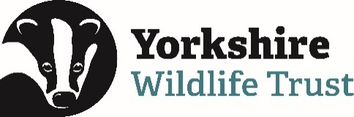 Volunteer Opportunity

Volunteer Opportunity Title
Marine Data Volunteer

Reserve, Project, Team or Area
Remote working, Marine Team
Volunteer Manager
Ana Cowie, Marine Projects Manager
Why do we need you?
Yorkshire Wildlife Trust’s (YWT) Marine Programme is generating an ever-increasing volume of valuable marine and coastal data. This comes from a growing portfolio of projects, including environmental monitoring for our seascape restoration work like the Wilder Humber project, alongside expanding citizen science initiatives recording intertidal species, marine mammals and invasive non-native species (INNS).

As our work continues to grow, so does the volume, complexity and importance of the data we collect. Without dedicated support to organise, manage and interpret this information, there is a real risk that valuable datasets become underused, inconsistent or inaccessible. At the same time, much of Yorkshire’s coastline and seas remain under-recorded, and there is still a lack of robust, long-term datasets needed to understand how climate change, coastal erosion and human pressures are affecting marine ecosystems – and whether our conservation work is making a measurable difference.

This is why we need a Marine Data Volunteer.

By supporting the Marine Team with the management and analysis of our datasets, you will play a vital role in transforming raw data into meaningful, usable evidence. This evidence is essential for:

- Detecting changes in key habitats such as kelp forests, saltmarsh and seagrass
- Monitoring important species such as seals and cetaceans
- Identifying early warning signs of climate impacts and the spread of invasive species
- Informing conservation decisions, marine planning and future protections
- Evaluating the impact and success of our restoration and monitoring projects

Your contribution will ensure that the data we collect does not sit unused for longer than we would like but instead becomes a powerful tool for protecting and restoring Yorkshire’s estuaries and seas as soon as possible

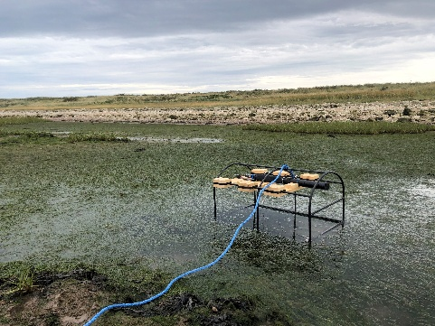
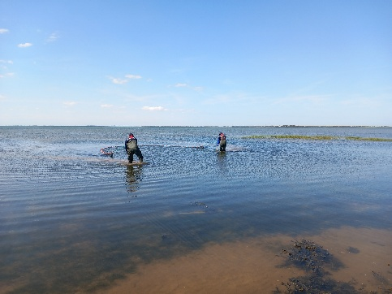
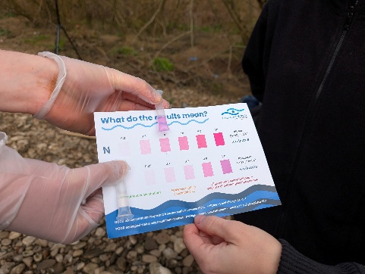
Photo 2: Collecting sonde data for the Wilder Humber project.
Photo 2: Collecting fish data for the Wilder Humber project.
Photo 1: Collecting water quality data for the Rivers to Reef project.
What will you be doing?
As a Marine Data Volunteer, you will play a key role in supporting the data lifecycle of our projects. Tasks may include:

- Organising and maintaining marine datasets
- Cleaning and validating biological and environmental data
- Supporting data entry into databases and online platforms
- Assisting with analysis of trends (e.g. species distribution, seasonal patterns, environmental change)
- Producing summaries, graphs or maps to support reporting
- Helping translate data into accessible outputs for volunteers, communities and stakeholders
- Working with project staff to ensure data is stored securely and consistently

There may also be opportunities to:
- Contribute to reports that inform conservation action
- Support the development of long-term monitoring datasets
- Link datasets to wider regional or national marine recording schemes

Experience, knowledge and skills needed for this opportunity
We welcome volunteers from a range of backgrounds. You don’t need to be an expert, but the following would be beneficial:

Essential:
- Good organisational skills and attention to detail
- Confidence working with data (e.g. spreadsheets such as Excel or Google Sheets)
- Ability to work independently and manage tasks
- Interest in marine conservation, ecology or environmental science
Desirable:
- Experience with data analysis or visualisation (e.g. graphs, charts, GIS)
- Understanding of biological recording or citizen science datasets
- Familiarity with marine species, habitats or ecological concepts
- Experience using databases or data management systems
Support and guidance will be provided, especially around project specific datasets and tools.

Does the volunteer need a driver’s licence?

No, a driving license is not required for this role, as it can be carried out remotely. However, there may be optional opportunities to join the team in the field to support data collection if you wish and are able to attend.

What’s in it for you?
This role offers a valuable opportunity to gain practical experience in marine data and conservation science while contributing to high-impact projects.

You will:
- Work closely with YWTs marine team on a wide range of projects
- Develops skills in data management, analysis and interpretation
- Gain experience working with real world ecological datasets
- Contribute directly to marine conservation and climate monitoring
- Build knowledge of Yorkshire’s coastal wildlife and habitats
- Enhance your CV with experience relevant to careers in ecology, conservation or data science

You will also play a vital role in ensuring that collected data leads to real environmental impact, helping to protect marine ecosystems for future generations.

Where is the opportunity based?
This opportunity is primarily remote. All datasets and online platforms (wherever possible) will be made accessible to enable you to carry out the role from home.

Commitment
The time commitment for this role is flexible and can be arranged around your availability.
Duration
Ongoing.
If you are interested in applying for this volunteer role please read the Volunteer Code of Conduct and send in a completed volunteer application form to volunteering@ywt.org.uk

