  Volunteer Opportunity

Volunteer Opportunity Title
Coastal Ranger Volunteer
Reserve, Project, Team or Area
North Yorkshire Coastline (various sites), Marine Team, River Esk Connect Project

Volunteer Manager
Ana Cowie, Marine Projects Manager (with training and support from Yorkshire Marine Nature Partnership)

Why do we need you?
At over 95 miles long, Yorkshire has an extensive stretch of coast, but life doesn’t just stop at the county borders. We’re connected to the rest of the world by oceanic currents that sweep past our shores, through the weather systems that roll in from all sides, with the mobile species that fly and swim incredible distances to visit our coastline. Within a single day on the Yorkshire coast, you could see dolphins playing amongst the waves, watch the UK’s largest seabird soar around the cliffs, and spot seals basking along the shore.

Wildlife on the Yorkshire coast is under pressure from our changing climate and human activities on a national, and international, scale. Whilst major environmental changes are beyond the control of a single person, everyone can help to make sure that our coastline is cared for, and our wildlife is given the space it needs to thrive – and that’s where you come in!

Could you help us identify, record and monitor marine life? We are seeking volunteers from all walks of life, with a keen interest in conservation to help us discover what is living in and amongst the intertidal zones. These surveys will take place at low-tide and at various locations between Staithes and Scarborough, collecting valuable data to help identify key areas for future focus and contribute to conservation action in the region.

Many hands make light work, and we need your keen eyes and dedication to detail to achieve our goal of recording as many species as we can. This is a dedicated 3-year volunteering opportunity through the River Esk Connect project, however we are hoping to extend this further in future. We will provide the training and the tools you need to get started.

Living near the coastline, or visiting frequently, you likely know these beaches better than we do! We are keen to hear your stories of how these landscapes are changing, log your observations and use this information to help prioritise the work that is needed to safeguard our coastal species and habitats.

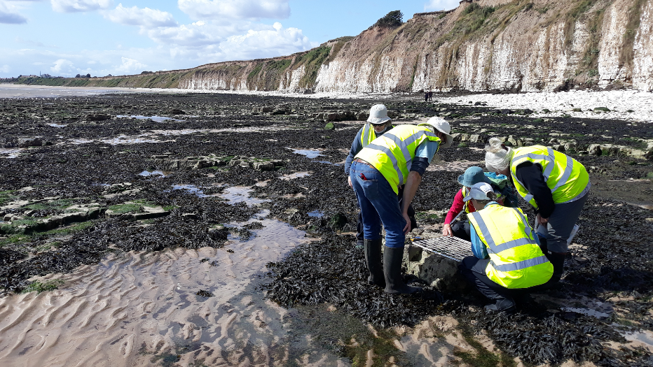
Credit: Heather Davison-Smith
What will you be doing?
Those interested in volunteering will be invited to an introductory workshop which will cover:

- What is citizen science and why it is important
- Different citizen science projects, methods and objectives
- Species ID (using guides, books and digital support)
- Data recording methodology
- Reading the tide – staying safe on the shore and knowing the best time to survey
- Health and Safety processes, including risk assessments and options for lone working volunteers

These workshops will provide a mixture of informative presentations and hands on exploration to determine whether volunteering is right for you, and to help you decide if you have any preference in the type of activities you want to get involved with.

Every citizen science project looks slightly different, but one thing they have in common is collecting and sharing observations and data. One day you could be surveying rockpools, another could see you monitoring seabirds, mammals or recreational disturbance.

Do you prefer to stroll along the strandline? Great! There are gaps in consistent data here, so we need eyes down for this one; if you fancy staying on the sand, why not spend an hour or so on the beach recording shark eggs cases, discovering shells, identifying seaweeds and jotting down jellyfish sightings.

Supported by staff from Yorkshire Marine Nature Partnership and Yorkshire Wildlife Trust, you will be working in small groups to learn the practical skills needed to survey effectively and respectfully, plus getting to grips with the information that needs to be recorded when in the field.

This will provide the opportunity to learn together, ask any questions when working outdoors and increase your skills and confidence should you wish to continue independently in the future. All records provided will require a clear photo to evidence each separate sighting, which will help verify the ID.
Experience, knowledge and skills needed for this opportunity
Required:
- Ability to access survey sites independently
- A passion for the marine environment
- An interest and knowledge of British marine life or the enthusiasm to learn
- Ability to record information accurately and in detail (recording forms provided)
- Ability to survey outdoors for approximately 1-2 hours
- A mature and responsible attitude
- Ability to read and understand tide timetables
- Flexible and adaptable approach
- An understanding and respect of health and safety guidelines and the risks of working by the sea

Desirable or willingness to learn:
- Knowledge of the marine environment
- A basic knowledge of marine species identification
- Interpersonal communication skills, when working as a team
- Proactive with the ability to work independently and unsupervised (if desired)
- Submitting data through existing webtools

Does the volunteer need a driver’s licence?

No. But the volunteer must be able to travel independently to the coastal sites.

What’s in it for you?
By joining the network of Coastal Rangers (Citizen Science) across Yorkshire, you will be contributing to a national database of information held on marine species in UK waters and so have a direct part to play in their conservation.

You’ll learn about the marine life living along the Yorkshire coastline, including non-native species that are putting pressure on our native populations, and gain valuable experience in field work, plus:

- Relevant training for the role e.g. species ID, survey methods, data collection, health and safety
- Become a valuable member of a volunteer network
- Experience of working within a recognised conservation partnership organisation
- Opportunity to learn more about marine ecosystems
- Opportunity to get involved in national citizen science projects
- Dedicated equipment provided
- Opportunity to meet and connect with other like-minded people in the area
- Opportunity to network and learn alongside experts

Where is the opportunity based?
Surveys will take place at various coastal sites along the Yorkshire Coastline, between Staithes and Scarborough. We will work with you to determine the best site based on your location, any access considerations and available modes of transport.

Commitment
We will be aiming to complete a survey at specified locations once per month, subject to good tides. We don’t expect volunteers to attend every survey, however regular attendance will help build their skills and knowledge. Those volunteers skilled enough to operate independently following a period of training can complete additional surveys if desired.

Duration
Group activities will be made available to run year-round between June 2026 and December 2028.
Independent surveys and data submission will be ongoing. The schedule of survey locations and focus of citizen science activities in some instances will be seasonal, so some variation will occur across the calendar year.

Is this opportunity accessible? Please provide as much detail as possible.
We aim to make every opportunity accessible to everyone, please see the section ‘experience, knowledge and skills’ for mobility and access considerations for conducting survey work.

It is important that individuals realistically and truthfully assess any challenges they need to consider, keeping both themselves and others safe when working outdoors.

Mobility and Access Considerations:

Rockpools and intertidal zones
- Uneven and slippery surfaces
- Sections of deep and shallow water
- Must be able to crouch, squat, kneel or sit at ground level
- Repetitive movements, bending over
- Hands will likely get wet and cold
- Potential for sharp rocks and marine life

Sandy beaches and shoreline surveys
- Potentially sloped surfaces
- Hard wet sand (seaward)
- Dry soft, uneven sand (landward)
- Potential for large uneven boulder/rocks
- Hidden dips and pools of water
- Estuarine streams and run off between tides
- Repetitive movements, bending over
- May need to crouch, squat, kneel or sit at ground level

For those able to access the beaches but would require adapted transport on the sand, Whitby Disability Action Group can offer beach wheelchairs for shoreline surveys. Please be aware that these may only be available at specific locations and will be subject to availability. These are not suitable for access to rockpool surveys.

Whilst all efforts are made to assess all risks for these activities and locations, volunteers are expected to adhere to the guidance provided during group safety briefings but are ultimately responsible for their own actions and personal belongings when conducting surveys.

Independent/lone working surveys, if requested, will only be approved under the Yorkshire Marine Nature Partnership and Yorkshire Wildlife Trust risk assessments when the volunteer is recognised as skilled and competent enough to complete this work independently.

If you would are interested in applying for this volunteer role please read the Volunteer Code of Conduct and send in a completed volunteer application form to volunteering@ywt.org.uk

