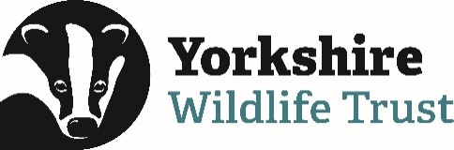 Volunteer Opportunity

Volunteer Opportunity Title
Great Crested Newt eDNA Survey Volunteer
Reserve, Project, Team or Area
North Projects Team
Volunteer Manager
John Thompson, Wetland Creation Officer
Why do we need you?
Can you help with eDNA surveys?
Great crested newt populations in the UK are significantly important internationally.
We carry out surveys to check if great crested newts are utilising the ponds that we have created or restored for annual breeding. Environmental DNA (eDNA) is a great method for doing this and we need volunteers to help us conduct these surveys. We’ll be surveying ponds across North Yorkshire and West Yorkshire.

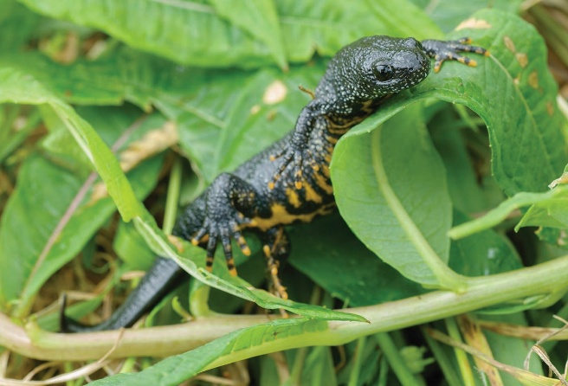
Image Great Crested Newt © John Bridges
What will you be doing?
Each day will involve meeting at the York Office before heading out and conducting an eDNA survey on several ponds across Yorkshire.

You will be supported throughout the day by a member of staff who will provide any training and guidance you may require.

You will be collecting water samples from ponds, from the banks. These samples will then be sent away for analysis. There is also a small amount of admin / data recording in the field.

All the survey kits and any PPE will be provide by the staff team.

Experience, knowledge and skills needed for this opportunity
This role is suitable for anyone who:
- Enjoys being in the outdoors all day
- Can be flexible with the day/date that they survey each week, as surveys cannot be carried out during inclement weather.
- Understands the importance in keeping careful records and site details confidential.
- Would like to learn more about eDNA sampling techniques.
Does the volunteer need a driver’s licence?
No – transport is provided from the York office. Due to the nature of the sites the staff team from Yorkshire Wildlife Trust will be organising transport to take volunteers and staff from the York Office, based on Tadcaster Road, York to the surveying sites.
What’s in it for you?
- Learn something new or use your existing skills in eDNA surveys
- Time outside with nature
- Exercise. You will be walking a fair bit with this role and where better to do this than at one of Yorkshire Wildlife Trust’s beautiful nature reserves or private third-party land.
- Meeting new people. Wherever possible we have small groups of volunteers working together to complete the surveys and on public facing sites there might be some engagement with interested locals too.
- Contributing to conservation efforts at a local and national effort. The data you collect will not only support conservation efforts at YWT, but nationally too as part of a long-term programme hosted by Natural England.
- Access to exclusive events and training for Yorkshire Wildlife Trust Volunteers. You will also be invited to our annual Volunteer’s Celebration event in June, as well as other exclusive opportunities only open to YWT volunteers.
- Access to a free volunteer training programme
- 15% discount in Yorkshire Wildlife Trust shop and 15% discount at cafes when volunteering.

Where is the opportunity based?
North and West Yorkshire
Commitment
One off opportunity. Volunteers will need to be available all day 9am - 5pm and to meet at the York office for onward travel with staff to that day’s sites.

Duration
Late May – June for 2 weeks – days to be decided. You don’t have to commit to every day and it can be flexible. They surveying day will be from 9am – 5pm.
Is this opportunity accessible? Please provide as much detail as possible.
Ponds will be in a variety of places which could mean walking across uneven, tussocky, wet ground.

