 Volunteer Opportunity

Volunteer Opportunity Title
Intertidal Fish Surveying Volunteer
Reserve, Project, Team or Area
Wilder Humber – Spurn Point National Nature Reserve
Volunteer Manager
Andrew Jayes – Marine Restoration Officer
Why do we need you?
The Wilder Humber programme delivers a detailed monitoring programme of finfish communities to support the assessment of seagrass and oysters’ restoration success at Spurn. By tracking fish populations over time, we can see how restored habitats are supporting wildlife and strengthening the wider estuarine ecosystem.

By welcoming eight to ten volunteers into the survey team, we can increase our capacity in the field, ensure surveys are delivered consistently throughout the season, and build a stronger, more resilient monitoring team. Volunteer support directly enables more comprehensive spatial and seasonal coverage, stronger datasets, and more robust evidence to guide future restoration decisions. Your time and effort will play a vital role in expanding what the team can achieve and in building a clearer picture of the health of the Humber’s estuarine ecosystems.

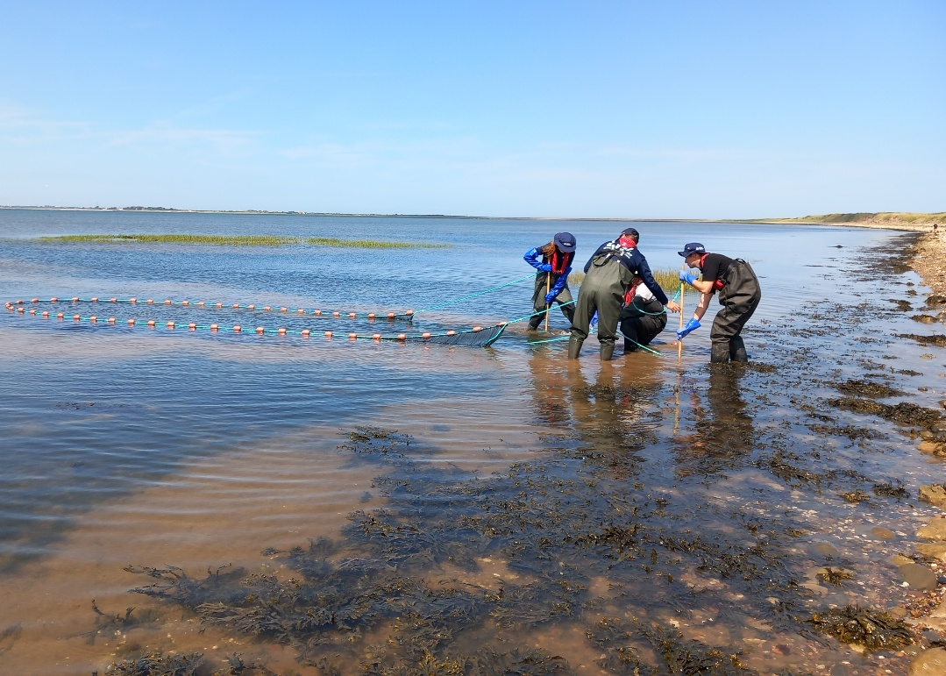
Photo Credit: Georgia Bennett

What will you be doing?
In this role, you will be involved in hands-on intertidal fieldwork, helping staff deliver finfish surveys in the Humber Estuary.

You will help carry out fish surveys using seine netting — a method where a long net is pulled through shallow water and brought back to shore to gently gather fish so they can be recorded and safely released.

You will assist with setting up and retrieving nets, as well as helping to count, measure, and identify estuarine fish species caught in the nets — developing your fish ID skills and gaining confidence in species identification over time.

You will also help collect and log environmental data such as water temperature and salinity. It’s active, practical work that provides valuable field experience while directly supporting biodiversity monitoring in the Humber Estuary.

Experience, knowledge and skills needed for this opportunity
Essential

- Enjoy spending time outdoors and a great eye for detail
- Team players who can follow instructions and work closely with others
- Comfortable with physical activity and working outside in changeable weather conditions
- Happy to be in shallow water, wearing waders and a lifejacket
- Willing to learn about local wildlife, survey techniques, and safe working practices around water
Desirable

- Some knowledge of estuarine fish species or experience with field surveys
- Confidence using basic data recording tools (such as digital devices or simple spreadsheets)
- Previous experience volunteering or working as part of a team in outdoor settings.

Don’t worry if you haven’t done this before! We provide full guidance, support, and training to help you get comfortable with all the tasks. Safety is our top priority, and we’ll work with you to make the experience accessible wherever possible.

Does the volunteer need a driver’s licence?
Driving is not required for this role; however, the project site at Spurn is in a remote location with very limited public transport links. We may be able to offer pick-up from Market Weighton, Beverley, or Hull, and there may also be opportunities to car share with other volunteers.

What’s in it for you?
- This is your chance to be part of one of the biggest restoration programmes in the UK and to play an active role in the recovery of the Humber Estuary. By supporting the monitoring of fish populations across seagrass and oyster restoration sites, you’ll be contributing to an ambitious, seascape-scale restoration programme that’s creating real, lasting change.
- You’ll gain hands-on field experience, develop skills in fish identification and finfish survey techniques, and build confidence working in a dynamic estuarine environment. Full training and support will be provided.
- You’ll also become part of a friendly, motivated team — spending time outdoors and meeting like-minded people.

Where is the opportunity based?
Spurn point National Nature Reserve
Commitment
Duration (how long will the role last? e.g. ongoing or every week from April-August)
April – October 2026
Is this opportunity accessible?
This volunteer role involves outdoor fieldwork and requires some physical activity. To safely take part, volunteers should be able to:
- Stand and walk for extended periods.
- Lift and carry equipment weighing up to 15kg (like nets, buckets of water, and other gear).
- Wade in shallow water and work on soft, uneven surfaces.
- Use hands confidently for handling nets, fish, and other sampling tools.

All equipment and tools will be provided including waders and life jackets.

If you are interested in applying for this role please send in a completed volunteer application form to volunteering@ywt.org.uk by Thursday 26th March.

Please note as part of this volunteer role you will have to attend essential finfish survey training on April 7th or April 8th

