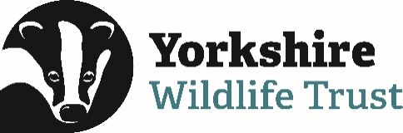 Volunteer Opportunity

Volunteer Opportunity Title
Volunteer Breeding Bird Surveyor
Reserve, Project, Team or Area
Yorkshire Wide Role (various locations), Data & Evidence Team
Volunteer Manager
Bethany Clarkson, Evidence Officer – With ongoing support from the Breeding Bird Survey Coordinator Volunteer.
Why do we need you?
Are you a keen birder who could put their skills to use and contribute to Yorkshire Wildlife Trust monitoring? Do you love early mornings, gorgeous sunrises, and exceptional wildlife sightings? If you love birds, getting out into nature and exploring, then you will be perfect for the Volunteer Breeding Bird surveying (BBS) opportunity!

We are currently looking to recruit Volunteer Breeding Bird Surveyors across our Yorkshire Wildlife Trust Reserves, particularly:
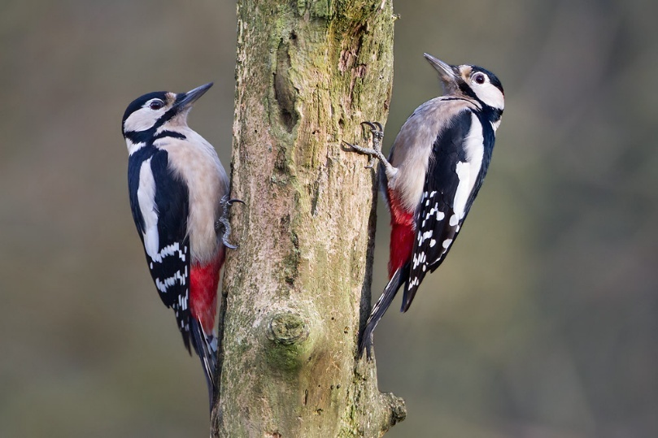
- Ashberry (North) | - Moorlands (East)
- Birch Wood (North) | - Strensall Common (East)
- Bolton-on-Swale Lake (North) | - Newbiggin Pastures (North-west)
- Garbutt Wood (North) | - Park Gill (North-west)
- Ripon City Wetlands (North) | - Semerwater (North-west)
- Staveley (North) | - Willow Garth (West)
- Upper Dunsforth Carrs (North) | - Stocksmoor Common (West)
- Fen Bog (North-east) | - Denaby Ings (South)
- Little Beck Wood (North-east) | - Sprotbrough Flash (South)
- Hodgson’s Fields (East) | - Thorpe Marsh (South)
- Allerthorpe Common (East)

Greater spotted Woodpeckers (Dendrocopos major), just one bird species you might see (or hear!) when conducting Breeding Bird Surveys.
Photo Credit: Kevin Agar
Breeding Bird Surveyors monitor the status and trends of bird populations. The data collected helps us create maps of bird populations in particular areas but more importantly for Yorkshire Wildlife Trust it will help to inform the work that we may or may not do on our nature reserves.

Data collected can show whether a particular bird species is in decline and that could help us to understand what we may need to do to manage a reserve to halt that decline and ultimately reverse it. It may lead to habitat creation, or changes in management practice that will hopefully benefit that species. Or it could be that we find out a species is thriving; prompting more research into why that might be.

If you are able to identify birds by call, song and by sight throughout spring and summer, we would love to hear from you. This is a great way to learn new skills, get some exercise and fill your lungs with fresh air.

What will you be doing?
You will be assisting with Breeding Bird Surveys on Yorkshire Wildlife Trust reserves, to maintain accurate records of breeding birds on our reserves for future management. You will do this by being involved with the following tasks:

- Undertaking bird surveys, usually 6 visits between April and July. Each survey will take around 2 hours on average, depending on the size of the site and the number of birds you hear.

- Mapping the behaviours, songs and calls you hear and see using the BTO (British Trust for Ornithology) codes provided.

- Reporting results back to the Breeding Bird Coordinator.

- Option to attend survey training session late March.

- This volunteer role involves visiting our reserves on your own. Full risk assessments and lone volunteering procedures will be shared as part of your induction.
Experience, knowledge and skills needed for this opportunity
- Ability to read and annotate maps.

- Some Bird ID skills (both by sight and call), though there is also scope for people to team up with a more experienced birder and learn on the go.

- Must be reliable and a good timekeeper.

- Must be able to carry out each survey at the same time for every visit – the survey needs to be started by 9am at the latest, in order to be finished by noon. If you wish to start earlier than this that’s fine, as long as you can start by this time for all your visits.

Does the volunteer need a driver’s licence?

A driving licence would be ideal as some of our reserves are in remote locations, however this is not needed if you live locally to a reserve and can travel there by walking or by cycling.

What’s in it for you?
- Training- As a Yorkshire Wildlife Trust volunteer you will have access to a whole host of free volunteer training and opportunities which you are able to attend.

- Meet new people- We run an annual Breeding Bird survey training session, which you are invited to attend.

- Get outside- Get to know new places and experience Yorkshire Wildlife Trust nature reserves throughout the Spring/Summer seasons. Best of all the surveys can only be done in good weather, so no rain or wind.

- Exercise- you’ll be walking a fair bit with this role and where better than out in nature!

- Be part of something- You’ll be involved in gathering important breeding bird records, which will allow us to monitor trends and see the impact of and guide our management of our nature reserves.

Where is the opportunity based?
Breeding Bird Surveys are conducted across our reserves. You can see a list of many of our nature reserves here: YWT Nature Reserves

Note: We are particularly looking for volunteers to help survey the reserves listed above, but if you would be interested in volunteering at one of our other reserves, we can look to accommodate this.

Commitment
Up to 6 surveys annually.
Duration
April to July on an annual basis.
If you are interested in applying for this volunteer role, please send in a completed volunteer application form to volunteering@ywt.org.uk

