 Volunteer Opportunity

Volunteer Opportunity Title
Conservation Gardener Volunteer
Reserve, Project, Team or Area
Pearson Park Office, Hull. East Team
Volunteer Manager
Andrew Gibson, Outer Humber Officer
Why do we need you?
Do you love gardening and want to do something outdoors in your spare time? We are looking for two volunteers to help us maintain the office grounds at our Hull Office.

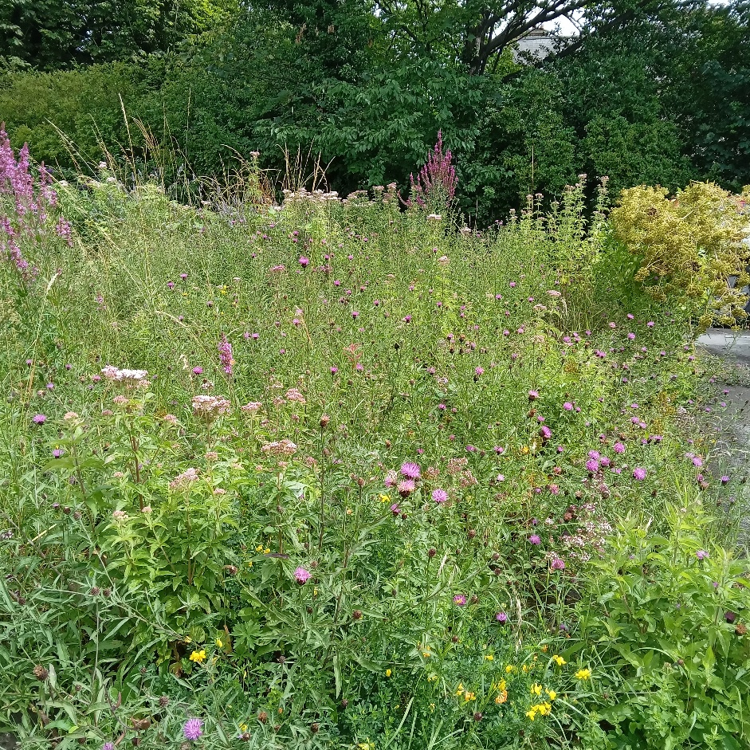
Our gardens are a vast living landscape. With an estimated 24 million gardens in the UK, the way they are cared for can make a big difference to the natural world. Hedgehogs, bats, sparrows, song thrushes and stag beetles are all declining species in the UK, but if we manage our gardens to benefit wildlife, these creatures and many more will find refuge.
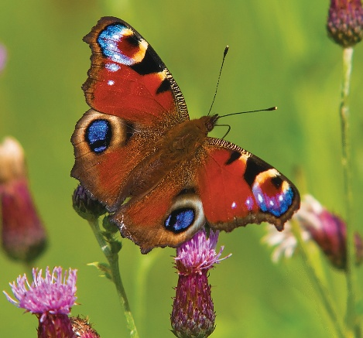

The office grounds at The Pearson Park Office are open to the public generally 9am to 5pm for public access. Once our office needs are fulfilled the aim is to provide the rest of the area for wildlife. The site area is 3000 square meters, which is less than half the area of a football pitch but has recorded 316 species.

Images: Wildflowers at The Pearson Park Office – Andrew Gibson © and Peacock Butterfly Bob Coyle ©
What will you be doing?
The work will be maintaining and enhancing the grounds for wildlife. It is light touch and will not involve much if any digging and turning soil over. It will involve lots of secateur work as shrubs send runners and branches over the paths. You may occasionally be using a handsaw. There are also regular litter picks to keep the site free of litter. All tools and facilities are available onsite and there is also secure cycle storage.
Experience, knowledge and skills needed for this opportunity
- A passion for change and enabling our office grounds to support as much wildlife as possible.
- Flexible approach to traditionally what we think of as gardening
Guidance and assistance will be offered for any one taking on this role.

Does the volunteer need a driver’s licence?
Driving will not be part of this role. The Pearson Park Office in Hull can be reached by public transport. There is also a cycle storage at the office.
What’s in it for you?
- The opportunity to make change in urban green space for nature.
- Be involved in making a difference to enable nature to flourish in our city.
- Be part of a friendly team.
- Induction and training in the use of species identification apps on the range of species that call our office grounds home including the regular fox that visits and watches what we do!

Where is the opportunity based?
Pearson Park Office of Princes Avenue, Hull.
Commitment
A set day to be agreed and can be flexible to meet your personal commitments it can be either fortnightly for half day or full day.
Duration
It will be year-round.
To apply for this volunteer role please complete a volunteer application and return it to volunteering@ywt.org.uk

