 Volunteer Opportunity

Volunteer Opportunity Title
Potteric Carr Event & Festival Volunteer
Reserve, Project, Team or Area
Potteric Carr Nature Discovery Centre
Volunteer Manager
Jennifer Pass
Why do we need you?
We want your help to bring our events and festivals to life, help them to run smoothly and tell our visitor’s just how amazing nature is!
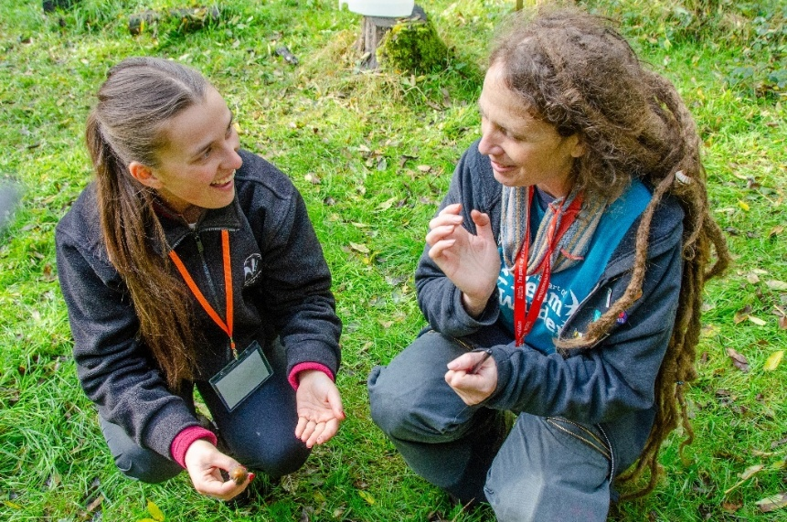
Potteric Carr Nature Reserve is bursting with potential for people to create connections with nature, whilst also providing ample opportunities for people to learn more about the wildlife they already love.
Each year we use this wonderful oasis to host events and festivals to shine a light on the wonders of nature that can be found not too far from the urban areas of Doncaster.
Photo credit – Sara Spillett

During the winter, we will be hosting the Yorkshire Robin Festival (6th – 7th December 2025). Get bob, bob, bobbin’ along to volunteer and help us celebrate a festive favourite and ‘gardener’s best friend’, the robin. The wintery, wildlife-themed weekend will feature breakfast birdwatching walks, robin nest box building workshops, seasonal food and drink, and guided robin rambles. Festival goes will receive lots of tips of how they can support robins and their feathered friends throughout the winter and beyond.

We are looking for friendly volunteers who would enjoy meeting and greeting visitors, and who would contribute to creating a warm welcome to all our festival and event attendees. You don’t need to commit to all of them and you can be flexible with which events and festivals you choose to support.

We need enthusiastic and approachable volunteers, who are passionate about seeing and experiencing wildlife, to help create a welcoming atmosphere on arrival at our events – and throughout an experience with us. If you would like to be part of a dedicated and friendly team and would enjoy inspiring others about the wonder of our nature world, this volunteer role would be perfect for you!

What will you be doing?
This is a public facing volunteer role featuring both indoor and outdoor volunteering with lots of opportunities to engage with visitors about the event, Potteric Carr nature reserve and Yorkshire’s wildlife.

- Providing support with welcoming event attendees and festival goers at Potteric Carr, proving information and signposting them to relevant activities and Visitor Centre facilities (e.g. café, toilets)
- Assisting with event attendees enquiries at the Nature Discovery Centre, handing our festival programmes and getting people excited about all the things they can see and do
- Helping with event set up and pack down, e.g. supporting in setting-up stalls and gazebos.
- Back marking guided walks
- Helping to deliver family friendly, craft-based activities
- Assisting with car parking stewarding

Event information will be provided along with an induction to Potteric Carr nature reserve and visitor centre.

Experience, knowledge and skills needed for this opportunity
- Friendly and welcoming personality
- Enthusiasm for excellent customer care and/or sharing wildlife knowledge and experiences with others
- Willingness to have fun outdoors in all weathers
- Capable of working on your own and with others
- Good communication skills

Does the volunteer need a driver’s licence?
No – Potteric Carr is available by public transport. Volunteer rota will be flexible to accommodate public transport timings.
What’s in it for you?
- Be part of a fun and inspiring team of YWT staff and volunteers
- A chance to inspire others about the natural world and be part of our exciting events programme.
- Development of communication skills
- Development of customer service and visitor engagement skills
- Access to our free in-house Volunteer training programme
- A chance to learn more about the amazing wildlife that calls Potteric Carr home.
- We can make a contribution towards reasonable travel expenses.
Where is the opportunity based?
Potteric Carr Nature Reserve, near Doncaster
Commitment
This volunteer role is to help us at our large-scale, annual events, however for the rest of the time in-between these events, you can also join in with some other volunteering opportunities we have at Potteric if they are of interest to you, including meeting and greeting visitors to the reserve.

Duration
Yorkshire Robin Festival
Saturday 6th & Sunday 7th December 2025
- Set up from 8am / Festival open from 10am – 4pm
- Volunteering slots:
- Morning: 8am – 1pm
- Afternoon: 12noon – 4.30pm

To apply for this role please complete a volunteer application form and send it into volunteering@ywt.org.uk – for any further questions please also email YWT Volunteering Support Team. Thank you

