 Volunteer Opportunity

Volunteer Opportunity Title
Digital Engagement Volunteer
Reserve, Project, Team or Area
Visitor Engagement Team
Volunteer Manager
Joy Little, Inspiring People Manager
Why do we need you?
Nature is amazing and we want to tell everyone! Yorkshire Wildlife Trust is creating a county rich in wildlife and we need passionate volunteers to help people develop a connection with nature.

We’re looking for someone to join our inspiring Visitor Engagement Team as a Digital Engagement volunteer.

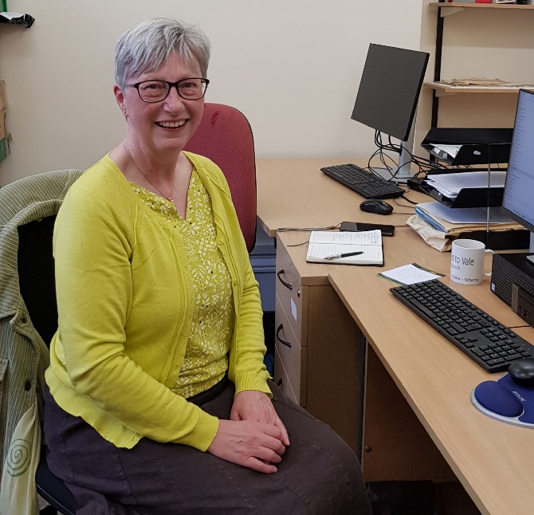
You’ll be desk-based and help us to keep our digital visitor information up-to-date and refreshed so that people across Yorkshire can use it to head out and be inspired by the incredible wildlife and wild places that we care for.

This role is vital to creating fantastic visitor experiences, as your work will guide visitors when they’re deciding which of our wild places they’d like to head out and explore!
Photo Credit: Howard Roddie

What will you be doing?

Within the Visitor Engagement Team, we oversee and deliver most of the events and schools and groups at Yorkshire Wildlife Trust. We are also responsible for keeping our visitors up-to-date with the latest information. You’ll support us in keeping our online listings and information relevant and refreshed so that our visitors can have a great experience!

Tasks will include:
- Updating visitor information for each reserve to reflect the latest edition of our Discover Yorkshire’s Wildlife guidebook.
- Checking and updating information on our website event listings and Eventbrite event listings.
- Supporting in the upload of events via the website and Eventbrite before our bi-annual events programmes.
- Ensuring that online listings have engaging copy and images attached to them.
- Ensuring that online listings have the correct information attached to them and are in a standardised format.
- Keeping templates on Eventbrite updated and cleaning up excess listings.
- Assisting the Inspiring People Manager in responding to visitor enquiries with regards to events.
Knowledge and skills needed for this opportunity
- Confidence using computers and working online (training for how to use the Yorkshire Wildlife Trust website and Eventbrite will be provided)
- Love of detail
- Good communication skills – both online and face to face
- Ability to work independently with support given where needed
Does the volunteer need a driver’s licence?
No. You will need to be able to get to our York office (1 St George’s Place, York) for your initial induction session.
What’s in it for you?
- A chance to develop or use your existing communication skills
- Travel expenses, uniform (if required) and necessary training will be provided
- Access to a free volunteer training programme
- Invites to exclusive volunteer events
- 15% discount in Yorkshire Wildlife Trust shop and 15% discount at cafes when volunteering
- Be part of a fun and inspiring team – opportunities to join engagement team meetings and be a part of events planning.
Where is the opportunity based?
You’ll be desk-based either in York or from home.
Time Commitment
Ideally at least two or three times a month all year round.
To apply for this volunteer role please complete a volunteer application form and send it into volunteering@ywt.org.uk – thank you

