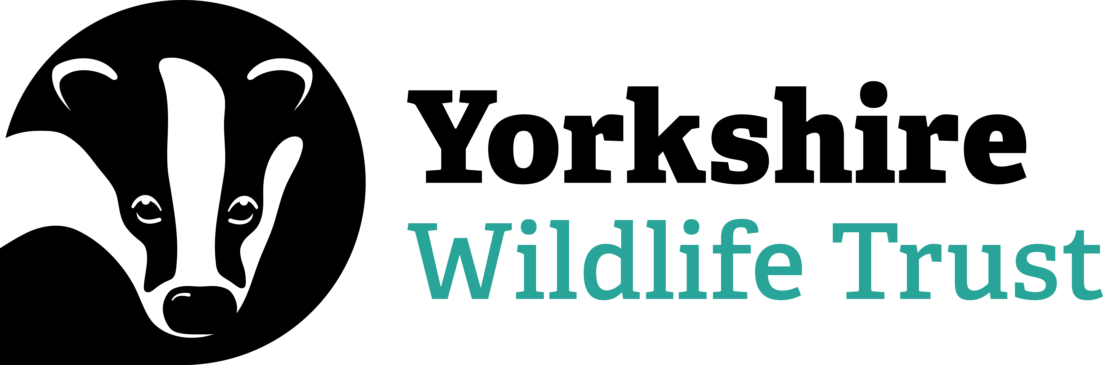

Voluntary Trainee Role Title
River & Wetlands Voluntary Placement – 6 Months
Supervisor
Claire Burton
Reserve/Project/Team/Area
North Project Team – Rivers Esk, Foss and Swale
Background
Yorkshire Wildlife Trust (YWT)’s mission is to create a Yorkshire rich in wildlife for the benefit of everyone – more wildlife, more wild places and more people having a strong connection to nature. Within our Northern region we manage 36 nature reserves, as well as a number of exciting projects. Enabling nature’s recovery takes time and effort and the North Team benefits from the help and support of volunteers to make our vision a reality, whilst providing a first-rate learning and development opportunity for people wanting to focus on a career in nature conservation.

The role of the River and Wetlands Voluntary Placement is for the volunteer to support and be involved in the management of conservation projects in North Yorkshire. Working alongside a team of knowledgeable staff, you will help in planning, development, and the practical delivery of this work. This role will allow you to get an in-depth understanding of working in the conservation sector - you will gain experience in developing river restoration and wetland projects on a local scale whilst working alongside landowners on private land. You will have an opportunity to be directly involved in projects which help to reduce sediment inputs into the watercourse, increase biodiversity and encourage natural flood management.
What will you be doing?
On this Voluntary Placement you will gain experience working on river restoration and wetland creation projects in North Yorkshire. You will be based in YWT’s York office with field work largely carried out near Northallerton, Whitby and York. You will primarily assist our Project Officers in undertaking work on third party land, however there will also be the opportunity to work with other members of the team to enhance your development. You have the opportunity to gain experience in the following areas:

- Riparian ecology and restoration (habitats located on the edge of rivers, streams, lakes and other water bodies).
- Land management techniques to improve water quality
- Wetland habitat creation
- Riparian surveys to identify sedimentation issues and other Water Framework Directive failures (WFD is a directive for the protection of all waterbodies).
- Assist in overseeing contractors undertaking practical conservation work (familiarisation with contracts etc.)
- Undertaking practical tasks such as tree planting, surveys, pond work & habitat creation
- Gain familiarisation with budgets and project management tools
- Mapping and GIS work using QGIS
- Publicising project work via traditional communications and social media
- Coordinating volunteers for survey work and events
- Engaging with farmers, landowners and other stakeholders

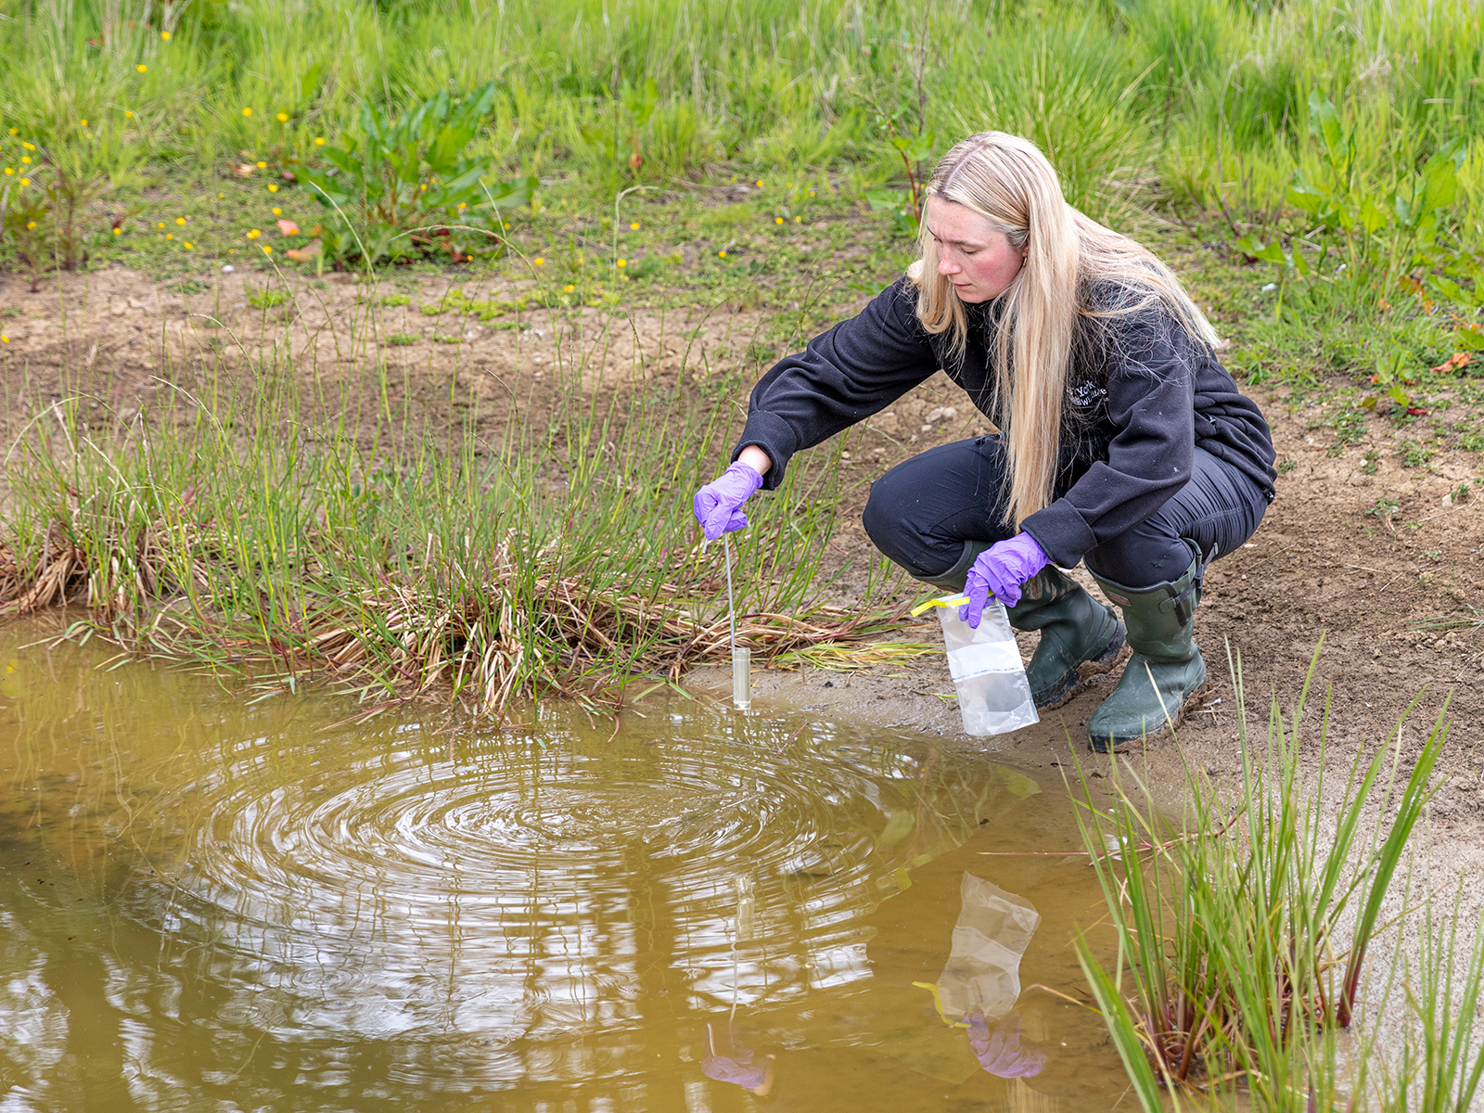
Great Crested Newt Surveying
Photo Credit: Paul Stephenson

What’s in it for you?
- A full induction to the role
- Regular one-to-one with your line manager
- Ongoing personal development, allowing you to develop nature conservation skills and valuable experience towards a career in this highly competitive sector.
- A training budget to include a level 1 certificate in River Restoration with the River Restoration Centre (RRC)
- A programme of in-house training courses will be available throughout your traineeship.
- Access to our free varied internal volunteer training programme
- Branded uniform
- Reasonable travel expenses
- An intensive and high-quality experience that will stand out on any CV, as a team member of one of the UK’s most vibrant and varied conservation organisations.

80% of volunteers on longer term voluntary placements with YWT have successfully found employment within the sector, or gone on to relevant further studies.
Experience, knowledge and skills needed for this role
You will need:
- Enthusiasm for wildlife and conservation
- A friendly and approachable nature
- Be reliable, motivated and able to use initiative
- Be able to work in a team and get along with a range of people
- The ability to communicate effectively and willingness to talk to groups
- Be computer literate in Word and Excel
- Have the ability to research, gather information and compile reports and plans
- Have good organisational and time keeping skills
- Experience of using GIS software, OR willingness to learn
- Happy to work from the office/in the field with occasional remote working

Does the Volunteer need a driver’s license? Yes - Most of our work sites are located in remote locations, away from main public transport routes, therefore this role is suited to a person who holds a full driving license and is willing to drive as part of the role. There are a pool of YWT vehicles based at the York office which are shared amongst the teams and you could have access to.

This role involves being outdoors in natural environments where there will be occasional risks from biohazards such as ticks, leptospirosis, insect bites and similar.
Tasks near or in shallow water are common, so applicants should ideally be able to swim.
Commitment
2 or 3 days per week, between Mon-Fri (flexible to suit the volunteer).
This role will be a mix of office-based work but will include travel to sites & reserves across the North region.
Duration
6-months (w/c 1st September 2025 until February 2026)
To apply for this opportunity, please complete an Application Form and return it to volunteering@ywt.org.uk by the closing deadline, 9am Monday 4th August. Interviews are anticipated to take place at our York Office on Wednesday 13th August 2025.

