 Volunteer Opportunity

Volunteer Opportunity Title
Spurn Ranger Volunteer
Reserve, Project, Team or Area
Spurn National Nature Reserve, Reserve Operations Team, Spurn
Volunteer Manager
Carl Lewis, Humber Operations Manager
Why do we need you?
Spurn National Nature Reserve is a nationally and internationally important site, and is classed as a Site of Special Scientific Interest and a Special Area of Conservation.

We welcome 80,000 visitors a year to Spurn who come from both near and afar to discover the reserve’s rich natural and social heritage. Although most visitors call into the Spurn Discovery Centre to collect key information and a map before heading out onto the reserve, those less familiar with the site often appreciate a friendly face that can provide additional information and guidance whilst they’re out exploring the peninsula.
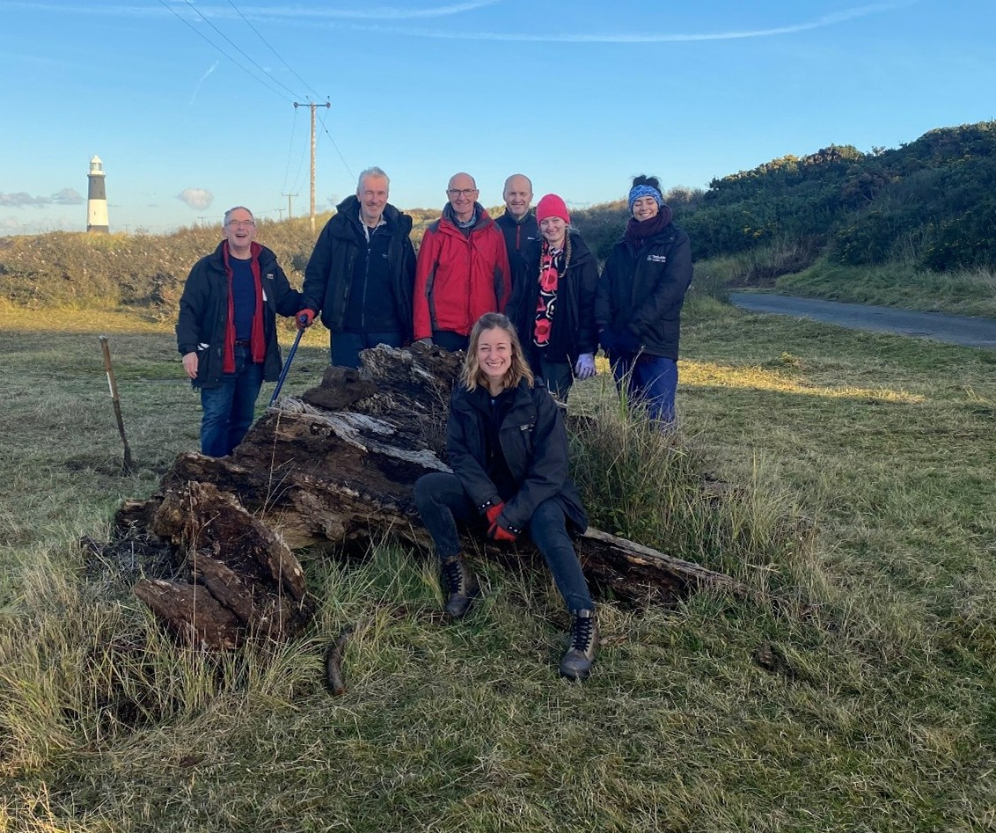
With a range of sensitive habitats spread across the 3.5 mile peninsula, our Ranger volunteers also play a crucial role in advising visitors of areas which are off limits to foot traffic, recommending suitable walking routes or to those that are visiting our site with four legged friends.
Photo Credit: Clare Galpin
What will you be doing?
The Spurn Ranger Volunteer role is highly visible and will involve:
- Talking to visitors, answering questions and providing information on the reserve
- Advising people as to which areas of the reserve are off limits and signposting them to designated paths/ dog-friendly routes
- Carrying out visual checks on the reserve during your shift and reporting any items of concern (e.g. disturbance to wildlife, monitoring beach nesting bird activity, damage to reserve infrastructure etc.) to the site staff
- If undertaking Ranger duties in a UTV buggy, duties will also involve collecting beach litter gathered during regular beach cleans and taking this back to the Spurn Discovery Centre for disposal

Experience, knowledge and skills needed for this opportunity
Essential requirements:
- A reasonable level of physical fitness, as the role will involve walking along the beach and over rough terrain at the south section of the reserve
- Supportive and personable to ensure our visitors feel welcome
- Good communication skills to engage well with visitors
- Enthusiasm and a willingness to learn new skills and further your knowledge
- An ability to follow instructions and work with low levels of supervision

Desirable experience/ knowledge:
- Experience of working with the public
- Local knowledge is desirable, but training via a buddy system will be provided

Does the volunteer need a driver’s licence?
No, but a licence would be preferable so that Ranger duties can cover the entirety of the Reserve
What’s in it for you?
- Meeting lots of new people of different ages and from various backgrounds
- Working as part of a friendly and enthusiastic team to look after Spurn and its heritage
- An opportunity to learn about and motivate others to get involved in the wide range of conservation activity that takes place across Spurn
- Access to a varied volunteer internal training programme
- 20% volunteer discount in our cafes while volunteering
- 15% discount in our shop

Where is the opportunity based?
Spurn National Nature Reserve
Commitment
Fully flexible with the ability to build around your other commitments. A ranger shift typically starts at 11am and finishes at 3pm, though this can be lengthened/ shortened. You can do as many or as few ranger shifts as you like throughout the year.
Duration
Ongoing
If you are interested in applying for this volunteer role then we’d love to hear from you, please send in a completed volunteer application form to volunteering@ywt.org.uk

