 Volunteer Opportunity

Volunteer Opportunity Title
Spurn Practical Conservation Volunteer
Reserve, Project, Team or Area
Spurn National Nature Reserve, Reserve Operations Team, Spurn
Volunteer Manager
Carl Lewis, Humber Operations Manager
Why do we need you?
Spurn National Nature Reserve is a nationally and internationally important site, and is classed as a Site of Special Scientific Interest and a Special Area of Conservation.

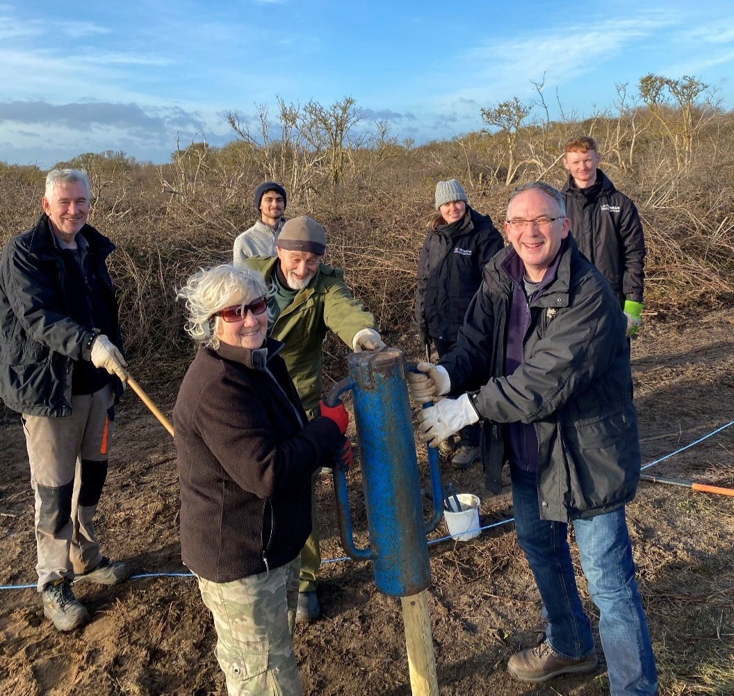
Our Management Plan for Spurn involves the delivery of practical conservation works across the reserve to enhance habitat and encourage species diversification which will further improve the overall condition of the site. The work we carry out is wide ranging and includes tasks such as invasive species control, repair and maintenance of reserve infrastructure and the maintenance of paths to allow visitors to safely navigate the site.
Photo Credit, Clare Galpin

We’re a small team, and we couldn’t achieve what we do without our tireless and good-humoured practical conservation volunteers that bring a huge range of diverse skills and knowledge to the site.

What will you be doing?
No two days are ever the same when carrying our practical activities at Spurn! You’ll be able to take part in a wide range of activities that we deliver as a team, which vary with the seasons. From habitat management in the winter to site maintenance and visitor engagement in the spring and summer.
Some of these tasks include:
- Repair works to reserve infrastructure (e.g. gates and fencing)
- Assisting with livestock movements across the site (Highland cattle and Hebridean sheep)
- Maintenance of paths (e.g. brushcutting)
- Habitat management (e.g. scrub and winter grass clearance)
- Invasive species control (e.g. thistle pulling)
- Specific project support (e.g. electric fencing setup for Beach Nesting Birds, sheep shearing and cattle hoof trimming)
- Survey works

Experience, knowledge and skills needed for this opportunity
Essential requirements:
- Willingness to complete tasks outdoors in a variety of weather conditions, this role can also involve completing tasks which are physically demanding.
- Ability to work as part of a team
- An ability to follow instructions and work with low levels of supervision
- Enthusiasm and a willingness to learn new skills and further your knowledge

Desirable experience/ knowledge:
- Local knowledge is desirable, but full training will be provided
- Good DIY skills are advantageous

Does the volunteer need a driver’s licence?
No
What’s in it for you?
- The opportunity to see the reserve develop and change through the practical conservation works that you are delivering
- The opportunity to learn skills in practical conservation and habitat management
- The opportunity to meet new people of different ages and from various backgrounds
- Access to a varied volunteer internal training programme
- 20% volunteer discount in our cafes while volunteering
- 15% discount in our shop

Where is the opportunity based?
Spurn National Nature Reserve
Commitment
Our practical conservation task days take place on a Wednesday each week. However, there is flexibility as volunteers can attend as many or as few Wednesdays as they like.
A task day typically starts at 10am and finishes at 4pm.
Duration
Ongoing

