 Volunteer Opportunity

Volunteer Opportunity Title
Spurn Livestock Volunteer
Reserve, Project, Team or Area
Spurn National Nature Reserve, Reserve Operations Team, Spurn
Volunteer Manager
Carl Lewis, Humber Operations Manager
Why do we need you?
Spurn National Nature Reserve is a nationally and internationally important site, and is classed as a Site of Special Scientific Interest and a Special Area of Conservation.

As part of our plan to ensure that Spurn is effectively managed, we use ‘conservation grazing’ to improve species diversity across the reserve. Our Hebridean Sheep and Highland Cattle graze and remove areas of competitive tall growing grasses, keeping soil nutrients low and thereby promoting wildflower growth in our meadows and fields. Grazing animals also remove grass to create patches of open, bare ground which warm up very readily in the sun. Warmth is very important for both invertebrates and reptiles. These grazed areas also encourage ground nesting birds like skylark and meadow pipit to nest.
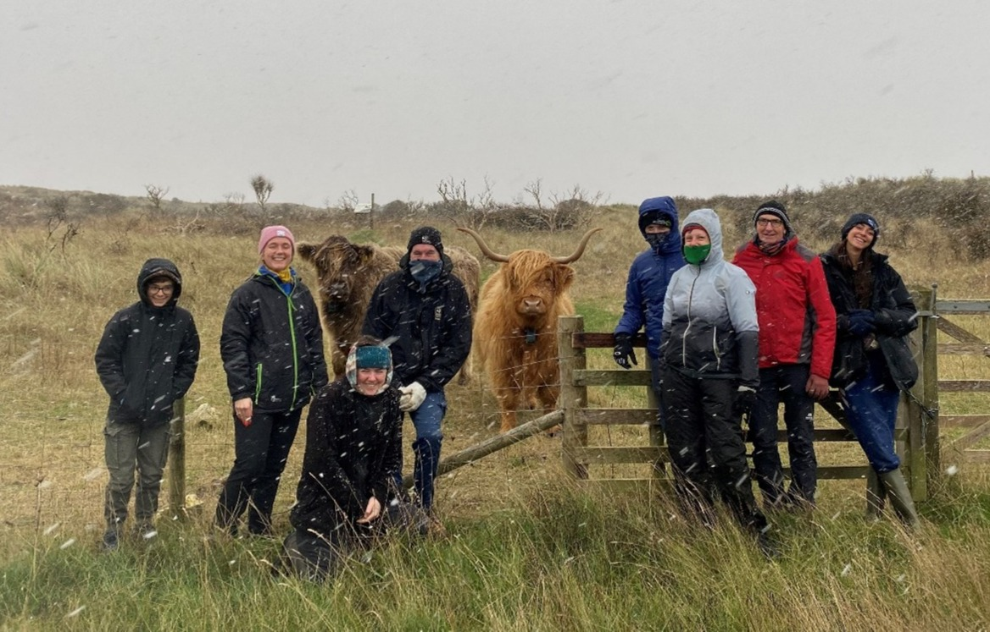
Our livestock play a crucial role in our wildlife conservation efforts, and our reserve team need the support of enthusiastic and eagle-eyed volunteers to visually check our sheep and cows on a daily basis. This helps ensure they are in good condition and remain within the areas they are meant to be grazing.

What will you be doing?
The livestock volunteer role involves:
- Visually observing the livestock, looking out for any signs of poor condition in the flocks and herds (e.g. lameness) so that the reserve team can ensure treatment is administered at the earliest opportunity
- Visually checking that fences are stock proof
- Scanning the fields within which the livestock are grazing for hazards and removing these (e.g. litter such as deflated helium balloons that could be ingested by the animals)
- Ensuring that water troughs are clean and topped up
- Assisting the reserves team to round up animals and to move flock/ herds between different fields on the site
- Assisting the reserve team in carrying out larger scale livestock management activity such as sheep shearing
- Bucket training the livestock to familiarise the animals with a procedure that makes rounding up exercises much easier
Experience, knowledge and skills needed for this opportunity
Essential requirements:
- This volunteer role will involve walking over fields with rough terrain from 1 – 2 hours to conduct the Livestock Checks.
- Reliability, as livestock checks will be required in all weathers
- Being comfortable/ at ease around sheep and cattle
- Enthusiasm and a willingness to learn new skills and further your knowledge

Desirable experience/ knowledge:
- Previous experience with livestock
- Local knowledge is desirable, but full training will be provided

Does the volunteer need a driver’s licence?
Not essential, but preferred as certain areas of the reserve are more challenging to access by foot/ bike.
What’s in it for you?
- The opportunity to see the reserve develop and change through the conservation grazing activity that you’ll be directly supporting
- The chance to get to know our sheep and cattle, all of whom have their own personalities and characters
- The opportunity to learn and develop skills in animal welfare and conservation grazing
- The opportunity to meet new people of different ages and from various backgrounds
- Access to a varied volunteer internal training programme
- 20% volunteer discount in our cafes while volunteering
- 15% discount in our shop

Where is the opportunity based?
Spurn National Nature Reserve
Commitment
Fully flexible with the ability to build around your other commitments. Daily livestock checking duties typically last a couple of hours, but you can do as many or as few days as you’d like.
Duration
Ongoing
If you are interested in applying for this volunteer role then we’d love to hear from you, please complete a volunteer application form and send it to volunteering@ywt.org.uk

