 Volunteer Opportunity

Volunteer Opportunity Title
Spurn Lighthouse Volunteer
Reserve, Project, Team or Area
Spurn National Nature Reserve, Visitor Services Team, Spurn
Volunteer Manager
Carl Lewis, Humber Operations Manager
Why do we need you?
Standing at 39m tall, the black and white tower of Spurn’s Grade II listed lighthouse is one of the most famous and striking landmarks on the Holderness coast.

The lighthouse and its lantern were decommissioned in 1985, but following lottery funded restoration works that were completed in 2016, people can now visit this iconic building to explore exhibits on the history of Spurn and to take in the stunning panoramic views from the platform in the lantern room.

Our friendly lighthouse volunteers support the Spurn visitor services team to open and staff the lighthouse, mainly on weekends and during school holidays, so that that our visitors can enjoy this unique historical structure which is one of the key highlights of a visit to Spurn National Nature Reserve.

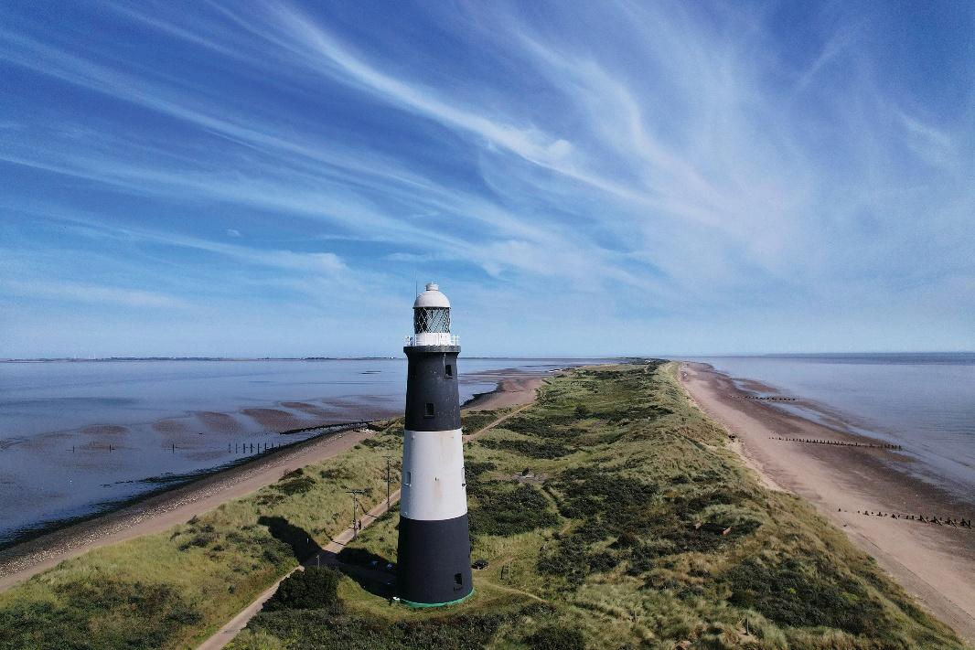
We’re looking for people with a passion for history to join our enthusiastic team that so skilfully bring the story of Spurn’s lighthouse to life and who inspire and create special memories for the thousands of visitors that we welcome to the lighthouse each year.

What will you be doing?
The lighthouse volunteer role is diverse and full training will be provided to enable you to carry out the following tasks:

- Opening up the lighthouse and setting up the interpretation to make the building ready for visitors to explore
- Greeting visitors to the lighthouse and explaining what they can discover on the different floors
- Taking payments for admissions, snacks and souvenirs
- Sharing your knowledge on the lighthouse and answering any questions that visitors may have, referring to colleagues or signposting them to additional information as required
- Undertaking basic housekeeping tasks (e.g. fire alarm checks, tidying chairs that have been moved around by the public etc.)

- Optional – undertaking light maintenance duties as part of a team (painting, polishing etc.)
- Optional – participating in research activity as part of a team (internet research, archive research, etc.)

Experience, knowledge and skills needed for this opportunity
Essential requirements:
- A head for heights, as volunteers have to make regular visits to the lantern room which is 39m above ground level
- A good level of physical fitness, as the lighthouse is a five storey that feature several flights of narrow stairs
- A friendly and helpful personality to ensure our visitors feel welcome
- Good communication skills to engage our visitors in conversation
- Enthusiasm and a willingness to learn new skills and further your knowledge

Desirable experience/ knowledge:
- Experience of working with the public
- Local knowledge is desirable, but training via a buddy system will be provided

Does the volunteer need a driver’s licence?
No
What’s in it for you?
- Meeting lots of new people of different ages and from various backgrounds
- The chance to be an integral part of a unique heritage project
- The opportunity to contribute to our ongoing volunteer-led research on the history of Spurn
- Access to a varied volunteer internal training programme
- Working as part of a friendly and enthusiastic team to look after Spurn and its heritage
- 20% volunteer discount in our cafes while volunteering
- 15% discount in our shop

Where is the opportunity based?
Spurn Lighthouse at Spurn National Nature Reserve
Commitment
Fully flexible with the ability to build around your other commitments. A typical lighthouse volunteer day would start at 10am and finish at 4pm, though this can be lengthened/ shortened.
Duration
Ongoing
If you are interested in applying for this volunteer role then we’d love to hear from you, please complete a volunteer application and send it into voluteering@ywt.org.uk

