

Volunteer Role Title
Events and Engagement Volunteer – Humber
Reserve, Project, Team or Area
Visitor Engagement Team, (Spurn NNR, North Cave Wetlands, Wilder Humber, Hull’s Dynamic Drains)
Volunteer Manager
Carmen Sole – Inspiring People Officer - Humber
Why do we need this volunteer?
Nature is amazing and we want to tell everyone! Yorkshire Wildlife Trust is creating a county rich in wildlife and we need passionate, inspiring volunteers to help people to develop a connection with nature.

We have a seasonal engagement programme brimming with events, including bat walks, beach cleaning, shark egg hunts, fossil walks, pond dipping and bug hunts, across our East Riding of Yorkshire sites (Spurn NNR and North Cave Wetlands).
In addition to our events programme, we also host education sessions with local schools and colleges.
As well as engaging visitors at our sites, we are part of funded projects including Wilder Humber and Hull’s Dynamic Drains and run outreach events in local towns and cities, including Kingston upon Hull. Spreading the knowledge on the importance of restoring marine habitats and reducing flood risk in our towns.

We are looking for people who can inspire others and help us to deliver these events throughout the seasons.
What will the volunteer be doing?
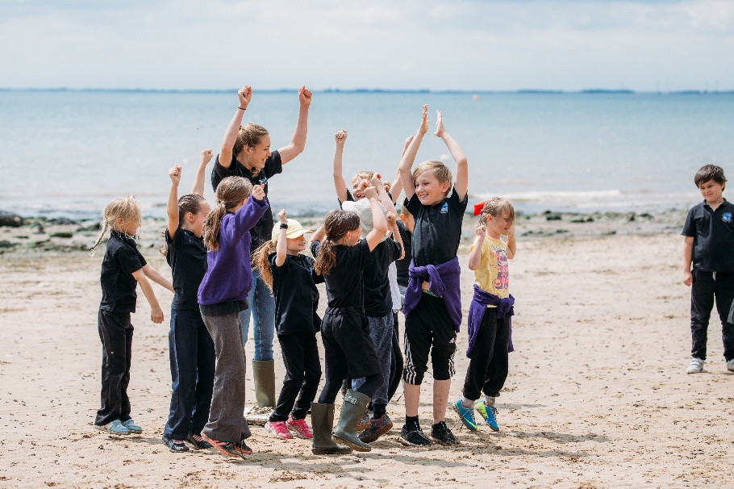
Yorkshire Wildlife Trust manages over 100 nature reserves across Yorkshire, and the East Riding is home to some of our most popular reserves, such as Spurn NNR and North Cave Wetlands. At these sites we run a variety of events to inspire people of all ages and ignite a passion for wildlife.

Staff and volunteers run a variety of events, from onsite school visits and public events such as fossil hunting at Spurn Point NNR, public events at North Cave Wetlands like pond dipping and outreach in local towns and cities as part of funded projects such as Wilder Humber and Hull’s Dynamic Drains, which can include assisting with seagrass seed bag making sessions and tree planting.
YWT

Tasks will include:

- Assisting the Inspiring People Officer – Humber and staff at Spurn in the smooth running of public events and school/group sessions.
- Assist in the preparing of equipment, resources and materials
- Back mark groups so no-one gets lost
- Check in people on events attendance list
- Meet and greet participants
- Engage with visitors and communicate on key messages to signpost to other events and activities
- Assist in the packing away of materials and equipment correctly
- Feedback event attendance to Inspiring People Officer – Humber
- Take a lead on running activities within events/sessions such as fossil hunting, bird watching or litter picking for example if a school group is over 30 people and needs to be split up

You are not required to assist with events at all of the sites listed. Volunteers are able to choose which sites and events they take part in.
Experience, knowledge and skills needed for this role
Essential:
- Ability to share knowledge clearly and inspire others
- An infectious passion for nature and being outdoors
- Willingness to have fun outdoors in all weathers
- Capable of working on your own and with others
- Ability to be reliable and punctual
- Ability to follow instructions and on occasions work with minimum supervision
- Reasonably physically fit
- Good communication skills
- Confident in communicating and presenting to others
- Good time keeping
- Awareness of yours and others safety

Desirable:
- Experience of working with children but don’t worry if you don’t have this experience as a full induction and training will be provided.
- Passion for and knowledge of the coastal environment and British wildlife
- Awareness of safety outdoors
- Experience of presenting to a wide audience
- Safeguarding training but this will also be provided as part of your induction

Does the volunteer need a driver’s license?
Yes – volunteers will require a driver’s license to assist at Spurn as buses from Hull are seasonal and run on weekends and bank holidays only.
What’s in it for the volunteer?
- Opportunity to share your knowledge and skills
- A chance to inspire others about the natural world
- Development and use of teamworking and leadership skills
- Development and use of communication skills
- Development and use of engagement skills
- Travel expenses, uniform and necessary training will be provided
- Access to a free volunteer training programme
- 15% discount in Yorkshire Wildlife Trust shop and 15% discount at cafes when volunteering
- Be part of a fun and inspiring team
- A chance to learn more about the amazing Yorkshire coast and the wildlife that calls it home
Where is the role based?
Most of our events take place at Spurn Discovery centre, but we also run sessions at North Cave Wetlands and other Yorkshire Wildlife Trust nature reserves within the East Riding of Yorkshire.
As well as our onsite activities we run outreach sessions in local towns and cities.
Commitment
Volunteers will be emailed a calendar of upcoming events, and they can choose which dates to volunteer.

Events and school/group sessions can take place on weekdays and weekends so you can volunteer as much or as little as you want but preferably at least one day each month on any weekday or weekend.
Duration
Ongoing –
Most of our onsite events happen between April and September and the bulk of our Wilder Humber engagement falls between October and March meaning there will be opportunities to volunteer all year round.
Does this role involve working with children or vulnerable adults?
Yes

Will the role involve any other sensitive tasks for which we may wish to check suitability via references or a criminal records check?
An enhanced disclosure is not needed for this volunteer role but it will be subject to reference checks as it involves volunteering with families and school groups.

If you are interested in applying for this role, please complete a volunteer application form and send it into volunteering@ywt.org.uk

