 | Volunteer Opportunity
Volunteer Opportunity Title |  | Serial Number
Wilder Humber Volunteer
Reserve, Project, Team or Area
Spurn point NNR, Marine team
Volunteer Manager/Supervisor
Laura Welton – Native Oyster Restoration Officer
Why do we need you?

Leading renewable energy company, Ørsted, is partnering with Yorkshire Wildlife Trust and Lincolnshire Wildlife Trust to launch Wilder Humber - an ambitious five-year programme to restore marine habitats and species throughout the Humber estuary, a large tidal estuary on the east coast of northern England, and one of the busiest and fastest-growing trade routes in Europe.
The iconic Humber estuary is also one of the most important natural features and conservation sites in the UK. These habitats are critical for marine biodiversity. For example, seagrass provides rich nursery habitats, breeding and feeding grounds for a vast array of marine and oysters are Oysters are ecosystem engineers that work tirelessly to keep our seas healthy and clean filtering 200 litres of water per day!
We’re after a team of volunteers to provide support to our Native Oyster Restoration Officer and help us to deliver this exciting new project which will see us:
- Restore and enrich nearly 40 hectares of protected habitats and rebuild the Humber’s lost native oyster population to over half a million oysters;
- Restore 30 hectares – in the 40-hectare area – of lost seagrass meadow at Spurn Point
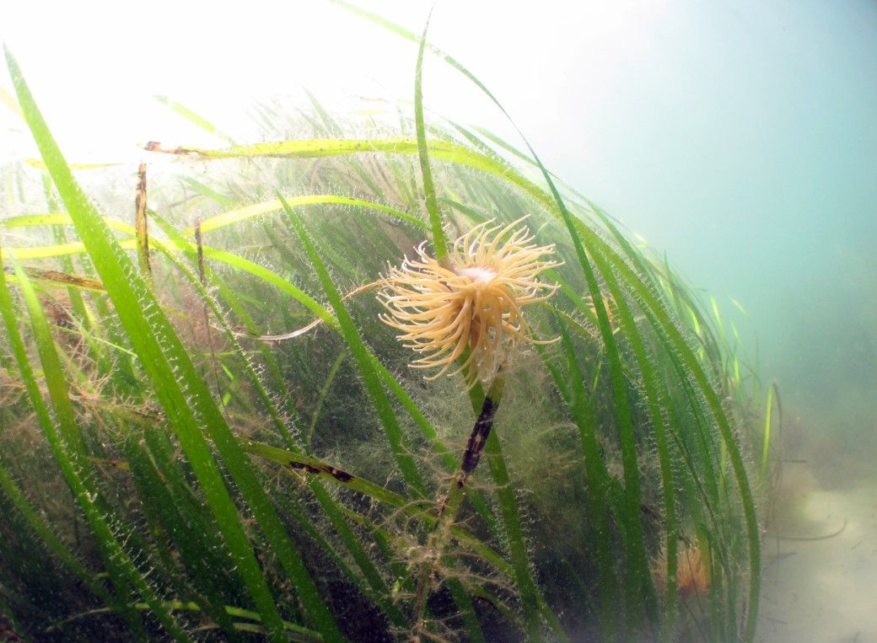

Seagrass provides rich nursery habitats, breeding and feeding grounds for a vast array of species, including shore crabs, juvenile flatfish, bass, brent geese and other wading birds.
(Photo Credit, Andrew Pearson)

What will you be doing?
Due to the dynamic nature of the project the tasks could be variable depending on the needs of the restoration team. Reporting directly to the Native Oyster Restoration Officer you will primarily be assisting with the following tasks.
Seagrass:
- Seagrass seed bag making
- Planting seagrass seed bags
- Collecting seagrass seeds and subsequent care

Oyster:
- Recording oyster biometrics
- Making oyster boxes
- Oyster husbandry

Saltmarsh:
- Saltmarsh nursery
- Saltmarsh monitoring
- Seed collection / Planting

There will be a suite of survey work and subsequent data management across the three habitat types. There is potential with adequate training to assist with specific survey works. Plus, there will be opportunity to assist with wider maintenance works requiring some manual labour at the discretion of the relevant project officer.

This role will require a reasonable level of fitness, needing to walk over soft ground in occasionally quite challenging weather conditions while carrying heavy equipment and regularly using a manual hand tool in a standing position.

Experience, knowledge and skills needed for this opportunity
An essential characteristic for this position is a passion for the natural world - you will be volunteering for a wildlife conservation charity so as such an interest in wildlife conservation, particularly in a marine context will be vital.
Essential:
- An infectious passion for nature and being outdoors
- Willingness to have fun outdoors in all weathers
- Capable of working on your own and with others
- Ability to be reliable and punctual
- Ability to follow instructions and on occasions work with minimum supervision
- Reasonably physically fit
- Good communication skills
- Good time keeping
- Awareness of yours and others safety

Desirable (Don’t worry if you don’t have these as we can provide training)
- Passion for and knowledge of the marine environment and British wildlife
- Working in an intertidal environment and adhering to the hazards this brings
- Good seabird and wader identification skills
- Awareness of safety outdoors
Does the volunteer need a driver’s licence?
Unless you live locally and can walk or cycle to this location we recommend that you will need to drive, as there is a very limited public transport service to Spurn Point NNR.

What’s in it for you?
- You will receive full training for any tasks carried out as part of your volunteering role
- Help with genuine on the ground conservation work that could feed information to a larger network of ecosystem restoration projects.
- Development and use of teamworking and leadership skills
- Development and use of communication skills
- Development and use of engagement skills
- Access to a free volunteer training programme
- 15% discount in Yorkshire Wildlife Trust shop and 15% discount at cafes when volunteering
- Be part of a fun and inspiring team
- A chance to learn more about the amazing Yorkshire coast and the wildlife that calls it home.

Where is the opportunity based?
Spurn Point NNR, Field Station.
Our Spurn point reserve is isolated and just South of Kilnsea. There is only one bus service that operates to Easington which is around 3 miles from Spurn point, this is from Withernsea and only operates between April and October.
Commitment
Commitment will be variable but will be flexible. There will be a number of opportunities on a monthly basis. We are happy to discuss this with you further when you apply.
Duration
This role will available until 2027.

