Voluntary Trainee Role Title
West Reserves Voluntary Trainee
Supervisor
Mary Painter, Nature Reserves Officer - West
Reserve/Project/Team/Area
Predominantly Stirley and Upper Park Wood Reserves in Huddersfield but with the opportunity to volunteer on Nature Reserves across all of West Yorkshire (Leeds/ Bradford/ Huddersfield/ Selby/ Wakefield/ Hebden Bridge). Office base is Stirley, Huddersfield, HD4 6FA.
Background
The West Reserves Team at Yorkshire Wildlife Trust look after a total of 25 nature reserves across the whole of West Yorkshire. These sites vary in size, have many different habitats including woodlands, grasslands and wetlands and face a whole range of challenges and opportunities. From the beautiful magnesian limestone meadows at Brockadale, to the fungi rich grasslands of Broadhead clough, to the urban oasis of Kirkstall Valley, as a West Reserves Voluntary Trainee you can expect to gain a valuable experience across a broad range of fascinating habitats and locations. You will be involved with a site that is developing into a nature reserve too, with wildflower meadow re-seeding, new hedges and tree planting.

In order to protect, create and manage these high-quality habitats for a whole range of species, we carry out a varied and important programme of both outdoor practical delivery and office-based work, which as a voluntary trainee you will get to experience firsthand.

Our volunteer trainee program is well established and as such, participants have become an invaluable addition to the Reserves team, further enhancing and protecting Yorkshire Wildlife Trust’s nature reserves whilst developing the skills and experience needed to take the first steps into a career in conservation.
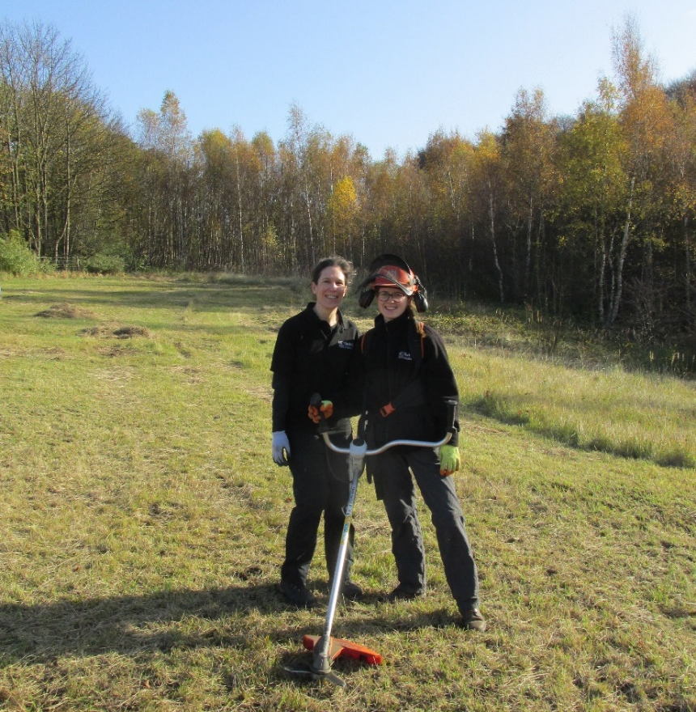

Past Trainees Lara and Anna cutting the meadow at Brockadale Nature Reserve
(Photo Credit, YWT)
What will you be doing?
The role will be split between practical habitat conservation work and office-based tasks and you will get a whole range of experiences including:
- Habitat management, for example: woodland thinning, scrub control, Himalayan balsam pulling, Invasive Non-Native Species (INNS) control, livestock management, fence and gate repairs, pond clearance and a variety of other jobs.
- Working with the local volunteer groups to manage sites including the opportunity to lead volunteer groups in practical activities.
- Organising and carrying out survey work.
- The chance to develop management plans and contribute to funding bid proposals and submissions.
- Promoting the work we do through media articles, social media posts and talking to the general public.
- Developing and delivering nature-based events.
- Due to the physical nature of these tasks, the role does require a reasonable level of physical fitness and willingness to work outdoors all year round.

There are plenty of training opportunities, skills, and experiences you can gain from the traineeship, our previous Voluntary Trainee Penny says:
“My traineeship with West Reserves team has provided me with a fantastic opportunity to begin the transition to a career in wildlife conservation. The staff team are brilliant – they have been welcoming and supportive and so willing to share their vast knowledge and experience about wildlife and plant life and how to create habitats in which they thrive.

One of the key aspects of the traineeship is helping to support (and eventually lead) task days on our many reserves across West Yorkshire. I have loved working alongside the regular volunteers who support these Task Days. Many of them have been volunteering for years (sometimes decades!) and they are a wonderful source of knowledge about the history of our sites and the wildlife that lives there.

I’ve learned so much in the time I’ve been here – including some of the challenges that we face when managing our reserves. The trust also provides a great training programme for trainees. It’s a fantastic opportunity that I’d recommend to anyone who is interested in learning about improving habitats for wildlife.”
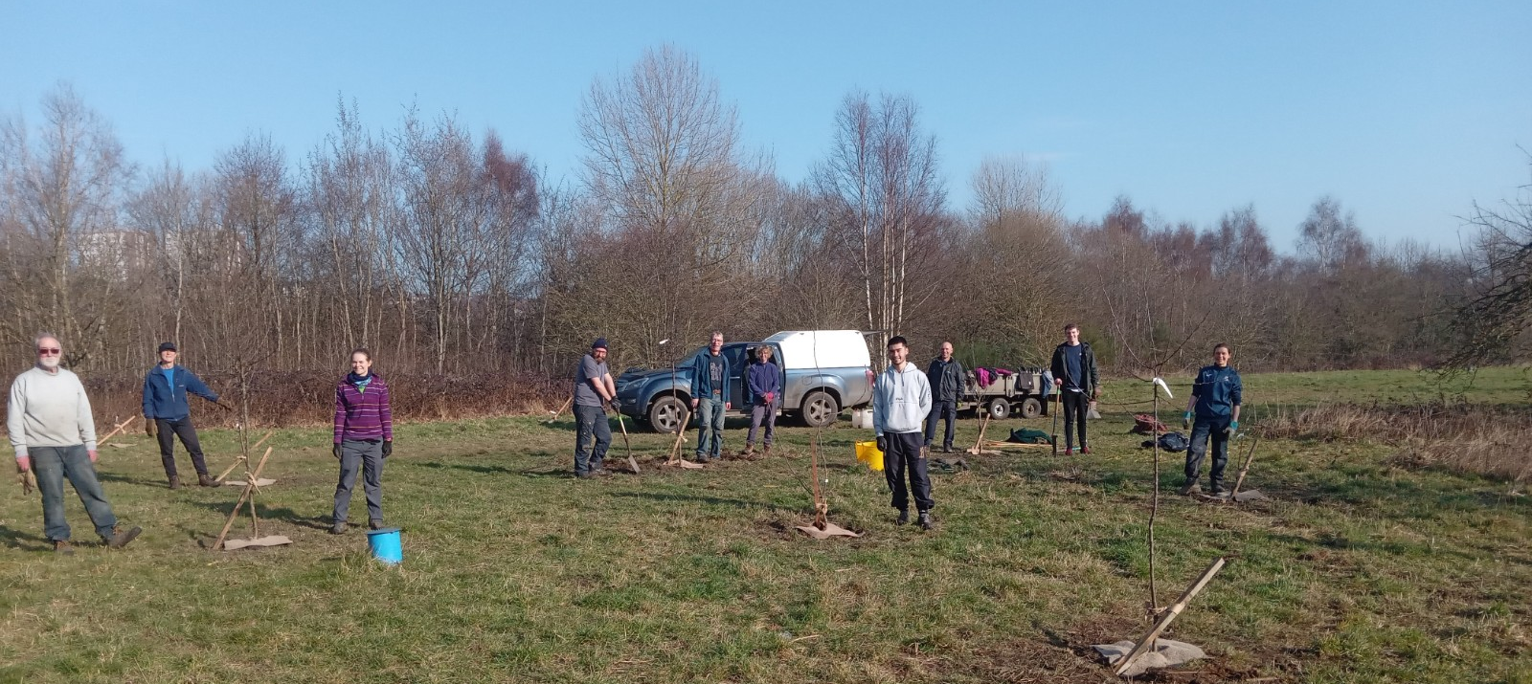

Volunteers planting orchard trees at Kirkstall Valley nature reserve
(Photo credit: YWT)

What’s in it for you?
You can expect:
- A full induction to the role
- Regular one-to-one with your trainee line manager and volunteering team staff
- Ongoing personal development, allowing you to develop nature conservation skills and valuable experience towards a career in this highly competitive sector
- A generous training budget which could include practical or theoretical qualifications – to include certificates in first aid and specific land management skills.
- Access to our varied internal trainee training programme
- Branded uniform
- Reasonable travel expenses – £16.20 per day of your traineeship, capped at £195 per month
- An intensive and high-quality experience that will stand out on any CV, as a team member of one of the UK’s most vibrant and varied conservation organisations.

This traineeship is the perfect opportunity to gain an in-depth experience of all the aspects of a practical conservation role and learn new skills and enhance your knowledge of the conservation sector. All this, in addition to having wider access and networking opportunities within Yorkshire Wildlife Trust gives you a fantastic introduction to the conservation world.

Experience, knowledge and skills needed for this role
You will need:
Essential
- Enthusiasm for wildlife and conservation
- Friendly and approachable nature
- Reliable, motivated and able to use your initiative
- Able to work in a team and get along with a range of people
- Computer literate in Word and Excel
- Willingness and ability to learn new practical skills and undertake physically demanding tasks.
- Ability to work outdoors, in all weather conditions for extended periods of time, sometimes in remote locations.
Desirable
- Experience of undertaking practical conservation tasks.
- Experience of working with volunteers

Does the Trainee need a driver’s license? Yes. Most of our nature reserves are located in remote locations, away from main public transport routes, therefore this role is more suited to a person who holds a full driving license and is willing to drive as part of the role. You will be able to access a company vehicle during normal working hours subject to other staff needs. YWT will cover reasonable fuel expenses for the trainee using their own vehicle to fulfil the requirements of the role.
Commitment
2-3 days a week (flexible – detail to be discussed with successful applicant) Generally for a 3 day a week traineeship the trainee will be in the office on 1 of the days and out in the field for 2 days.
Duration
12 months to start from May 2024
Does this role involve working with children or adults at risk?
Yes very occasionally – sometimes we run family events or have volunteer days with vulnerable adults, but the voluntary trainee will never be working alone with these groups.
Will the role involve any other sensitive tasks for which we may wish to check suitability via a criminal records check?
No
All Trainees will be asked for two references
If you are interested in this role, please complete an application form and return it to volunteering@ywt.org.uk by the closing deadline,9am 29TH April 2024. Interviews are planned to take place on Monday 13th May at Stirley, near Huddersfield.

