Volunteer Opportunity

Volunteer Opportunity Title
Volunteer Butterfly Surveyor
Reserve, Project, Team or Area
Yorkshire Wide Role (various locations), Data & Evidence Team
Volunteer Manager
Bethany Clarkson, Evidence Officer – With ongoing support from a Survey Coordinator.
Why do we need you?
Do you love walking in the countryside on a sunny day? Can you identify the most common butterfly species that we have here in Yorkshire? If so, the role of butterfly surveyor could be perfect for you.

We are currently looking to recruit Volunteer Butterfly Transect Surveyors across our Yorkshire Wildlife Trust Reserves, particularly:

- Ashberry (North-east Yorkshire) | - Brae Pasture (North-west Yorkshire)
- Fen Bog (North-east Yorkshire) | - Spurn Point (East Yorkshire)
- Askham Bog (North Yorkshire | - Sprotbrough Flash (South Yorkshire)
- Staveley (North Yorkshire)
- Wheldrake Ings (North Yorkshire)

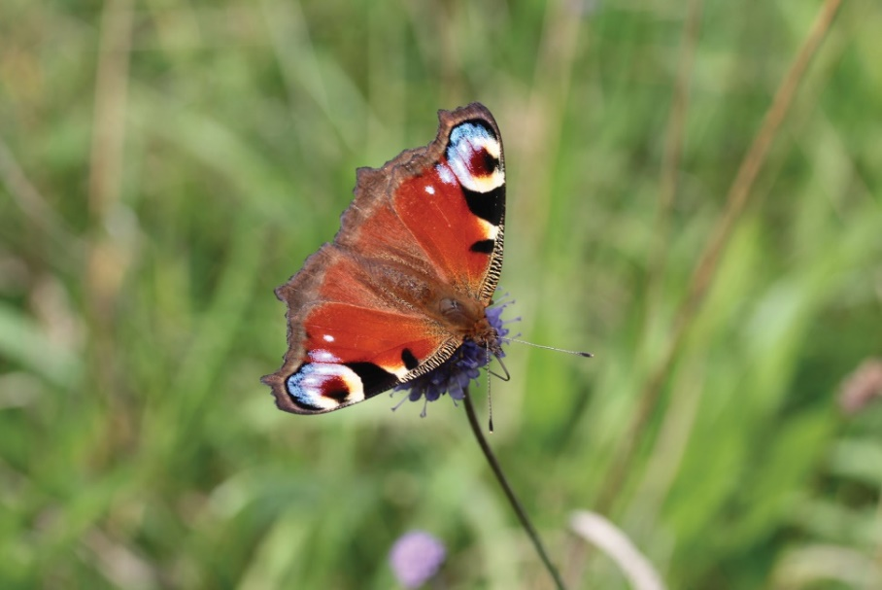
The Peacock butterfly Aglais io, just one striking species you might see across Yorkshire.
Photo credit: Jim Horsfall

With rapid life cycles and often high sensitivity to environmental conditions, butterflies are uniquely placed amongst terrestrial invertebrates to act as indicators to environmental changes. As a result, butterfly surveys are a key ecological monitoring program on Yorkshire Wildlife Trust reserves. Collecting data on the species present, as well as the abundance of these species over time, allows us to identify trends. These trends help to inform us on how best to manage reserves, for example:

- If data shows a species is in decline; we can investigate what may have caused this and consider what actions might be needed to halt or even reverse it e.g., habitat creation, or changes in management practices.

- If data shows a species is thriving; this may prompt research into why that might be and if there are lessons we can take and apply at other reserves.

Additionally, the data collected through the butterfly surveys is shared with Butterfly Conservation through entry into the UK BMS (United Kingdom Butterfly Monitoring Scheme) database and thus it contributes to a national monitoring initiative. The result of which is a knowledge base that, amongst other things, informs government policies addressing environmental issues.

So, whether a life-long butterfly enthusiast or someone who has only recently come to appreciate their beauty and importance, we would love to hear from you. Butterfly surveying is a great way to learn about and enjoy nature, get some exercise, and fill your lungs with fresh air.

What will you be doing?
You will be assisting with Butterfly Surveys on Yorkshire Wildlife Trust reserves, to maintain accurate records of butterflies on our reserves for future management, and to inform county wide and national trends. Alongside other volunteer surveyors, you can:

- Join us for an online Butterfly Identification Session on 14th April from 7-8:30 pm, to increase your knowledge and meet other potential volunteers!

- Undertake butterfly transect surveys, which are ideally done weekly from April to September.

- Help to create a rota at the start of each season, identifying any gaps when cover may be needed, which ensures that the survey will be completed regularly throughout the season.

- Enter the results from the survey into UK BMS, an online database where you can view trends for other sites across Yorkshire too.

- View online individual site reports for each transect, which helps to frame the potential findings of the results collected each year in light of the bigger regional and national picture.

- Attend the end of season online meeting (co-hosted by Yorkshire Wildlife Trust and Butterfly Conservation) where the results of surveys from across Yorkshire (Yorkshire Wildlife Trust reserves and beyond) are shared.

- Attend training on Butterfly ID and survey techniques.

- Maintain a risk diary of any hazards you identify when completing the survey, helping to ensure that Yorkshire Wildlife Trust can take appropriate action to ensure adequate access.
Experience, knowledge and skills needed for this opportunity
- Butterfly identification skills: You do not need to be an expert, as long as you know the most common species and are willing to learn then we would love to hear from you.

- Reasonable physical fitness: To be able to complete the survey you will need to be able to walk 2km comfortably, sometimes on slightly uneven terrain with stiles etc.

- Reliablity: For the data collected to be most useful, the surveys need to be completed each week of the season where weather conditions are suitable (dry and calm), particularly in the weeks of July when butterflies are most active.
Does the volunteer need a driver’s licence?

A driving licence would be ideal as some of our reserves are in remote locations, however this is not needed if you live locally to a reserve and can travel there on foot or by cycling.
What’s in it for you?
- Time outside in the sunshine. Butterfly surveys are only conducted over the spring and summer season and, even then, only on days that are over 13° and not raining.

- Exercise. You will be walking a fair bit with this role and where better to do this than at one of Yorkshire Wildlife Trust’s beautiful nature reserves.

- Meeting new people. Wherever possible we have small groups of volunteers working together to complete the surveys at a particular reserve. In addition, you will be able to meet the wider population of surveyors at the annual event.

- Contributing to conservation efforts at a local and national effort. The data you collect will not only support conservation efforts at that reserve, but nationally too.

- Access to exclusive events and trainings for Yorkshire Wildlife Trust Volunteers. We will run a training event early in the season jointly with Butterfly Conservation.

Where is the opportunity based?
Butterfly surveys are conducted across our reserves. You can see a list of some of our nature reserves here: YWT Nature Reserves

Note: We are particularly looking for volunteers to help survey the reserves listed above, but if you would be interested in volunteering at one of our other reserves, we can look to accommodate this.

Commitment
- The time commitment needed from you would be dependent on the number of volunteer surveyors there are for a particular site.

- At most, if you are the only surveyor for a site, it would be roughly 1.5 hours per week plus travel time for the duration of the season (April to September). The season is a total of 26 weeks, and it is ideal for 15 or more weekly visits to be conducted during this time.

- If you have restrictions as to how many weeks per season you can commit to, this wouldn’t be a problem, please just let us know so we can take this into account when deciding how many volunteers to recruit for a particular site.
Duration
April to September on an annual basis.
If you are interested in applying for this volunteer role, please send in a completed
volunteer application form to volunteering@ywt.org.uk

