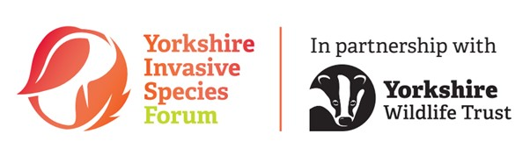 Volunteer Role Description

Volunteer Role Title | Role Number
INNS and Projects Volunteer
Reserve, Project, Team or Area
INNS Team, West Yorkshire. Work generally takes place on the Calder (Ripponden) and Colne catchments
Volunteer Manager/Supervisor
Elliot Baxendale (alongside the INNS Team)
Why do we need this volunteer?
Our Invasive Non-Native Species (INNS) and river restoration project teams are looking for passionate individuals to volunteer within the West Region INNS Team. INNS are the second biggest threat to biodiversity within the UK, cost around £2 billion annually to manage, and cause numerous issues across Yorkshire such as infrastructure damage and increased bankside erosion. As part of the team, you will have the opportunity to assist staff with INNS surveying, treatment, and post-treatment restoration.

You will have the opportunity to learn how to identify a number of key native and INNS species, biosecurity, and surveying techniques including the use of our GB-wide app INNS Mapper. Furthermore, there is the opportunity to assist staff members within the wider West Region Projects team and attend skills training days run by the volunteer team.

This role will take place across the Calder and Colne catchments around Huddersfield and Ripponden, primarily on private land and land of partner organisations. Working in a ‘top-down’ manner, volunteers will help us to identify and control INNS across the catchments.
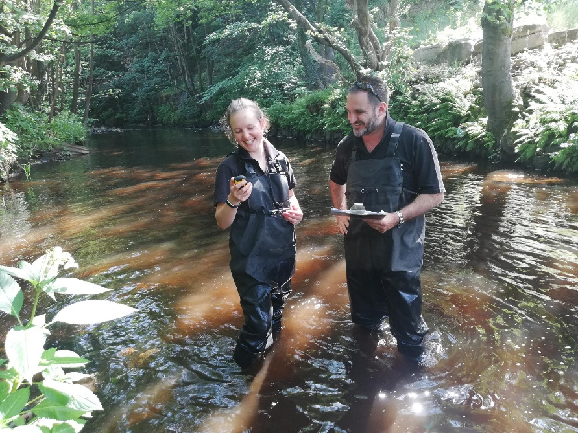
INNS surveying © YWT
What will the volunteer be doing?
Volunteers will first be invited to a training session which will cover:
- Biosecurity
- What INNS are and why they are important
- INNS ID (how to identify our most common invasive species)
- Recording methodology
- Yorkshire Wildlife Trust H+S processes including risk assessments and lone volunteering

Surveying
Volunteers will either accompany staff in river courses or pair up to survey along the canals, logging the presence or absence of any INNS they may find. Both sides of the watercourse are surveyed and any areas which were unable to be reached safely should be noted. Data from the surveys will be collected by staff and then uploaded to the webtool INNS mapper.

Treatment activity
Volunteers will have the opportunity to tackle INNS head on by assisting with their treatment across the Calder and Colne catchments, helping continue the work that has been taking place over the last 7 years. This may include pulling/bashing Himalayan balsam, and digging plants like American Skunk Cabbage.

Restoration
The Yorkshire Invasive Species Forum (hosted by the Yorkshire Wildlife Trust) is currently involved in a pioneering project to explore restoration techniques on riverbanks after INNS treatment. Volunteers would have the opportunity to get involved with this crucial work by helping survey the sites where restoration work has begun, and helping with the other restoration delivery including seed scattering and plug planting, willow spiling, bank revetment, and coppicing.

River Monitoring
We are looking to carry out water quality and riverfly monitoring in the Calder and Colne, as well as assist with river restoration in other catchments. Training will be provided on the day.
Experience, knowledge and skills needed for this role
Volunteers will:
- Be able to walk long distances (2-5 miles) on uneven ground safely and operate hand tools (following training). Some of the surveying takes place on canal tow paths which are more accessible.
- Be ok to walk in-channel in flowing water (waders and walking poles provided by YWT).
- Have access to a smartphone (or at least mobile and printer at home) to be able to access maps and contact the volunteer manager during surveying.
- Be able to identify key INNS (following training provided by YWT).
- Understand basic biosecurity procedures (following training).
- Interested in tackling INNS in Yorkshire.
- Have a good eye for detail and the ability to record data accurately.
- Lone working may be possible in some situations, which can be discussed with volunteers.
Does the volunteer need a driver’s licence? Not essential – if staff are heading to the site, then there is often an option to head over with them. Ideally volunteers should be able to make their way to our West Region Office at Stirley, Huddersfield, or be able to get to the meeting points before a survey. There is no need for volunteers to drive staff vehicles.
What’s in it for the volunteer?
In this role volunteers will:
- Help stop the spread of invasive non-native species and help protect local habitats for future generations.
- Gain identification experience of plant species.
- Gain experience of surveying in and around watercourses.
- Have the opportunity to meet and engage with landowners and the wider public.
- Have the chance for quiet walks in the Yorkshire countryside that may otherwise be inaccessible.
- Contribute to wider scientific study of INNS across the UK.
- Have access to specific INNS and biosecurity training as well as the wider Yorkshire Wildlife Trust Volunteer Training Programme which includes Task Day Leader and Event Day Leader training.
- Potential opportunity to survey with other INNS Survey Volunteers and YWT Staff.
- Access our internal (and free) Volunteer Training Programme with sessions ranging from hedge laying to environmental law to bush craft skills.
- Get 15% off in YWT shops and 15% off in the café, on any days they volunteer at a reserve with a café.
Where is the role based?
Primarily in the Colne Catchment and the Calder (near Ripponden), but other areas as required. Our office base is Stirley, Hall Bower Ln, HD4 6FA - just outside Huddersfield.

Commitment
1 or 2 surveys a month between June-November – Any day Monday to Friday
Attendance at a number of INNS treatment and river restoration task days across the year.

Duration
February 2024 – April 2025. The schedule will vary across the calendar year, however most of the work will take place during the INNS season (March-November). Below is a rough calendar displaying the approximate mix of tasks volunteers can get involved in. The West Projects Team also have opportunities for freshwater surveys including riverfly monitoring and water quality monitoring which will be occurring within these dates. It is worth noting however that this calendar is subject to change with the weather/with site access restrictions. Specific dates will be determined closer to the time – historic works have generally taken place on a Monday, but this is flexible to when people are most free.

April – 2024
• Week Commencing 1st – INNS ID and Surveying Training
• Week Commencing 8th – Post-INNS Treatment Restoration
• Week Commencing 15th – Post-INNS Treatment Restoration
• Week Commencing 22nd – Riverfly Monitoring
• Week Commencing 29th – Post-INNS Treatment Restoration

May
• Week Commencing 6th – Himalayan Balsam Rust Fungus Survey Sites
• Week Commencing 13th – High Royd Restoration Vegetation Survey
• Week Commencing 20th – INNS WEEK – Balsam Bash
• Week Commencing 27th – Riverfly Monitoring

June
• Week Commencing 3rd – Balsam Bash and Restoration
• Week Commencing 10th – Balsam Bash and Restoration
• Week Commencing 17th – Survey Methodology Training (using INNS Mapper)
• Week Commencing 24th – Riverfly Monitoring

July
• Week Commencing 1st – INNS Treatment/INNS Mapper Surveys on Canals
• Week Commencing 8th – INNS Treatment/INNS Mapper Surveys on Canals
• Week Commencing 15th – INNS Treatment/INNS Mapper Surveys on Canals
• Week Commencing 22nd – Riverfly Monitoring
• Week Commencing 29th – INNS Treatment/INNS Mapper Surveys on Canals
August
• Week Commencing 5th – INNS Treatment/INNS Mapper Surveys on Canals
• Week Commencing 12th – INNS Treatment/INNS Mapper Surveys on Canals
• Week Commencing 17th – High Royd Restoration Plant Survey
• Week Commencing 24th – Riverfly Monitoring

September
• Week Commencing 3rd – INNS Surveys on Tributaries and Landowner Engagement
• Week Commencing 10th – INNS Surveys on Tributaries and Landowner Engagement
• Week Commencing 17th – INNS Surveys on Tributaries and Landowner Engagement
• Week Commencing 24th – Riverfly Monitoring
• Week Commencing 30th – INNS Surveys on Tributaries and Landowner Engagement

October –
• Week Commencing 7th – Post-INNS Treatment Restoration
• Week Commencing 14th – Post-INNS Treatment Restoration
• Week Commencing 21st – Riverfly Monitoring
• Week Commencing 28th – Post-INNS Treatment Restoration

November
• Week Commencing 18th – High Royd Vegetation Survey
• Week Commencing 25th – Riverfly Monitoring
If you are interested in applying for this volunteer role, please send in a completed volunteer application form to volunteering@ywt.org.uk

