 Volunteer Role Description

Volunteer Role Title | Role Number
Grass Wood Warden Volunteer
Reserve, Project, Team or Area
Northwest Reserves – Saturdays, Sundays and Bank Holiday Mondays

Volunteer Manager/Supervisors
Becky Dennison, Nature Reserves Assistant – Northwest
Graham Standring, Living Landscape Officer – Northwest

Why do we need you?
Do you already walk in Grass Wood and want to use your time to help support the Yorkshire Wildlife Trust in welcoming people to explore and enjoy the reserve responsibly? Do you live in or near Grassington and are interested in exploring this local site further while supporting YWT? Then this could be just the role for you!

Grass Wood has many features that draw visitors from all over Yorkshire and beyond, for lots of different reasons, including wildlife, walking and heritage. Grass Wood has had different uses by humans for over a thousand years and you can see the rich history right before your eyes. Not to mention the abundance of wildlife, rare and beautiful plants, breeding woodland birds and incredible butterfly species. The reserve is also connected to many walking routes and is ideally located, being just under 1.5miles from Grassington. During the spring and summer, the site experiences an increase in visitors, this is also the most sensitive time for many of the species found here. Therefore, we would like volunteers to walk the footpaths at weekends enjoying the reserve themselves and informing and interacting with visitors to the site.

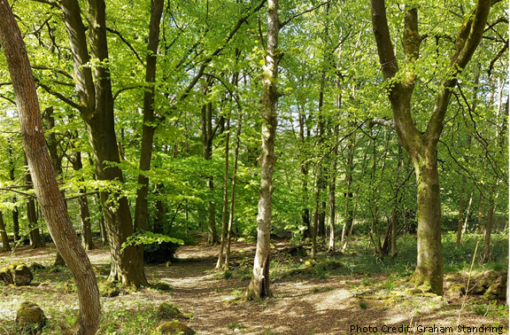

As a Grass Wood Warden, you will provide visitor assistance and site care over the weekends. You will interact with visitors on site, offering information and help if needed, thanking dog owners for walking their pets responsibly or asking them to do so if they are not already. You will also be responsible for keeping the site tidy and free of rubbish, recording the number of visitors, any issues on the reserve and any natural history/species records of interest. We will provide you with the support you need in how to do this.

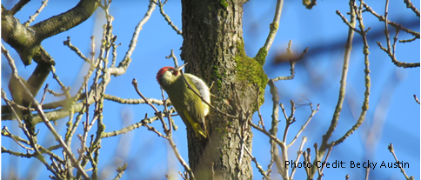

What will you be doing?
- Talk to visitors at Grass Wood, make people feel welcomed and provide information during their visit.
- Litter pick
- Carry out site checks, check signs, gates and stiles, any signs of fires or camping and report any issues.
- Interact with visitors, bringing Grass Wood to life by helping to answer any questions or point out hidden gems which visitors may not have spotted.
- Thank visitors for walking dogs responsibly and encourage them to do so if not already.
What’s in it for you?
- Having the opportunity to walk around a beautiful nature reserve at a lovely time of year.
- Helping other people to enjoy the reserve responsibly.
- Working with people who share a common interest in a beautiful environment.
- The knowledge that you are helping to manage YWT Grass Wood Nature Reserve to secure its future for all to enjoy.
- You will be provided with training for your role and access to our internal YWT training courses for volunteers.
- You will be provided with a YWT vest or badge depending on your preference and availability so you can be identified as TWT volunteer by visitors.
Where is the role based?
Grass Wood Nature Reserve
Commitment
Flexible- to be agreed. The role is part of a rota with staff and other volunteers and you will be able to pick days/times that suit you through April-September. The maximum would be 5 days across the season. Within daylight hours -Saturday, Sunday and Bank Holiday.
Duration
Weekends and bank holidays through April – September each year
If you’d like to apply for this volunteer role, please send in a completed volunteer application form to Volunteering@ywt.org.uk

