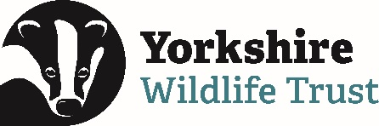
Volunteer Application Form
Please complete the details below and return this form to volunteering@ywt.org.uk or post to
Volunteering Support Team, Yorkshire Wildlife Trust, 1 St Georges Place, York, YO24 1GN
Title of the opportunity you’re applying for

Your details:
Title:
First name:
Last name:
Phone:
Email:

Address:
Town/City:
Postcode:
Date of Birth:

If you are under 16, please provide your parent or guardians email address. If you are 16 or 17 we will ask that you provide a parental/ guardian consent form. Volunteers under the age of 16 will require a parent or guardian to accompany them.
About you:
Tell us why you are interested in volunteering. You can choose to ‘X’ as many of the options below as you feel are relevant. This will help us to understand what you’re looking for and the types of opportunities you’d like;

Belief in the work of the Wildlife Trust
Develop my knowledge/interests
Fun
Fill some time
Exercise
Get some work experience or help with my CV
Help others
Make a difference to the local community

Make a difference to the natural environment
Preserve our heritage for future generations
Share my passion for a particular place
Spend more time in nature
Spend time with like-minded people
Use my skills
Other

Tell us when you are generally available and would like to volunteer (mark with an ‘X’):
 | MONDAY | TUESDAY | WEDNESDAY | THURSDAY | FRIDAY | SATURDAY | SUNDAY
Mornings
Afternoons
Evenings

Volunteer Application Form
Tell us about your skills, experience and any relevant qualifications
(eg. Project management, pesticide use, creative skills, chainsaw certificate):

Why do you think you would be suitable for this role and why would you enjoy it?

We want volunteering to be fully inclusive and consider your wellbeing if you start to volunteer with us. Please let us know if you have any access requirements, health conditions or medication you take that we should be aware of.

Volunteer Application Form
In an emergency, who should we contact?
Name:
Home phone:
Work phone:
Mobile:
Having an emergency contact that we can contact should an incident occur is important to us for your wellbeing. We will only keep this information should you begin to volunteer with us, otherwise it will be destroyed.
Keeping in touch:
Data Protection: We may from time to time contact you to inform you about other ways in which you can help with our work which we feel may be of interest to you as a supporter of Yorkshire Wildlife Trust. This may include information about our campaigns, fundraising activities, volunteering and events. For further information please see our privacy policy at www.ywt.org.uk/privacy-policy. This sets out how and why we collect information, how we use and protect your personal data and what your rights are.
If you are happy for us to keep in touch about our work please let us know how we may contact you. You can contact us at any time to update your contact preferences. Please be aware that opting out from receiving email communications will mean that we will not be able to send you newsletters including the volunteers’ e-newsletter, information about volunteering or other activities about wildlife.

Post
Yes No
Phone
Yes No
Email
Yes No
Text
Yes No

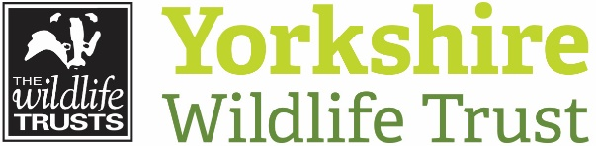

Communicating with Young volunteers
As we sometimes send out marketing related content in our mailings, we cannot add under 18’s to our mailing lists. This is to ensure we are following best practice when working with young people. If you are under 18 and would like to receive all our mailings, please provide your parent/guardians email address.
If you are aged under 16 any communication about your volunteering role will be through your parent/guardian’s email.

Volunteer Application Form

Extra information:
Are you legally entitled to volunteer in the UK?

Yes No
If you’re from the UK you are free to volunteer. Most EU citizens are also free to volunteer within the UK. If you’re from outside the EU we advise you to contact the UK Borders and Immigration Agency to find out if your visa allows you to volunteer.
Do you have any convictions which are unspent under the Rehabilitation of Offenders Act 1974?

Yes No
Holding an unspent conviction does not automatically exclude you from volunteering with Yorkshire Wildlife Trust. We encourage you to discuss this with us during your application.

Declaration
I have completed this form fully and accurately.
If selected to volunteer with Yorkshire Wildlife Trust (YWT) I will support the aims and values of the organisation. I will abide by the Volunteer Code of Conduct provided in the recruitment pack, and all relevant policy and procedure. In my capacity as a volunteer, I will act as an ambassador in my community and safeguard the reputation of YWT.
I understand that, if selected to volunteer, my details will be held on the YWT database in accordance with the YWT Privacy Policy and that this information will be used for purposes related to my volunteering only, unless I give my further consent.
I understand that this is a voluntary agreement, not a legally binding contract nor an offer of employment, and that it may be cancelled at any time by either party.

Signature
/ /
Date

Thank you for your application
Please return this form to volunteering@ywt.org.uk
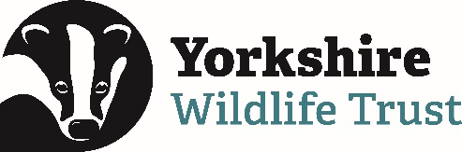
EQUAL OPPORTUNITIES MONITORING FORM
CONFIDENTIAL

Yorkshire Wildlife Trust is committed to a policy which seeks to provide equality of opportunity, openness and accessibility for all parts of the community including gender identity, race, ethnic origin, colour, religion, marital status, age, sexual orientation or disability. This section of the application form will enable YWT to monitor the effects of this policy. Completion is voluntary and will not affect your volunteering.

We would be grateful if you could complete this form in addition to your application. This will have no bearing on your selection for the post as this form will be separated from your application before it is considered.

The Trust treats personal data collected during the recruitment process in accordance with its data protection policy. Information about how your data is used and the basis for processing your data is provided in the Trust’s privacy policy which can be found on our website.

------------------------------------------------------------------------------------------------------------------------------------------------------

Please state where you heard about this opportunity?

…………………………………………………………………………………….

Your ethnic origin (please tick):

Asian |  | White
Asian/Asian British |  | British
Bangladeshi |  | English
Chinese |  | Gypsy or Irish Traveller
Indian |  | Irish
Pakistani |  | Scottish
 |  | Welsh
 |  | White other
Black |  | Mixed
Black/Black British |  | White and Asian
African |  | White and Black Caribbean
Caribbean |  | White and Chinese

Other ethnic group

Arab

*Other (specify below if you wish)

Prefer not to say

*Other:

………………………………………………………………………………………………….

Gender Identity:

Man (including Trans man)

Woman (including Trans woman)

Prefer not to say

Age:

16-24 |  | 50-54
25-29 |  | 55-59
30-34 |  | 60-64
35-39 |  | 65+

40-44

45-49

Prefer not to say

Sexual Identity:

Bisexual

Gay man

Gay woman/lesbian

Heterosexual/straight

Other

Prefer not to say

Your Religion or Belief:

No religion |  | Jewish
Buddhist |  | Muslim
Christian |  | Sikh
Hindu |  | Other

Prefer not to say

Disability:

The Equality Act 2010 defines a disabled person as someone who has a physical or mental impairment which has a substantial and long-term adverse affect on their ability to carry out their day-to-day activities

Do you consider yourself to have a disability?

Yes

No

Prefer not to say
If Yes please specify:

………………………………………………………………………………………………….

