PART A: What are you risk assessing?
Assessor: Andy Dalton | Job title / role: Operations Manager (acting) | Line manager check (if applicable): Mike Winstanley
Date of assessment: 16/03/22 | Date for revision: 15/03/23 | Other related assessments – give filename/s (eg. site or task): Numerous task risk assessments including, TRA 1530, TRA 1436, TRA 1517
Site/s or Location: Stirley | Map of site – give filename/location: See below | Facilities/welfare on site (eg. toilets): Toilets, hot water, first aid kits.
This risk assessment has been written specifically for general use of the site (e.g. staff, farm team etc.) and should be accompanied by SRA 1469 which is the covid overarching RA for the site. For Education and Events see SRA 1114 |  | Local Authority area: Kirklees
 |  | RA Reference Number: SRA1904 (See Site Risk Assessment Tab of Risk Assessments Log)
For Invasive Species risk assessment section see page 3.
PART B: In an emergency
Use this section to plan what you would do in the case of an accident or emergency incident on this site
Communications in the event of an emergency | Location of nearest landline/s: Office  Location of strongest mobile signal (eg. entrance, top of hill): Everywhere  Which network?: All  What are the alternative means of communication if necessary ?: N/A  Details of emergency contacts (other than 101/111/999) eg. utility companies, railways: Electricity: Northern Power Grid tel: 105  Gas: 0800 111 999  Highways agency: 0300 123 5000  Kirklees Council road emergencies: 01484 414700  Environment Agency Flooding hotline: 0800 80 70 60  Kirklees Council Flooding hotline: 01484 414700  Site Security (Duty Manager): 07801 190346
Emergency Access locations/terrain etc.  http://gridreferencefinder.com | Nearest postcode: HD4 6FA  Road access points (OS Grid refs and detailed description for each access point: Hall Bower Lane: SE 14634 13936  4 x 4 vehicle access points (OS Grid refs and detailed description for each access point): Hey Lane: SE 14791 13617, Lady House Lane: SE 14351 13987  Helicopter landing site/s (OS grid ref/s and detailed description of location & terrain): SE 14552 13750, flat/well managed field <200m from the main farmhouse buildings  See map below for access points (page 10)
Nearest A&E details | Hospital: Huddersfield Royal Infirmary  Address (inc Postcode): Acre Street, Huddersfield, West Yorkshire, HD3 3EA  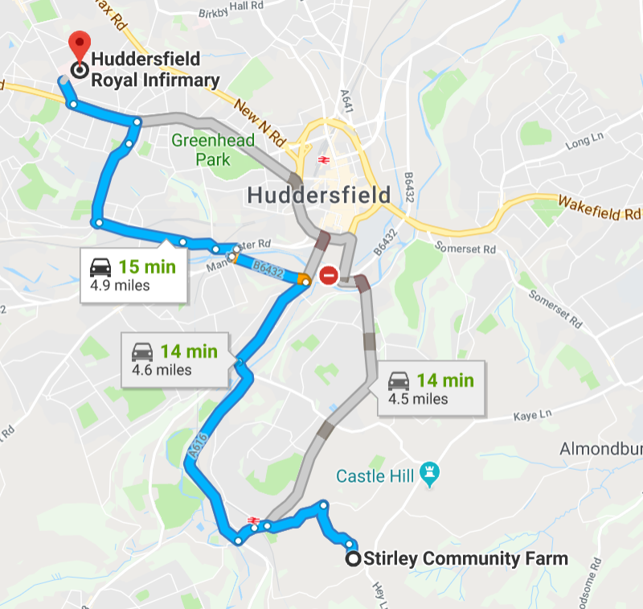 | Directions  - Take Cold Hill Ln and Lady House Ln to Woodhead Rd/A616  - Continue on A616 to Huddersfield  - Take Church St and Luck Ln to Westbourne Rd/A640  - Turn left onto Westbourne Rd/A640  Continue to follow A640  - At the roundabout, take the 3rd exit onto Acre St

First aid | Name of first aider/s or location of notices (for permenantly manned sites): First-aid trained staff are listed to the left of the entrance of the main office where all staff and vistors sign in when on site.  Fixed first aid kit location/s, notices to this effect and kit type/contents required: Office / Cre8 Barn
Accident reporting | Location of accident book/s & Incident Report Forms: Office /Cre8 Barn

PART C: Assessing the Risks
Assess each risk below:-
Hazards/hazardous events | Who is affected and how many people?  (staff, contractor, volunteer, public, vulnerable group/s) | Typical outcome  eg. minor injury, serious injury, death | How will the risk be controlled?  Completed by whom, when and how often?  How will the control measure be communicated?  (see Code of Practice 8 for advice on PPE) | Remaining Risk Level  Likelihood / Severity matrix  eg. likely x harmful = moderate
Livestock in fields - cattle charging or trampling.  NB REDUCED LEVELS OF STOCKING CURRENTLY ON SITE – SO LESS OF An immedieate risk. | All site users – staff, volunteers, contractors, members of the general public | serious injury – death | - All staff to be briefed on how to behave around cattle during induction. All visitors to be briefed on arrival if they are to be in close proximity with them.  - Adequate signage to be put up in any fields that have cattle in, at the entrances/exits for all public access to fields.  - Avoid loud or aggressive behaviour and dog walkers keep dogs under close control.  - All stock checkers to be trained and confident working with cattle (see Stock Checking task risk assessent and method statement)  - Cattle handling to only be undertaken as per task risk assessments and method statements)  - Only trained and confident personnel to be in fields with cattle.  - Find alternative routes if cattle are proving an obstacle to a particular path. | Unlikely x very harmful = Moderate  NB REDUCED LEVELS OF STOCKING CURRENTLY ON SITE – SO LESS OF An immedieate risk.
Fire – burns, smoke inhallation, death (Also see Fire Risk Assessments for Farmhouse & farm buildings, and Cre8 Barn). | All site users – staff, volunteers, contractors, members of the general public | Burns, smoke inhallation, death | - All staff and volunteers briefed on fire evacuation procedure during site inductions.  - All visitors given H&S talk at start of activites, including fire safety and evacuation briefs.  - Fire safety equipment (including extinguishers/alarms/sensors) checked and maintained on a regular basis as per specific fire risk assessments and maintenance logs. | Very harmful x unlikely = moderate
Uneven/wet surfaces.- Slips, trips and falls. | All site users – staff, volunteers, contractors, members of the general public | Minior injury or strains, sprains or breaks | - Remove obstacles from walkways.  - Report or appropriately indicate (using wet floor signs) any wet surfaces.  - Pre activity talk to visitors about taking care when walking around the site if appropriate (e.g. visits will include walking across rough terrain) | Harmful x likely = moderate
Moving farm machinery i.e. tractors, vehicles, trailers.  NB Change in use from farming to land management – far less movements taking place | All site users – staff, volunteers, contractors, members of the general public | Minor injury – death. | - Main farmyard area (where movement machinery happens most) fenced off from rest of site. Fencing to be maintained and gates kept closed.  - All staff and volunteers to be briefed on dangers of moving farm machinery during site inductions.  - Pre activity talk about behaviour when walking around site for all visitors as appropriate.  - All visitors should remain behind fencing and away from main farm operating area, unless accompanied by staff.  - Extra precautions to be taken when visitors on site (e.g. school groups).  - Staff/volunteers use safe-stop; any personel operating machinery to stop, put handbrake on, turn off engine and take keys out of ignition upon any visitors entering either the farmyard or the farm track.  - All staff and volunteers to not walk into farmyard unless completely necessary to do so, and to remain vigilant if required to go into area.  - Staff operating machinery all to have appropriate training (certifications/licenses/adequate training as required by the task – see appropriate TRA), and to ensure area is free of any personel before starting work.  - Staff operating machinery to do so at low speeds (<10mph) when on private roads and farm yard, (<5mph) when moving in or out of farm barns. | Very harmful x unlikely = moderate  NB Change in use from farming to land management – far less movements taking place
E coli infection from cow manure, soil, compost and fresh fruit and vegetables, contamination from clothing and footwear.  - Weils disease.  - Lymes disease.  - General zoonosis. | All site users – staff, volunteers, contractors, members of the general public | Minor injury (illness) – death. | - Gloves to be worn when carrying out gardening / planting activities.  - Pre activity health and safety talk about keeping hands away from mouths.  - Wash hands thoroughly before eating.  - No eating in areas used by farm animals / housing farm machinery.  - No food to be consumed directly from garden. Food to be washed in designated food washing sinks.  - All site users to wash hands in warm water with antibacterial soap provided after every activity outdoors and in particular before eating using designated sinks on the outside of the Bre8 barn.  - Footwear to be cleaned in boot washing area outdoors (virkron (or similar) disinfectant dips) , or removed and left in Barn reception.  - No persons wearing outdoor clothing from field or cow barn to enter Cre8 barn kitchen area, and staff main office. | Harmful x unlikely = slight
Pedestrians and public using footpaths around farm land. Visitor / contractor vehicles moving through farmyard. | All site users – staff, volunteers, contractors, members of the general public | Minor injury - death | - Speed limit to be kept to a reasonable speed (<10mph), especially when driving along pedstrian accessed areas. Drive to the roads conditions.  - Walking routes to avoid lines of possible farm traffic/main farmyard area fenced off.  - Any children/vulnerable adults to be accompanied by supervisory adults (teaching staff, parents, trained YWT staff and volunteers) at all times when on site.  - Road maintained where possible on a regular basis. | Harmful x likely = Moderate
Well and deep water – drowning, injuries sustained through falling | All site users – staff, volunteers, contractors, members of the general public | Serious harm | - Lid to well is sturdy, secure and well maintained.  - Site checks carried out quarterly by staff to identify any H&S concerns and ensure appropriate precautions taken including signage. All users of the site told to report any issues/potential H&S problems/missing or damaged signage at any time. YWT personnel prohibited from entering/maintaining well due to confined space. Contractors to be engaged but will require a Permit to Work. | Very harmful x unlikely = Moderate
Fragile roofs and guttering – fall injuries | All site users – staff, volunteers, contractors, members of the general public | Serious harm | - Prominent Fragile roof signs placed to warn workers of fragile roofing (cattle barn and machinery barn)  - Use of appropriately trained and approved contractors only, to carry out work on fragile roofs and gutters. No YWT staff or volunteers allowed to carry out work on fragile roofs or gutters. Permit to Work to be issued to contractor for any access to/work on fragile roofs or gutters.  - Site checks carried out quarterly by staff to identify any H&S concerns and ensure appropriate precautions taken including signage. All users of the site told to report any issues/potential H&S problems/missing or damaged signage at any time. | Very harmful x unlikely = Slight
Moving parts (ie gates) trapping fingers. | All site users – staff, volunteers, contractors, members of the general public | Minor injury. | - All gate fittings to be well maintained. | Slight harm x unlikely = trivial.
General rubbish / detritus on site | All site users – staff, volunteers, contractors, members of the general public | Minor injury – illness. | - Regular litter picks carried out by staff and volunteer groups.  - Gloves to be worn for any activity which could result in contamination / injury from detritus.  - Any asbestos discovered by site users must be reported to farm staff – all work occuring in close proximity to be stopped immediately. | Slight harm x likely = Slight.
Barbed wire in fencing - cuts. | All site users – staff, volunteers, contractors, members of the general public | Minor injury | - All fencing to be well maintained. | Slight harm x likely = Slight.
Slurry tank - toxic gases, flammable gases, drowning. | All site users – staff, volunteers, contractors, members of the general public | Serious harm | - Lid to slurry tank secured with substantial metal plate and padlocks. Key stored in office. YWT personnel are prohibited from accessing the slurry tank. Permit to Work required if contractors have to access the tank.  - Permenant fencing erected around slurry pit. Fencing around slurry pit well maintained to prevent access from general public.  - Warning signage displayed – ST/KM to check quartely if still intact  - Site checks carried out quarterly by staff to identify any H&S concerns and ensure appropriate precautions taken including signage. All users of the site told to report any issues/potential H&S problems/missing or damaged signage at any time.  - Annual inspection and maintenance to be carried out by professional contractors only – who use appropriate air-fed respiratory protective equipment (RPE). Permit to Work required to access tank. | Unlikely x very harmful = Moderate
Hazardous Substances stored on site | All site users – staff, volunteers, contractors, members of the general public | Minor-Major illness or harm | - Material Safety Data Sheets are stored in the COSHH folders located in the Farm office or on the Y Drive under Sites. These sheets provide information on chemical products that describe the hazards the chemicals present, and give information on handling, storage and emergency measures in case of accident.  - Any users/handlers of any chemicals should familiarise themselves with the data sheets before handling it. Hazardous substances are kept in a locked secure container in correspondance with their specific safety data sheet requirements.  - Keys are stored in a locked building which can only be accessed by authorised personel, staff and volunteers, who have all recived a H&S/site induction. All visitors are accompanied by staff when on site, which limits possible access by unecessary users.  - Anybody accessing these containers should be aware of what is in them and can find this in the appropriate chemical store logs (this includes the diesel store), these can be found on the Y Drive under sites or projects.  - All chemicals stored in these containers should be labled appropriatley. Safety Data Sheets will make you aware of any necessary PPE you may need to wear.  - The public should not have access to the machinary barn where the stores are kept. The stores should be locked immediately after use. | Unlikey x very harmful = Moderate
Red diesel store | All site users – staff, volunteers, contractors, members of the general public | Minor-Major illness/injury or fire | - Red diesel only to be purchased from from a company who is HMRC registered  - The diesel store located in the machinary barn should be locked at all times. Keys for both the store and machinary barn are stored in a locked building which can only be accessed by authorised personel, staff and volunteers, who have all recieved a H&S/site induction.  - All visitors are accompanied by staff when on site, which limits possible access by unecessary users.  - Material Saftey Data Sheet for the diesels stored can be found in the COSHH folder located in the main office. The Material Saftey Data Sheet will provide information on chemical products that describe the hazards the chemicals present, and give information on handling, storage and emergency measures in case of accident.  - Any users/handlers of diesel should familiarise themselves with the data sheets before handling it. Diesel is a flammable source and no naked flames in the machinery barn.  - The container is stored out of sunlight in a well ventilated area. | Unlikely x very harmful = moderate
Cleaning products | All site users – staff, volunteers, contractors, members of the general public | Access to cleaning products by younger generations could result in their accidental drinking which could cause serious health risks and even death. | - Cleaning products are located in the main office, cre8 barn and main toilet, which can only be accessed by authorised personel, staff and volunteers, who have all recieved a H&S/site induction.  - All visitors are accompanied by staff when on site, which limits possible access by unecessary users. | Unlikely x very harmful = moderate
Add more lines if needed

Invasive Species Risk Assessment (Additional to Site H&S Risk Assessment)
Japanese Knotweed | All Site users | No risk to human health | Knotweed has spread from a neighbours site onto a field of the farms. There is treatment plan for the knotweed on the farm and discussions with the neighbours is underway to manage and treat it on their land to stop its spread. The location of the knotweed is away from any of the multiple footpaths across the farm and those managing the site are aware of its location. It’s spread by site users should therefore be limited. | Slight

Access points:

Stirley Farm House

Main access to farm from road
(SE 14634 13936)

Secondary access to farm from road
(SE 14791 13617 & SE 14351 13987)

Potential helicopter landing
(SE 14552 13750)
