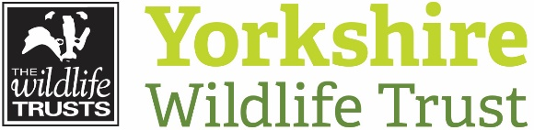 Volunteer Opportunity

Volunteer Opportunity Title
Livestock Checker

Reserve, Project, Team or Area
Potteric Carr and Carr Lodge, Doncaster

Volunteer Manager
Katie Baker, People & Wildlife Assistant- South
Why do we need you?
Yorkshire Wildlife Trust manages over 100 reserves, restoring biodiversity, protecting habitats and wildlife and providing wonderful opportunities for visitors to get close up and see some of our most enthralling wildlife. Part of the management of many of our grassland, fen and heathland reserves is carried out by grazing animals. Grazing helps control competitive, less wildlife-friendly plant species that can out-compete the more delicate, rarer species of grasses and wildflowers that we seek to encourage. We aim to check all our livestock daily to spot any health issues and ensure the fields are safe and secure as many have footpath access. Local volunteers who can visit the reserve each week will reduce the need for staff to travel to this site on a daily basis and ensure livestock are happy and well.

“Being out in the field with the livestock and wildlife is a tonic for one’s wellbeing. It is lovely to be able to make a meaningful contribution to the Trust and help look after some of Yorkshire’s furry faces!” – Georgie, Potteric Livestock Checker
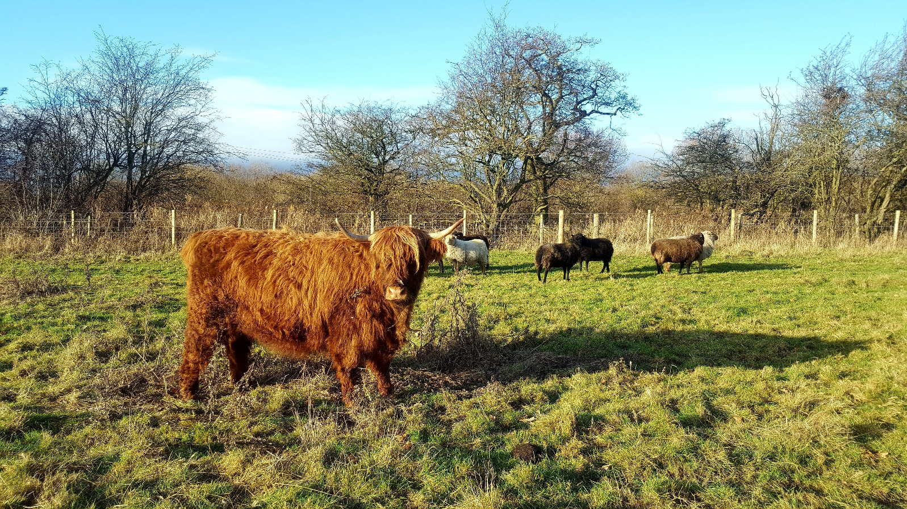
Photo credit: Katie Baker

What will you be doing?
- Each visit involves a short to medium walk around the area being grazed, checking fence lines, counting the number of animals and looking for any signs of ill health. If you do see any problems, you are not be expected to deal with them yourself, simply contact your volunteer manager to let them know.
- We work a rota system, so a group of people take it in turns to check stock at a certain site, so each individual’s commitment is not too great. Roughly once a week or once a fortnight is normal. Once livestock have been checked volunteers are asked to send a brief message to their volunteer manager, letting them know all is well.
- An introduction to the site and livestock will be given, with a site and task risk assessment. Training on what to look out for, common problems encountered, tell tale signs of illness etc. will be given in person and followed up by a reminder document.
- There will be other opportunities to learn about the livestock and help with routine animal welfare tasks if volunteers express a wish to do so.
Experience, knowledge and skills needed for this opportunity
- No previous knowledge or experience necessary, but you need to feel confident being around grazing animals, and any past experience or knowledge of livestock is welcome.
- The main requirement is reliability – the volunteer must check the livestock on their allocated day, or let us know if they can’t so we can make other arrangements.
- You also need to be fairly physically fit as grazing areas are often off footpaths in a large field.
Does the volunteer need a driver’s licence?
Ideally yes – but only to get to the reserve (unless they live within walking distance of the reserve or can be dropped off). The actual checking will all be done on foot.
What’s in it for you?
- The chance to spend quiet time on one of YWT’s superb reserves ; you will often spot fantastic wildlife close up while stock checking.
- The chance to get to work with our livestock and learn more about the amazing role cattle and sheep play in creating wildlife friendly habitats.
- Learn skills in animal welfare and management if desired.
- Learn some more about nature reserve management and meet other like – minded people.
- Access to our free volunteer training programme and volunteer events throughout the year.
- 15% discount in Yorkshire Wildlife Trust shops & 15% discount at Yorkshire Wildlife Trust cafes on the days when you are volunteering.
- Be-spoke training will be provided to enable you to carry out your Livestock Volunteer role safely

Where is the opportunity based?
Within Potteric Carr and Carr Lodge nature reserves
Commitment
Flexible - The level of commitment will vary throughout the year as the livestock are rotated around the site and their numbers fluctuate to provide the required level of grazing. You could volunteer as much 2 x per week or a minimum of once a month, with weekends being especially desirable although not essential.
Duration
Ongoing – we will always be wanting cattle and sheep to be grazing our reserve and the numbers fluctuate according to time of year and land availability.

