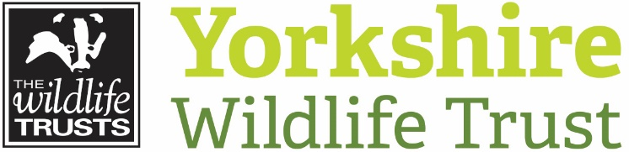

Communications and Marketing Manager
About us

Yorkshire Wildlife Trust is one the region’s largest and oldest nature conservation charities, starting life by taking on the ownership and management of Askham Bog nature reserve on the edge of York in 1946. It is one of the 46 Wildlife Trusts and the Royal Society of Wildlife Trusts that together collectively form The Wildlife Trusts Partnership. Together, they are one of the biggest organisations in the UK working solely for nature.
Today, we employ more than 160 staff, work alongside over 800 volunteers and 50 trainees and are supported by nearly 45,000 members. We manage over 100 nature reserves covering just over 3,000 ha of land and work with many other land managers assisting them to improve wildlife on their land. We involve people in nature conservation through the simple inspiration of visiting a Trust nature reserve, through events, environmental education and community involvement. We communicate and advocate for nature across all of Yorkshire, not least through commenting on over 700 planning applications each year.
Our mission is to restore wildlife by making Yorkshire wilder together. In pursuit of our vision where, Yorkshire is rich in wildlife for the benefit of everyone with more wildlife, more wild places and more people having a strong connection to nature.
In 2020/21 we refreshed Yorkshire Wildlife Trust’s Strategy, to be bolder in our ambitions for a Wilder Yorkshire, from 2021 to 2025, we will focus on five delivery themes to:
  - Restore and Grow Wild Places;
  - Partner for a Wilder Yorkshire;
  - Create a Wilder Future;
  - Foster a One Trust culture; and to
  - Be Financially Strong and Sustainable

Fundraising and Engagement
The Communications and Marketing Team are part of the Fundraising and Engagement Directorate whose main purpose is to enhance our relationships with supporters and diversify and strengthen our engagement proposition to inspire more people to take action for wildlife.
The Communications and Marketing Manager manages the Communications and Marketing Team and is a member of the Extended Leadership Team.
The Communications and Marketing Team bring together the public voice of the charity, creating communications and campaigns that lead to positive brand awareness, increased and more diverse reach and stronger relationships with supporters.
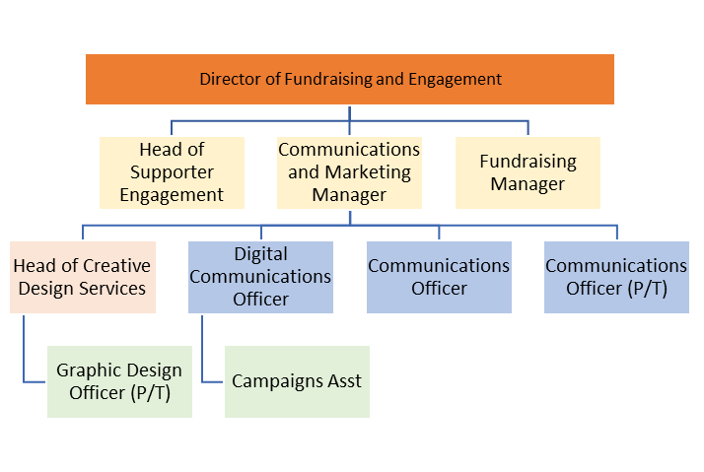

Job Description

Outline
Responsible to: Director of Fundraising and Engagement
Responsible for: Communications and Marketing Team, Trainees and Volunteers as appropriate
Based at: York, Potteric Carr or Stirley with flexible home working. The post holder will also be required to travel to other YWT sites across the Region and sometimes outside of County to fulfil their role.

Brief
To lead in the development and delivery of an integrated, inspiring and effective communications and marketing strategy to support strategic objectives including inspiring 1 in 4 people to take action for wildlife. The post-holder will be required to oversee all internal and external communications and marketing activity, working in collaboration with colleagues and partners to achieve cohesion around messaging and consistency with brand to enhance and strengthen support for Yorkshire Wildlife Trust.

Main objectives

- To manage the resources of the communications and marketing team in order to develop and deliver inspiring, effective and integrated communications that will strengthen brand recognition and support for Yorkshire Wildlife Trust

- Develop and lead an integrated communications strategy incorporating PR, marketing and online activity to support the strategic direction of the organisation

- Deliver high impact communications campaigns that inspire and motivate people to take action for wildlife, including through financial contributions
- To ensure all communications and marketing activities achieve optimum reach and engagement and fit with strategic priorities
- To manage the resources and brand integrity of our in-house Creative Design Services

Main responsibilities

Management

- To provide leadership and support to inspire and motivate team members ensuring individuals have the skills, knowledge and technical expertise to successfully carry out their current role and develop into future roles including undertaking supervisory sessions, team meetings and budget management

- To manage the communications budget and ensure it is use is fully optimised for maximum impact

- To carry out team meetings, appraisals and one to ones with staff and volunteers where appropriate

- To be a proactive member of the Extended Leadership Team working collaboratively with colleagues to ensure timely delivery, reporting, evaluation and monitoring of communications and marketing activities across the Trust

Communications and Marketing
Leadership

- Lead in the development and delivery of the communication and marketing strategies to ensure activity is aligned with strategic objectives and reflects our core values

- Provide technical expertise and guidance to Senior Leadership Team and regional teams to strengthen communications and marketing and manage challenging PR issues

- Provide leadership and management of the day-to-day communications activities including provision and editing of content for media, website; social media and quarterly ‘Wildlife Yorkshire’ membership magazine

- Lead in the creation and delivery of communications and marketing activities to support strategic fundraising and engagement campaigns including 30DaysWild, Great Yorkshire Creature Count and annual fundraising campaigns

- Implement communications plans to enhance and strengthen brand awareness with internal and external stakeholders

Activity

- Cultivate relationships with key media, individual influencers and Trust Ambassadors to secure and grow media coverage and strengthen brand awareness

- Monitor, analyse and review communications and marketing to ensure activity is inspiring and relevant and achieves consistency of brand and messaging

- Engage with strategic partners to promote exemplar communications that support and enable effective fundraising and engagement campaigns

- Provide internal business areas with a comprehensive and professional communications service; helping stakeholders with scoping of activities, editorial assistance, proofing (including guiding on tone, use of language and inclusion of key messages) to ensure we’re sending clear, balanced and effective messages

- Working with the Director of Fundraising and Engagement and members of the Senior Leadership Team to develop, test and shape key communications messages to support organisational priorities, ensuring they’re up to date, based on robust intelligence and implemented effectively across the organisation

- Work with the Director of Finance and Central Services to ensure our Creative Design Services are operating in line with our trading policies and procedures, and are achieving a net contribution towards budget each year

- To understand the role of RSWT in relation to the Trust and actively liaise with relevant members of staff with regard to communications activities

Other
- To play a proactive role in the Fundraising and Engagement Directorate and build mutually supportive relationships across all fundraising and engagement team activities
- To keep up to date with best practice and comply with relevant legislation and regulation, and to work within the organisation’s policies and procedures to ensure that good practice is observed and implemented across the organisation
- Promote the Trust and partner organisations whenever possible.
- Demonstrate our Trust values every day behaving with courage, respect, and integrity whilst trusting others and taking responsibility for your actions at all times.
- Support and promote the Trust’s commitment to equality, diversity and inclusion.
- The Trust is committed to safeguarding and promoting the welfare of children, young people, and adults at risk and expects all staff and volunteers to share this commitment.
- Undertake other duties as requested by your line manager and in line with the post.

Person Specification
To be successful in this role you will need a proven track record of managing and leading a team to deliver an exemplar communications and marketing programme. You will also need considerable experience working with key influencers and stakeholders to inform the development of inspiring and effective communications and engagement campaigns.
Experience
Criteria | Essential/Desirable | Measured By:  Application/Interview
Demonstrable experience developing and leading an integrated communications strategy incorporating PR, Marketing and Online to support business objectives | Essential | A/I
Track record of managing and implementing communications and marketing activities to strengthen brand awareness and grow support | Essential | A/I
Proven people management: ability to motivate, inspire and build a high performing team | Essential | A/I
Highly articulate individual with excellent interpersonal skills and an ability to influence and inspire at all levels | Essential | A/I
Proven experience working with key stakeholders, partners and colleagues to create meaningful communications that have impact | Essential | A/I
Experience working within PR, marketing or communications, or a similar discipline within the Charity and/ or Environmental sector | Desirable | A/I
Experience creating and managing an internal communications programme including Intranet | Desirable | A/I
Knowledge and Understanding
Criteria | Essential/Desirable | Measured By:  Application/Interview
Significant knowledge of the core components of good communications campaigns (media, social media and online) and how to monitor and evaluate their success | Essential | A/I
Expertise in creating communications to convey complex issues simply and clearly and build common purpose | Essential | A/I
Understand the value of brand and monitoring, collating and analysing this to enhance profile across a variety of audiences and channels | Essential | A/I
Proven knowledge and ability, to create and manage high profile communications and marketing campaigns in order to grow and diversify reach, income and support | Essential | A/I
Deep understanding of how to develop effective initiatives and strategies to reach a target audience and be able to apply this to digital platforms and traditional mediums | Essential | I
Good understanding of the charity sector and how to proactively cultivate relationships to increase opportunity and strengthen networks | Desirable | A/I
Good grasp of wildlife and nature conservation | Desirable | A/I
Skills and Qualifications
Criteria | Essential/Desirable | Measured By:  Application/Interview
Excellent organisational and project management skills and an ability to work effectively and sensitively with internal and external stakeholders to deliver shared objectives | Essential | A/I
Excellent writing, editing and proofing skills with an eye for detail and accuracy | Essential | A/I
Ability to creatively distil complex topics into engaging and inspiring content and messaging | Essential | A/I
Proven ability to present inspiring and effective communications with credibility and confidence | Essential | A/I
Highly competent in use of Microsoft Office- including word, Excel, database, email etc. | Essential | A/I
A degree in English, marketing, communications, journalism or similar experience / professional qualifications | Desirable | A
Experience of using Content Management Systems, Creative Suite and other complex software packages | Desirable | A
Driving Licence and ability and willingness to drive as required | Essential | A
Personal Qualities
Criteria | Essential/Desirable | Measured By:  Application/Interview
Natural communicator, highly articulate and able to convey complex information in a concise, compelling and sensitive way to a range of audiences | Essential | A/I
Ability to work in a highly organised way whilst maintaining the flexibility to respond to opportunities | Essential | I
Working with independence, intelligence, drive and initiative | Essential | I
A strategic thinker with a hands-on approach | Essential | A/I
A creative, passionate and energetic individual who is able to work at pace with good attention to detail. | Essential | A/I

Terms and Conditions
Salary: | £34,000-£36,000 pa. Salaries are paid on the 20th of each month by bank transfer and cover the period of the 1st of the month to the last day of the month.
Hours: | 35 working hours per week, Monday to Friday. The nature of the post’s duties may from time-to-time require evening and weekend work. Paid overtime is not available, but time off in lieu will be given.
Contract | Permanent
Flexibility: | Subject to ensuring that the needs of the business and the role are met, the Trust, where possible, endeavours to meet the flexible working needs of its employees.
Holidays: | 25 working days per annum in addition to normal public holidays plus 3 additional office closure days between Christmas and New Year (pro rata for part time employees).
Pensions: | You may be eligible to be auto enrolled into the Trust’s Group Flexible Retirement plan. Written terms of the scheme are available on request from finance.
Cycle to work scheme: | The Trust runs a Cycle to Work Scheme. Details of which are available on request.
Employee Assistance Programme: | The Trust provides paid staff with access to an Employee Assistance Programme. This is a confidential service which aims to provide staff with support for a range of issues. Further details are available from the HR and Training Manager.
Health Questionnaire: | You will be required to complete a health questionnaire prior to any unconditional offer of employment being made.
Equal Opportunities: | Yorkshire Wildlife Trust is committed to equal opportunities and appoints on merit. We welcome applicants from all sections of society regardless of gender, sexual orientation, race, disability, marital status, age and religion, perceived community background or political beliefs.
Notice Period: | 8 weeks. One of the conditions of passing the probationary period is that all appropriate online Healthy and Safety training modules are passed.
Place of Work: | The post will be based mainly at the York, Doncaster or Stirley Offices with some flexible home-working as appropriate. There is a requirement to travel across the Region and occasionally out of county as part of the role.
Travel: | Public transport is encouraged although pool vehicles are available. The use of the officer’s own vehicle may be necessary for business use for which a mileage rate of 40p per mile will be paid.
Training: | The Trust is fully committed to personal development and training and offers each employee an individual training budget which can be spent on a variety of both internal and external training.
Closing deadline: | Monday, 29th November at 9am
Interview date: | Monday, 13th December 2021

