

Volunteer Opportunity Title | Serial Number
Mindfulness and Wellbeing walk leader - Volunteer
Reserve, Project, Team or Area
Fundraising Team
Volunteer Manager/Supervisor
Sarah Robinson, Corporate Partnerships Assistant
Why do we need you?
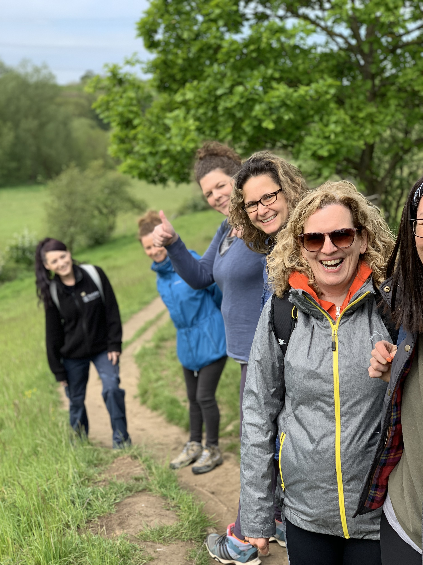
If you love being outside in the fresh air, leading walks and helping people to reconnect with nature and themselves then our Wellbeing walk leader would be perfect for you!

Yorkshire Wildlife Trust has a business membership scheme, and we would like to offer employees from these businesses mindfulness and wellbeing walks. Modern workplaces can be hectic, sometimes isolating, and very desk based. Mindfulness walks at our nature reserves will help people to reconnect with wildlife and wild places, destress and relax.

Our business members range from bed manufacturers to outdoor clothing companies based across Yorkshire and, in some instances, nationally. These walks will part of the benefits they receive in return for their membership, groups of colleagues (10-15) will be able to join a walk, connect with nature, and practice mindfulness.
PwC walk Summer 2019

What will you be doing?
You’ll be leading health and well-being walks (45 minute to 1 hour) around some key nature reserves to promote mindfulness and wellbeing to groups of 10-15 people. You will be responsible for preparing and planning the content and timings of walks including undertaking an introductory ‘welcome’ and ‘finish’ at each walk to further engage participants with Yorkshire Wildlife Trust. Each walk will encourage participants to ‘be in the moment’ by fully participating through all the sensory experiences, to connect with nature and temporarily forget about all other aspects of their life.

Walk participants will be mainly employees of our business supporters, who are looking to destress and reconnect with nature. You will be a person they may choose to confide in, however it will be made clear at booking, that this is a non-medical activity and not an expert session, rather an activity that may help with overall wellbeing.

Experience, knowledge and skills needed for this opportunity
You will be confident walk leader and experienced with mindfulness practices. You will be approachable and personable, creating a safe and welcoming environment.

Essential:
- Proven experience of mindfulness exercises and how these can be applied in an outdoor setting
- Good experience in: Mindfulness Based Stress Reduction or Mindfulness Based Cognitive Therapy or mindfulness meditation
- A confident and personable speaker and leader
- An understanding of Yorkshire Wildlife Trust values and mission
- Excellent listening and interpersonal skills
- Good knowledge of safeguarding best practice

Desirable:
- Proven experience leading group session
- A passion for nature and wildlife
- Some experience in counselling, therapy, clinical psychology, social work

Does the volunteer need a driver’s licence?

Not essential, some sites are accessible by public transport. They will need to be able to make their own way to the nature reserves.
What’s in it for you?
This role will provide a chance to make a difference to someone’s life; this may their first experience of mindfulness and using nature as a way to destress. You will have the opportunity to inspire people to enjoy wild places more and all the benefits associated with mindfulness. You will be giving something back to the local community, and have the opportunity meet new people and enjoy time outdoors on our reserves.

We will provide first aid training, and there are various opportunities to join courses on wildlife and conservation.

You will be part of a team raising income and awareness for Yorkshire Wildlife Trust; engaging more people and businesses with our work is critical to protecting and restoring wildlife and wild places. By connecting more people with nature we will amplify our effectiveness.
Where is the opportunity based?
- Leeds urban nature reserves (Kirkstall Valley, Rothwell Country Park, Kippax Meadows)
- or York nature reserves (Askham Bog)
- or Potteric Carr nature reserve near Doncaster.
Commitment
Mid-week – Flexible can be arranged to suit your commitments
Duration
ongoing

Recruiting Information
How many volunteers are needed in this role/team? Ideally one for each of the Leeds, York and Doncaster areas.

Recruitment start date: 01/09/21 End date (if any): 30/09/21

Interview date (if applicable): flexible depending on availability of candidate

Any particular requirements or suggestions (e.g. a volunteer centre, local publications):

Does this opportunity involve working with children or vulnerable adults? (give details)
If yes, will the volunteer have supervisory responsibility for the children or vulnerable adults? If so how frequently? (give details, eg once per week, per month)

Very unlikely, potentially vulnerable adults but very infrequently if so and will probably be with appropriate colleagues or carers. Some participants may have mental health difficulties and thus fall into ‘at risk’ category; therefore candidates will need to understand and apply the safeguarding principles .

Will the opportunity involve any other sensitive tasks for which we may wish to check suitability via references or a criminal records check?(e.g. confidential data, finances)
No.
Have you carried out a risk assessment for this opportunity or the main tasks it involves? Not yet

Please list any relevant factors Uneven surfaces, wet and muddy footpaths, adverse weather conditions but event would cancelled if this is forecast.

Please refer to the generic Volunteer Induction Checklist and tailor to suit this role :

What training is required?
An induction / training will be given into Yorkshire Wildlife Trust, corporate fundraising, and how to ‘welcome’ and ‘finish’ the walk in YWT style and tone.

Training for those leading practical activities (or significant work alone or unsupervised):
- First Aid? Yes 1day
- Manual handling online? No
- Slips, Trips, Falls online? Yes

Training for those based regularly in an office environment (about once a week or more):
- Visual Display Equipment online? No
- Fire Safety online No

Other Essential: safeguarding due to mental health aspects
Other Desirable:

What equipment is required to fulfil this role? (inc. computer software/licences, PPE)
Fleece and Polo Shirt and hi-vis jacket. Also first aid kit.

Office: no
Personal Protective Equipment: Sturdy shoes and outdoor clothing Other: first aid kit / hi-vis jacket

Have you identified the necessary budget to cover the training, PPE, equipment and travel expenses of this volunteer role? (give details)
Yes – corporate fundraising

Consider the level and type of communication you will need to have with volunteers in this role.
Do you consider that a volunteer will be able to carry out this role effectively if they opt out of receiving communications from you and/or from the Volunteering Development Team?
No
Is this role suitable for a young volunteer?
Yes if parental consent is given (age 16yrs up)

No, if under 16, level of professionalism required.

