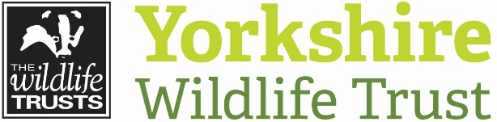 Volunteer Role Description

Volunteer Role Title | Role Number
Livestock Checker
Reserve, Project, Team or Area
East Yorkshire- Cali Heath and Jeffry Bog

Volunteer Manager/Supervisor
James Searle
Why do we need this volunteer?
Yorkshire Wildlife Trust manages over 100 reserves, restoring biodiversity, protecting habitats and wildlife and providing wonderful opportunities for visitors to get close up and see some of our most enthralling wildlife. Part of the management of many of our grassland, fen and heathland reserves is carried out by grazing animals. Grazing helps control competitive ‘rough’ plant species that can out-compete the finer, more interesting species of grass and wildflower that we seek to encourage. Livestock on the reserves need to be checked on three to four times a week to ensure that their health is good, and that they are still all there. If you fancy keeping fit and getting some fresh air, this is a great role to enjoy getting out and about whilst making sure our animals are fit and well.

What will the volunteer be doing?
- Each visit involves a short to medium walk (depending on site) across the area being grazed, counting the number of animals and looking for any signs of ill health. If you did see any problems, you would not be expected to deal with them, simply to ring us at YWT to let us know.
- We usually work a rota system, so a group of people take it in turns to check stock at a certain site, so each individual’s commitment is not too great.
- An introduction to the site will be given, with a site and task risk assessment. Plus information on what to look out for, more common problems encountered, tell tale signs of illness etc. This will be given in person on site and/or followed up by a written reminder document.

Experience, knowledge and skills needed for this role
- No previous knowledge or experience necessary, but you need to feel confident being around grazing animals, and any past experience or knowledge of stock welcome.
- Reliability – the volunteer must check the stock on their allocated day, or let us know if they can’t so we can make other arrangements.
- You also need to be fairly physically fit as some of the grazing areas have rough terrain, tussocks, boggy ground etc. that you need to be able to negotiate.

Does the volunteer need a driver’s license? Yes – unless they live within walking distance of the reserve.
What’s in it for the volunteer?
- The chance to visit one of YWT’s superb reserves throughout a season, seeing it develop and change, and enjoying the wildlife it supports.
- The chance to get to work with our grazing stock – cattle, sheep or ponies. Each have their own personalities and are a joy to get to know.
- Learn skills in animal welfare and care.
- Learn some more about nature reserve management

Where is the role based?
East Yorkshire

Commitment
Each checking visit may take between fifteen minutes and an hour, depending on the site. You can commit to doing this as little or as often as you can manage - any help is appreciated. Weekly or twice monthly visits are average.

Duration
Depends on grazing period of site. From six weeks to six months each year.

