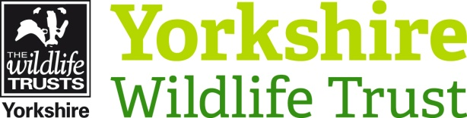

Volunteer Role Title | Role Number
Inspiring People Assistant | 52
Reserve, Project, Team or Area
Potteric Carr Nature Reserve, Doncaster

Volunteer Manager
Kat Woolley Inspiring People Officer
Why do we need this volunteer?
Nature is amazing and we want to tell everyone! Yorkshire Wildlife Trust is creating a county rich in wildlife and we need passionate, inspiring volunteers to help people to develop a connection with nature. Across our sites the Trust runs regular events from education sessions with local schools to bat walks and bush craft workshops for the public. We are looking for people who can inspire others and help us to deliver these events throughout the seasons.
What will the volunteer be doing?
At Potteric Car we run a range of events across the year to inspire people about nature. Staff and volunteers run the majority of these events from school group visits to bookable events for the public. In this role you will help to deliver these activities, representing Yorkshire Wildlife Trust, and share your passion for nature with others providing a high quality visitor experience.
Tasks will include:

- Assisting the Inspiring People Leader in the smooth running of events and sessions
- Assist in preparing of equipment, resources and materials
- Assist in room set up
- Back mark groups so no one gets lost
- Check in people on events attendance list
- Meet and greet participants
- Engage with visitors and communicate ‘onward messages’
- Assist in the packing away of materials and equipment correctly
- Feedback event attendance to co-ordinators or Inspiring People Officer
- Run activities such as pond dipping, minibeast hunts and craft activities

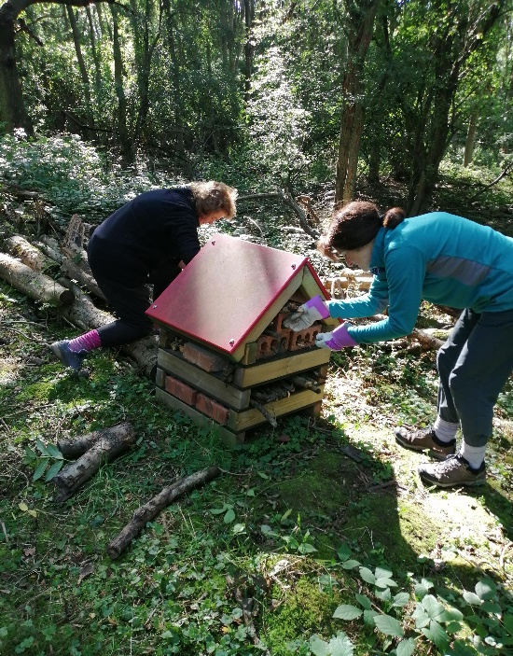

Having fun building a bug-house!
Photo Credit: Kat Woolley

Experience, knowledge and skills needed for this role
Essential:
- Ability to share knowledge clearly and inspire others
- An infectious passion for nature and being outdoors
- Willingness to have fun outdoors in all weathers
- Capable of working on your own and with others
- Ability to be reliable and punctual
- Ability to follow instructions and on occasions work with minimum supervision
- Reasonably physically fit
- Good communication skills
- Good time keeping
- Awareness of yours and others safety

Desirable:
- Experience of working with children and other age groups
- Passion for and knowledge of the natural environment and British wildlife
- Awareness of safety outdoors
- Experience of presenting to a wide audience
- First Aid certificate

Does the volunteer need a driver’s license? No
What’s in it for the volunteer?
- A chance to inspire others about the natural world
- Development and use of leadership skills
- Development and use of communication skills
- Development and use of engagement skills
- Access to a free volunteer training programme.
- 15% discount in Yorkshire Wildlife Trust shop. 15% discount at cafes when volunteering.
- Be part of a fun and inspiring team.
- A chance to learn more about the amazing Potteric Carr Nature Reserve and the wildlife that calls it home.

Where is the role based?
Potteric Carr, South Yorkshire.
Commitment
As much as you want but at least once a month.
Volunteers will be emailed a diary with future event dates each month and then they can choose which dates to volunteer.
Duration
Ongoing – Most of our events happen between April and September. This is when you will be busiest.
Does this role involve working with children or vulnerable adults?
Yes

Will the role involve any other sensitive tasks for which we may wish to check suitability via references or a criminal records check?
Yes – booking forms contain personal information.

