Yorkshire Wolds dew ponds

History of the ponds

Did you know?

Dew ponds were once found all across the Yorkshire Wolds but today numbers have dropped with many ponds now completely lost. As farming practices changed, the ponds were often no longer needed and ploughed in or became silted up
- Dew ponds were predominantly built in the 18th, 19th and early 20th centuries to provide a vital water source for livestock in dry areas. Before dew ponds were created livestock would have had to be herded to and from the local village water source to drink.
- The term ‘dew pond’ began to be widely used in the 19th century by the Victorians and before then the ponds were simply known as artificial ponds.
- Other names used were cloud, mist or fog ponds. Mystery surrounded them as they appeared to have a consistent water supply without being fed by a stream or spring and this conjured up the idea that the dew collected over night, within these circular almost cone shaped ponds.
- Dew ponds were made by local pond makers and the skills often handed down throughout generations, with each pond maker using their own methods.

Historically a lime and sand mix were often used as a base layer and this would prevent worm damage to the clay liner. The clay would have been laid down in layers and kneaded and worked to create a watertight seal. This clay layer was between 6-12” thick and ‘puddled’ using a wooden mell [hammer] which would halve the thickness. An alternative method would be to fence around the pond, introduce sheep to the area and let them walk over the clay, forcing all the gaps within the clay to close up. Wheat straw was then used as a layer thought to not only provide protection to the clay liner but also to help prevent the clay from drying out, as the straw has a wicking effect, keeping moisture in the clay. The final layer to be added was broken chalk which would further protect the liner from the trampling actions of animal’s hooves, as they used the pond for drinking.
Below are two pictures showing the action of sheep hooves [left] and the modern-day equivalent, using a tracked excavator, which makes more uniform track marks on the clay. Both have the same end result – sealing the clay and making it watertight.

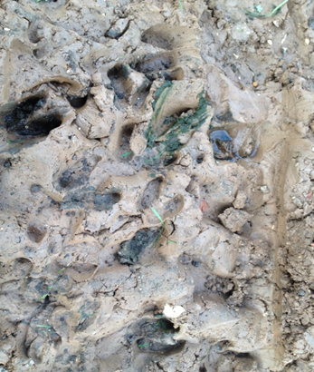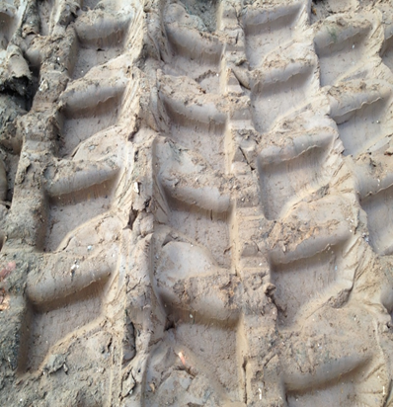

Today, pond construction and restoration can use modern machinery with tractors able to carry and load materials and tracked excavators to dig out and level, but otherwise the methods employed to carry out dew pond works still relies on these historic tried and tested work practices.

Make your own mini dew pond!

We’ve got some instructions on our website on how to make a big dew pond, perfect for those who have the space to do so. You can find them here: https://www.ywt.org.uk/wolds-dew-ponds/restoration.
However, most people don’t have the space, so here’s how to create your own mini dew pond. Why not compare it with the big dew ponds and see what the differences are?
What you need:
- Trowel
- Tea towel
- Modelling clay
- Straw
- Pebbles

- This can be achieved using a small colander/sieve using the tea towel as the membrane liner to prevent the clay being forced through the holes.

- Line it with the modelling clay use your knuckles to “puddle” the clay by pushing the clay (approximately ½ cm thick).

- Put a thin layer of straw (Yorkshire dew ponds always use wheat straw) so you can no longer see the clay (approximately 1cm deep).

- Then place the pebbles (the dew pond restoration used chalk) all around the pond liner with your hands.

- Unlike dew ponds that will naturally fill with rain you can add water. Does it hold water?

Ponds are vital for wildlife. More information about the wildlife found in and around the Yorkshire Wolds dew ponds can be found on the website https://www.ywt.org.uk/wolds-dew-ponds.

References
Hayfied, C, and Brough, M, (1986) Dewponds and Pondmakers of the Yorkshire Wolds. Folk Life 25.
Pearce, F, (2006) Dew ponds of the Downlands, pp 93-96 www.countryliving.co.uk
Mitchell, S, (2006) Dew Ponds to the Rescue www.countryliving.co.uk

