Dew pond food chains
Arrange the pictures on the food chain diagram.

Cut out the pictures and stick them onto the food chain diagram.

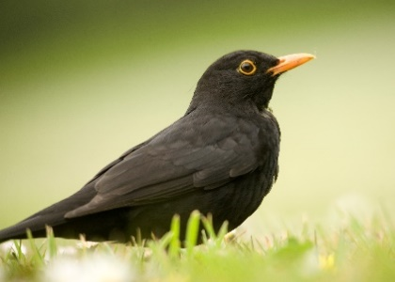 |  | 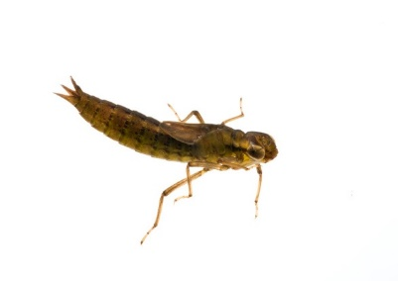
Bird |  | Dragonfly nymph
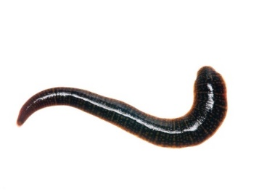 |  | 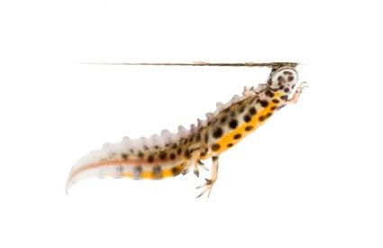
Leech |  | Newt
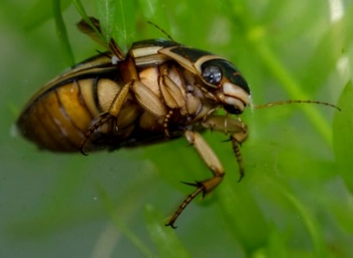

Diving beetle |  | Tadpole
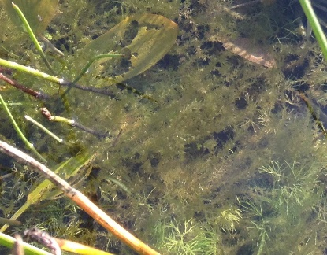 |  | 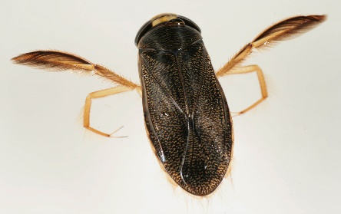
Decaying plant matter,  algae and micro organisms |  | Lesser water boatman

Dew pond food chains: answers

Bird
Newt

Leech
Diving beetle

Dragonfly nymph
Frog tadpole

Lesser water boatman
Decaying plant matter, algae and micro organisms

Dew pond food chains: clues
I look a bit like a lizard but I’m actually an amphibian
I have wings and two legs

I am an insect with hard wing cases

I am a bit like a worm

When I grow up I will be a beautiful dragonfly
I am a baby frog

I have two long legs that I use like oars to glide through the water
Tiny plants & creatures & old plant material

