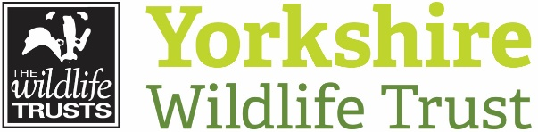
Volunteer Application Form
Please complete the details below and return this form to volunteering@ywt.org.uk or post to
Volunteering Department, Yorkshire Wildlife Trust, 1 St Georges Place, York, YO24 1GN
Title of the opportunity you’re applying for

Your details:
Address:
Town/City:
Last name:
Postcode:
Date of Birth:

Title (delete): Mr / Mrs / Ms / Dr
First name:
Last name:
Phone:
Email:

Your email address is important to us because it’s the main way that we communicate with our volunteers.
For insurance purposes we need to know your date of birth. We also want to make sure people of all ages have the opportunity to get involved with us. If you are 16 or 17 we will ask that you provide a parental/ guardian consent form. Volunteers under the age of 16 will require a parent or guardian to accompany them.
About you:
Tell us why you are interested in volunteering. You can choose to ‘X’ as many of the options below as you feel are relevant. This will help us to understand what you’re looking for and the types of opportunities you’d like;

Belief in the work of the Wildlife Trust
Develop my knowledge/interests
Fun
Fill some time
Exercise
Get some work experience or help with my CV
Help others
Make a difference to the local community

Make a difference to the natural environment
Preserve our heritage for future generations
Share my passion for a particular place
Spend more time in nature
Spend time with like-minded people
Use my skills
Other

Tell us when you are generally available and would like to volunteer (mark with an ‘X’):
 | MONDAY | TUESDAY | WEDNESDAY | THURSDAY | FRIDAY | SATURDAY | SUNDAY
Mornings
Afternoons
Evenings

Volunteer Application Form
Please let us know if you have any particular access requirements or health conditions that we should be aware of.
We want volunteering to be accessible to everyone. This information helps make sure we find the right role for you
and put in place the right support.

Tell us about your skills, experience and any relevant qualifications
(eg. Project management, pesticide use, creative skills, chainsaw certificate):

Why do you think you would be suitable for this role and why would you enjoy it?:

Volunteer Application Form
Staying in touch with us
We would like to use the information you have given us to keep you informed about other Trust wide news that may be of interest to you. Please ‘X’ if you’re happy for us to contact you in this way. Your consent will enable us to mail you for a couple of years if and when you choose to leave.

Email Mail Phone SMS
We will never pass your details on to other organisations. http://www.ywt.org.uk/privacy-policy
How did you hear about volunteering with us?

Extra information:
Are you legally entitled to volunteer in the UK?

Yes No
If you’re from the UK you are free to volunteer. The majority of EU citizens are also free to volunteer within the UK. If you’re from outside the EU we advise you to contact the UK Borders and Immigration Agency to find out if your visa allows you to volunteer.
Do you have any convictions which are unspent under the Rehabilitation of Offenders Act 1974?

Yes No
Holding an unspent conviction does not automatically exclude you from volunteering with Yorkshire Wildlife Trust. We encourage you to discuss this with us during your application.

Signature
/ /
Date

Thank you for your application.
Please return this form to volunteering@ywt.org.uk

