Volunteer Opportunity

Volunteer Opportunity Title
Peat Dragonflies Monitoring Volunteer
Reserve, Project, Team or Area
Various locations on Yorkshire Dales peatlands, initially Swarth Moor SSSI
Volunteer Manager
Jessica McMaster – Peat Project Officer, YPP
Why do we need you?
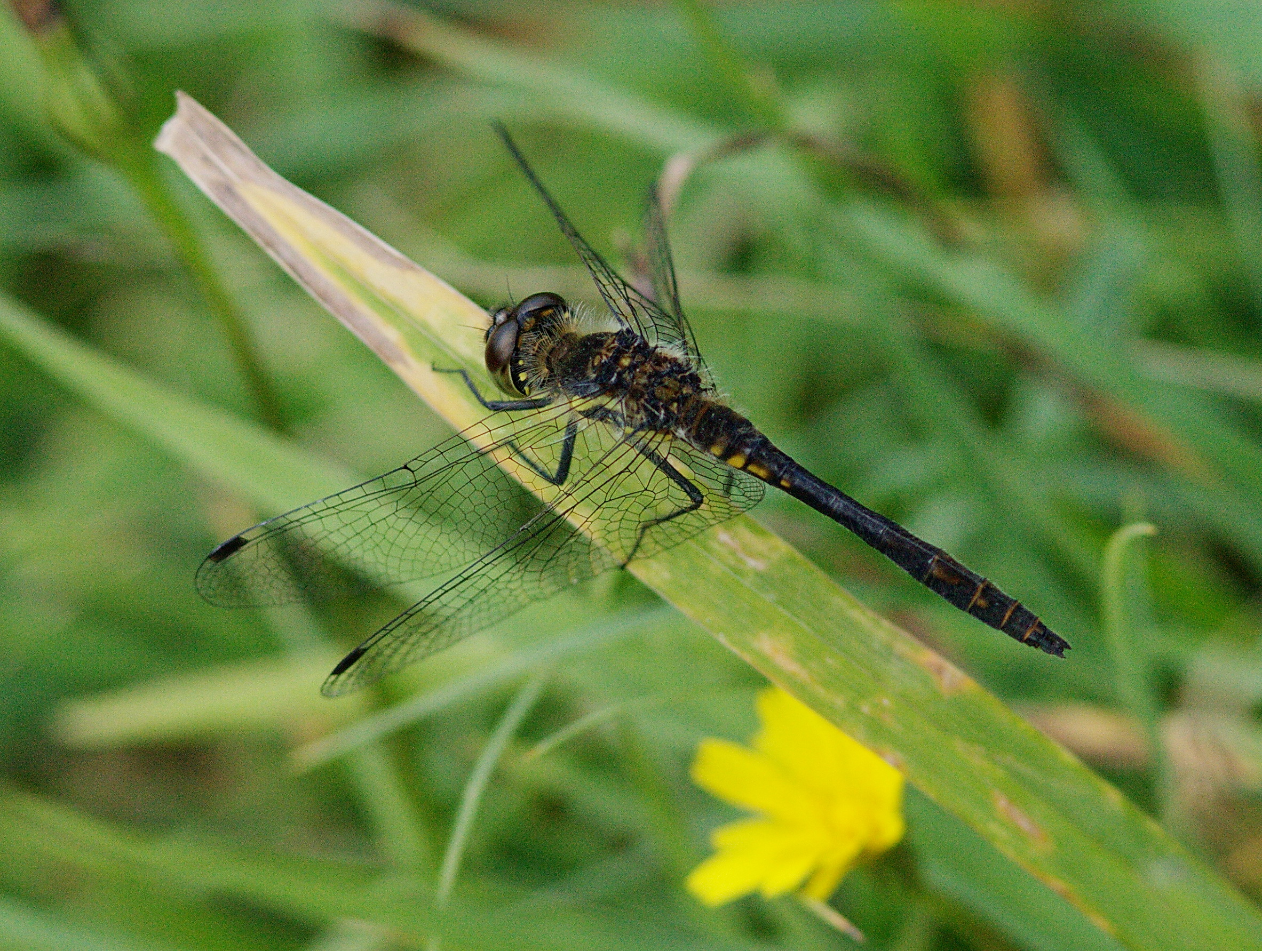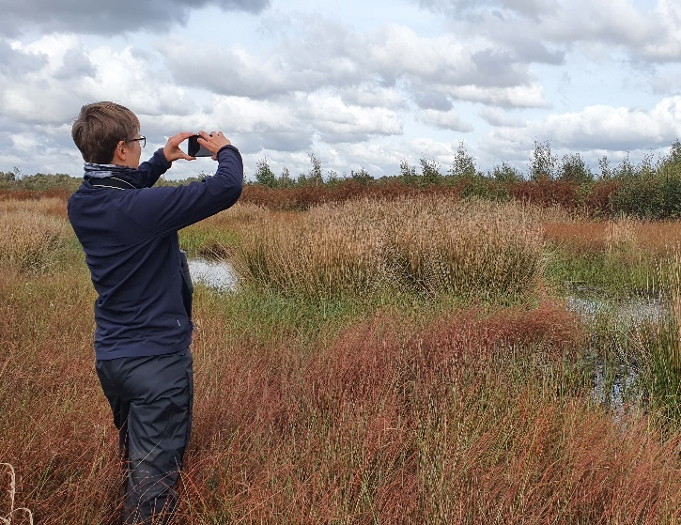

Left – Male black darter. Right – Surveying for Dragonflies
Photo credit: Richard Willison, Beth Thomas

Do you want to be involved in helping monitor populations of dragonflies and damselflies across Yorkshire’s peatland habitats? Do you enjoy spending time outdoors off the beaten track in sunny weather? How about contributing to data collection efforts to help with dragonfly conservation? If so, then this role will be perfect for you!

Around half of our British dragonflies and damselflies depend upon peatlands, bogs and mires; however, our peatlands are not in a good condition today. Yorkshire Peat Partnership has been busy restoring peatlands since 2009, and when we restore bogs we notice these charismatic creatures making a return – but we need to record that data to understand how to help them most effectively!

The biological records in these surveys will contribute to our ‘Dragons in the Dales’ project for the Species Recovery Programme, which is focused on the red-listed white faced darter dragonfly (currently extinct from Yorkshire). We are gathering baseline data about dragonfly populations in under-recorded peatland habitats to quantify changes in dragonfly populations before and after restoration, and better understand how to help these peatbog specialists thrive.

We need your help to monitor these species to contribute to dragonfly iRecord records for the British Dragonfly Society, and for field research into peatbog dragonflies.
What will you be doing?

You will be traversing peatlands paired up with a member of staff or another volunteer looking out for dragonflies and damselflies, recording the species and behaviour onto a digital recording form.

There will also be opportunities to participate in other monitoring activities such as measuring the water table using bubblers, counting dragonfly moults ‘exuviae’, or vegetation monitoring (all additional training will be provided!).

It is important that if volunteers apply, they are aware of the task variability as dragonflies are highly sensitive to weather conditions and are inactive in cold, wet or windy conditions. However, the role will also have opportunity for flexibility if certain days are suitable to the volunteer.

Experience, knowledge, and skills needed for this opportunity
Essential:-
- Experience of spending time outdoors in wet or muddy places
- Confidence working safely near water and traversing difficult terrain
- A desire to learn and improve identification skills
- A desire to contribute to data collection and biological records
- Able to attend a Yorkshire Peat Partnership Volunteer Training Day for the role
Desirable:-
- Familiar with lowland peat bog landscapes
- A good level of dragonfly and damselfly identification skills
- Prepared to be flexible within reason if bad weather calls for survey dates to be rescheduled (dragonflies also prefer the calm sunny weather!)
- Experience with surveying
- Able or keen to learn to take photos for later identification
- An interest in surveying or data collection
- An interest in wildlife, dragonflies, or peatlands

Does the volunteer need a driver’s licence? No
For Swarth Moor surveys: Lifts can be provided from Skipton Auction Mart YWT office and from Settle train station.
If you are coming from farther afield, you may have to get to the survey site under your own steam, which may be by car.
What’s in it for you?
- Training in dragonfly & damselfly identification & surveying skills
- Contribution to part of a larger project
- Getting to know important peatland habitats the ground on a special SSSI (Sites of Special Scientific Interest) site in the Ingleborough National Nature Reserve, and learning about seasonal dragonfly habits
- Access to the YWT volunteer training programme
- Opportunity to meet like-minded people
Where is the opportunity based?
Initial survey site for 2024: Swarth Moor SSSI, Helwith Bridge, near Settle in the Yorkshire Dales. Potential for future surveys to take place in other lowland or upland bogs in the Yorkshire Dales, Nidderdale, or Yorkshire.

Commitment
Surveys are once every 2-3 weeks in small groups – depending on popularity, this could be a regular 3 week survey, or on a rota over the survey season.

Volunteers will be sent a rota once their application has been accepted with dates.
Some flexibility with dates would be appreciated: dragonfly surveys have to occur in fairly still and warm conditions, so bad weather will require a survey date to be rescheduled by the Volunteer Manager to a more suitable date that week.

Duration
Seasonal: during the dragonfly survey season, which is May-September, Monday – Friday Please note this is flexible and weather dependent as dragonfly surveyor is best carried out in sunny and calm conditions.

Your time on site may last between 1 to 4 hours, depending on experience and enjoyment!
To apply for this volunteer role, please send in a completed volunteer application form to volunteering@ywt.org.uk by the closing deadline: 9am, Monday 22nd April.

Please note that in order to carry out this volunteer role you will need to attend the essential training session which will be held on Monday 29th April 10-4:30pm.

