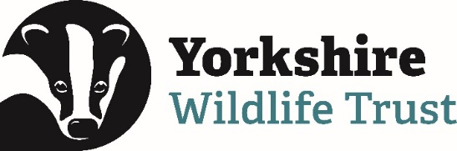
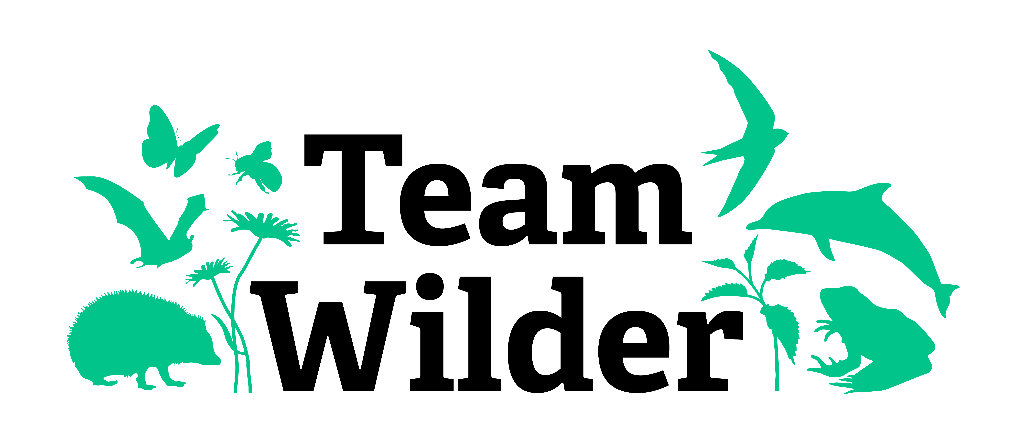

Volunteer Role Profile: #TeamWilder Community Champion
Are you a natural leader? Can you support others to take positive action for wildlife in your community? If so, read on…
What is #TeamWilder?
#TeamWilder is an ever-growing movement of like-minded, passionate people from all walks of life and from right across our county, who acknowledge that our natural world is in crisis and who are committed to changing the future by taking positive and sustainable action for Yorkshire’s wildlife where they live.
Why have we formed #TeamWilder?
Here at Yorkshire Wildlife Trust, we know that no matter how hard we work to slow the loss of our natural environment and protect what remains, we will only be able to reverse the decline when Yorkshire’s communities are supported and empowered to make their own positive change for a more sustainable future. We firmly believe that the recovery of nature must not be something which is done to people; it needs to be done by people - inclusive, welcoming, diverse, growing communities of people - if it’s going to happen at the scale and pace required to make a difference. The science tells us that, by 2030, we’ll need at least 1 in 4 people in Yorkshire to be taking positive action for nature’s recovery as part of their daily life if we’re to successfully combat the climate and biodiversity crisis we’re all facing, so we’ve formed #TeamWilder to bring passionate Yorkshire folk together and empower each other to lead and deliver the change we all need to see.

Everyone who joins #TeamWilder will:
- Receive access to an enormous bank of inspiration and guidance
- Become part of a large network of likeminded, friendly people
- Be pointed towards sources of support and funding
- Get regular updates about key Yorkshire issues and our future plans
- Be given exciting opportunities to share your stories and celebrate your success
- Receive invites to our inspirational and educational events and training sessions
- Be supported to inspire other people in their community to take meaningful action too
Yet, more than simply inspiring other people to take action, we also need some super-members of #TeamWilder to help us to really kickstart meaningful action for wildlife in their local area or amplify the long-term impacts of existing projects…
…and this is where our #TeamWilder Community Champions come in!

What does being a #TeamWilder Community Champion involve?
To help us deliver our vision, we are establishing a crack team of highly motivated, innovative, and energetic volunteers to help us organise communities right across Yorkshire to take meaningful, positive action for wildlife! Community Organising is at the heart of #TeamWilder. This approach involves building relationships with communities, empathetically listening, supporting, and empowering communities to take or increase their action for nature.

As a #TeamWilder Community Champion, you’ll play a leading role in engaging, inspiring, and coordinating others. You will represent Yorkshire Wildlife Trust and be an ambassador for our work. You will enjoy engaging with others and be confident speaking in public to a wide range of audiences; and of course, you’ll be passionate about creating a Wilder Yorkshire!

As a #TeamWilder Community Champion volunteer you’ll help us by:
- Using your local knowledge to liaise with groups and individuals from all walks of life, bringing together and uniting your local community
- Nurturing and developing relationships with individuals, community groups, schools, businesses, and other organisations to build self-sustaining networks and kick start community-led initiatives to create a wilder future for our towns and cities
- Listening to your local community and identifying opportunities for people to act together for wildlife
- Inspiring others by sharing your passion, skills, knowledge and experience through workshops, talks, presentations, and skills share events for community participants
- Supporting people to deliver change for nature in their communities by using #TeamWilder resources to build confidence in others, sharing good practice and helping them to establish their initiatives
- Engage with your local MP, attend public meetings or parish council meetings and take an active role in speaking up for nature within your community
- Build momentum and amplify the action of your communities through sharing stories and growing networks of support
- Assist Yorkshire Wildlife Trust in capturing the actions taking place across the county
Why should I become a Community Champion?
Because you will…
- Make a real difference for wildlife and be at the forefront of delivering change for nature with Yorkshire Wildlife Trust. We cannot do this alone!
- Use your knowledge and enthusiasm to inspire others, this will be a really rewarding role.
- Learn new skills and benefit from a range of training events for our champions.
- Meet new people and make new friends with regular catch ups and opportunities to connect with other champions.
- You will be an integrated part of our volunteer team and eligible for expenses and recognition.
- As a volunteer you will be fully insured and supported through training and regular communication.
- Be invited to volunteer events, our volunteer training programme, and our annual Volunteer Conference
- Be provided with a #TeamWilder Community Champion T-shirt to identify you in your community

Community Champions role details:
When you join #TeamWilder, you will become part of a team of enthusiastic, like-minded individuals! It is expected that this role will fit into your lifestyle, meaning that the days and time you choose to give can be flexible around your personal commitments and the needs of the communities you will be volunteering with.
This voluntary role is open to all and can be based within any community in Yorkshire. We’d love to see volunteers who are truly reflective and representative of the communities they will be supporting. The ability to drive is not essential, although some travel will be necessary for training and events.
What support will be provided?
Managed by the Community Engagement Team, you will be fully insured and given training to carry out your role. There will be mandatory training on Health and Safety, Safeguarding, GDPR and additional workshops and skills development provided such as community organising tools and techniques. As representatives of Yorkshire Wildlife Trust out in the community, you will be expected to abide by agreed role profile, risk assessments, safe working practices and our volunteer code of conduct.

What skills and knowledge will be beneficial?
- Inclusive attitude with excellent listening and negotiation skills, and a curious and empathetic nature
- Confident public speaker with the ability to inspire, lead and engage others by communicating effectively with a wide range of people.
- Knowledge and passion for wildlife (although you don’t need to be an expert!) and a good understanding of the complex issues facing our communities, wildlife, and climate.
- Good local knowledge and some existing connections with community groups and stakeholders will be helpful, but not essential
- Enthusiastic, organised, with a can-do attitude and the ability to get stuck in to take practical action and make change happen on the ground.
- Understanding of community organising techniques will be useful, but not essential as training will be provided
- The ability to capture and share success stories and compelling case studies of people acting for wildlife in their towns and cities will be useful, but not essential as training will be provided

To find out more or express your interest, please contact us at volunteering@ywt.org.uk
If you live in the Sheffield and Rotherham area, please contact Sheffield & Rotherham Wildlife Trust if you’d like to volunteer to take action by emailing: takeaction@wildsheffield.com

