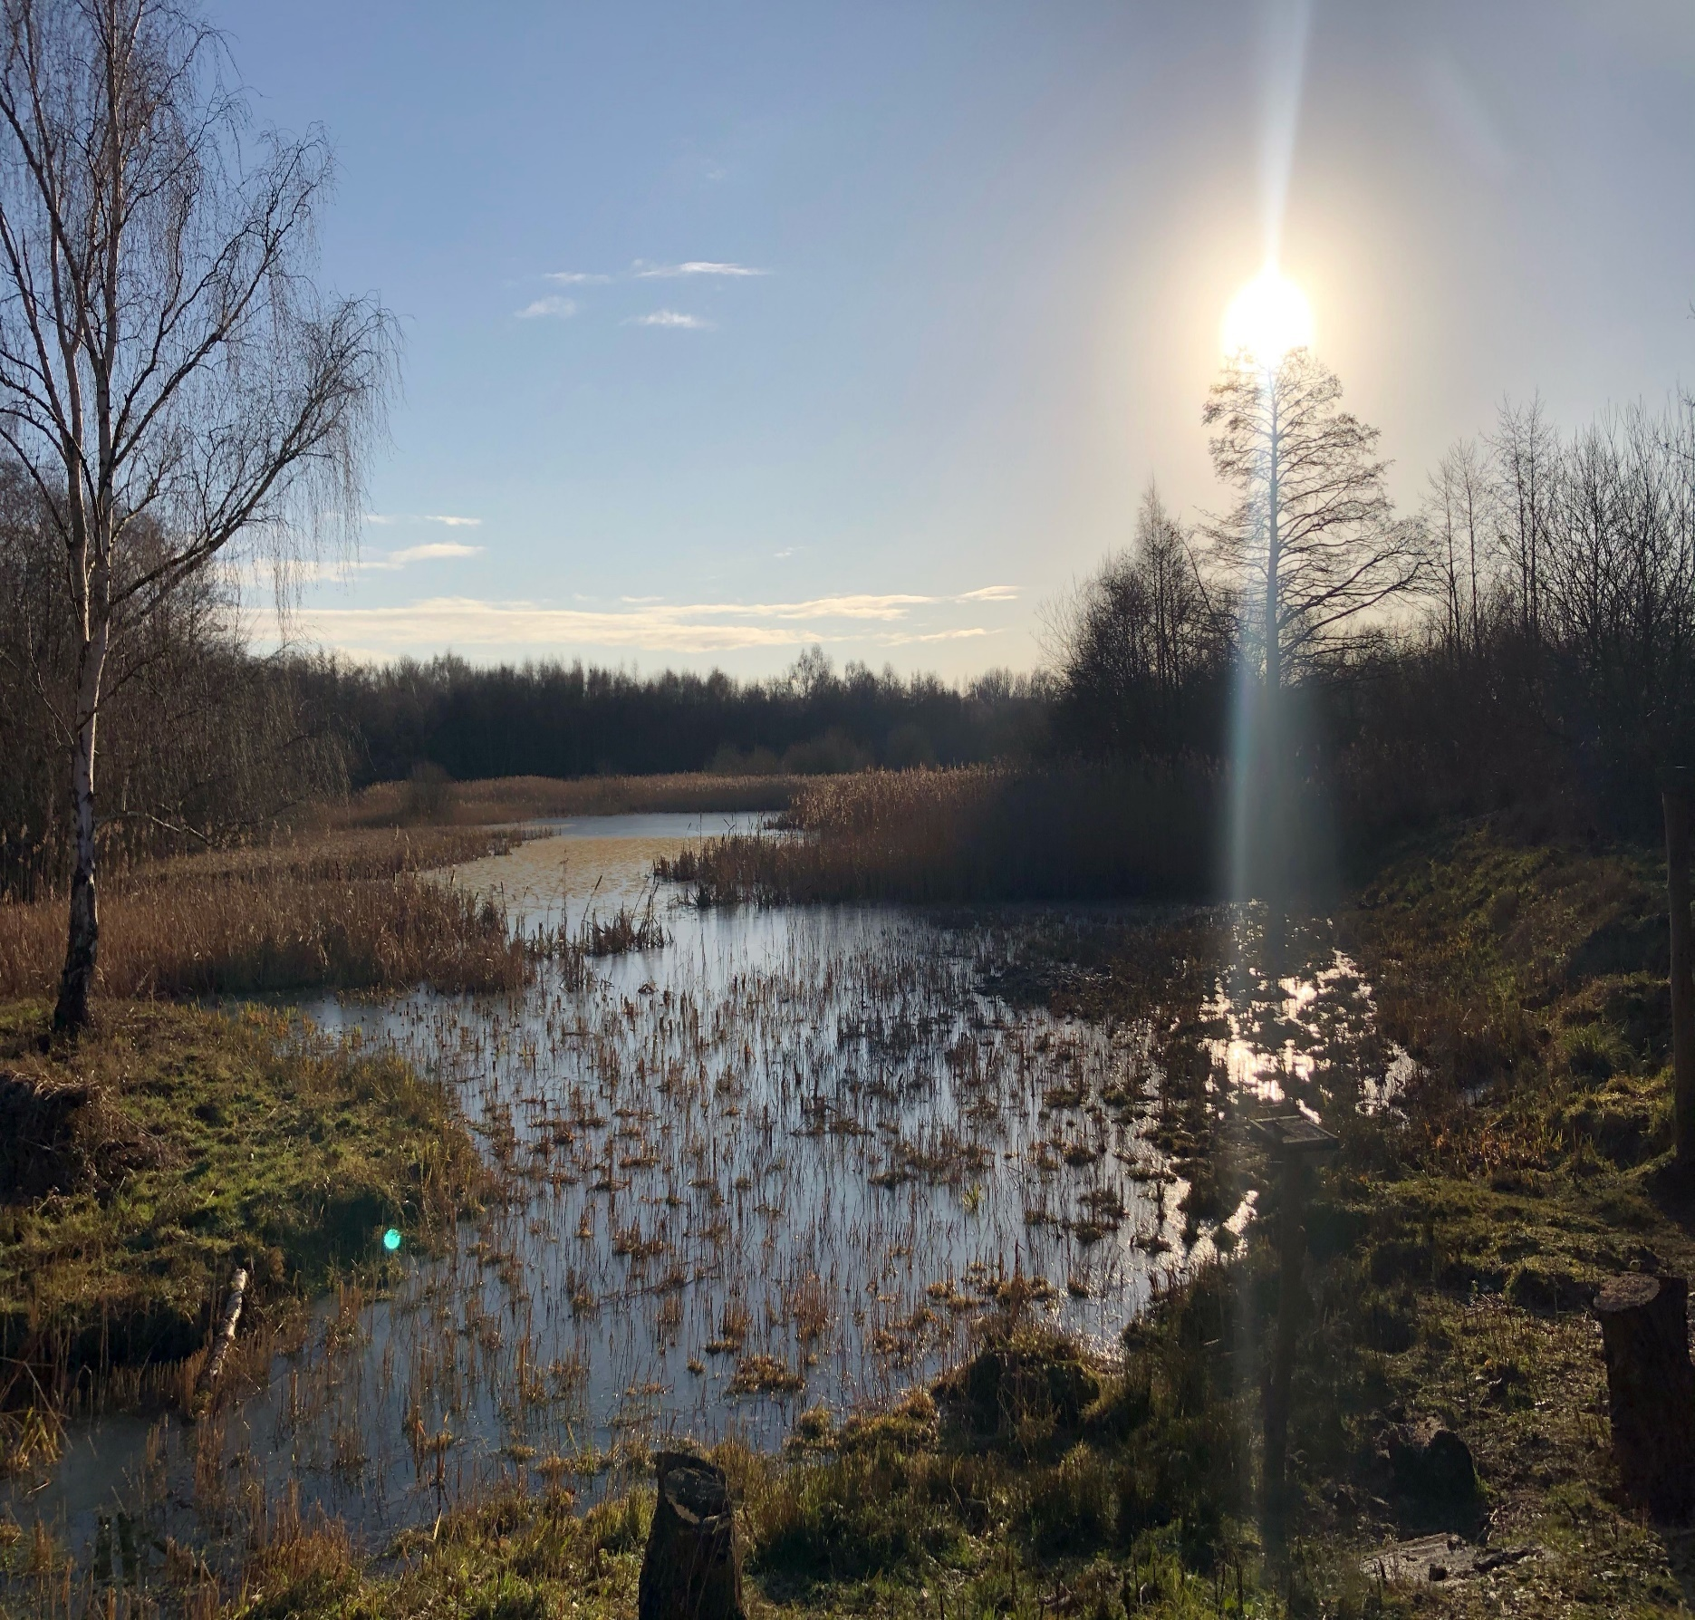
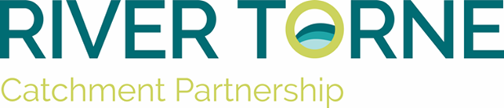
PROGRESSING OUR PROJECTS

2022-2023 rIVER TORNE CATCHMENT
bRYONY CARLING
Table of Contents
Introduction 3
How to use the project pages 4
How to use the summary table 5
Summary Table 8
Completed projects 11
Papermill dyke case study 2015/2016 11
Sandall beat wood case study 2015/2016 12
Iwait case study 2016/2017 14
SuDS in schools – PG/1718/WEIF/EMD/0005 17
Papermill Dyke (WEIF) - PG/1718/WEIF/EMD/0006 19
Floodplain Reconnection PG/2021/WEIF/EMD/009 22
Funded projects 24
Torne Feasibility Study (WEG) 24
Let’s be Fens! 24
Appendices 26
About this document 26
How to add a project and put forward project ideas 27
Blank project template guide 29

Introduction

Starting near Sandbeck Hall in Maltby, South Yorkshire and reaching its confluence with the river Trent in Keadby, North Lincolnshire. Today, the River Torne sub-Catchment covers a total of 520km2 and is vital collection of water bodies that provide drainage and flood protection for industry, agriculture, homes, and businesses across parts of South Yorkshire and North Lincolnshire. This functionality is central to our vision for the catchment; serving as a mechanism to engage with this diverse range of stakeholders to provide education and raise awareness about the importance of effective water and water body management.
Initial stakeholder workshops quickly identified a series of target projects that the partnership could pursue, and an action plan created. This document has been developed with the intention that it be used to progress aspirational projects and coordinate the next steps within the partnership.
It should be viewed as a means for the partnership and partners within the partnership to share what they want to deliver, what they are delivering, and what has been delivered.
By doing this we can truly embrace the catchment-based approach and work holistically together to maximise our resources and maximise our returns.
This is a living document, with lead partners expected to update their ‘project pages’ quarterly for the benefit of catchment partnership and catchment steering group meetings. In doing so the document can be kept up to date as a current record of the work of the catchment.
Below is a map representing the aspirational projects for the Catchment. It highlights the water bodies overall WFD status in Red (bad), Blue (poor) and green (moderate). The location of proposed aspiration projects and their main rational are plotted as points to show the spread of projects across the catchment.

What is the Catchment Based Approach?
A shift in thinking led the UK government to realise that looking at smaller water catchment areas rather than large river basins was a positive step in achieving improvements to water bodies and their associated environment, and towards achieving the targets of the Water Framework Directive (WFD). This led to the introduction of the ‘catchment based approach’ by DEFRA (Department for Environment Farming and Rural Affairs) to enable local stakeholder groups to promote the protection and improvement of the water environment.

How to use the project pages

This document together with the Torne Catchment vision document forms an ‘Integrated Catchment Plan’ for delivering success in the Torne Catchment.

The general principles that guide the delivery of this document are given in Appendix 1.

This will allow the progress of a project to be tracked from initiation through to completion. It also allows a projects relative benefits and contribution to the partnership aims be compared against cost and ease of delivery. This allows an efficient comparison of aspirational projects and a way to prioritise potential project against available funding streams.

The initial list of projects in the 2015/16 edition of this document are derived from the current ‘action plan’ document agreed by stakeholders of the Torne Catchment Partnership.

Some of these project ideas have been improved upon by the delivery of two reports commissioned in 2014 by the catchment partnership. These reports co-delivered variously by the Yorkshire wildlife trust and by Ecus environmental solutions on behalf of the Torne Catchment Partnership are available at http://www.catchmentbasedapproach.org/humber/torne

Any project impacting the water environment may be included but the Torne Catchment Partnership will prioritise their collective efforts towards projects that deliver Water Framework Directive benefits and help the partnership deliver its vision http://www.catchmentbasedapproach.org/humber/torne

All projects should be assigned an owner. The owner should progress the project where possible and report back to the wider area using the second page of the ‘project pages’. If there is no owner, a project will not be advanced until there is an owner.

Progress will be reviewed on all owned projects at a timely interval in a group setting (i.e. a Catchment Partnership meeting). The point of this is to find synergies and avoid duplication of effort.

Where possible all partners should try to provide help and advice to aid the progress of projects.

Projects can be delivered by the Torne Catchment Partnership (or by officers and organisations on behalf of the partnership), or by partners in isolation.

All projects should acknowledge the support of the Torne Catchment Partnership when reporting success.

How to use the summary table

The summary table below show the multiple benefits for each project against recognised funding themes and the aims of the Torne Catchment partnership. It allows projects to be identified and compared by the funding criteria they meet and their contribution to the partnership aims.
The list is presented in order of priority. This is because different funding streams will have different funding priorities and look for different rationales behind projects. Where funding becomes available the summary table gives a starting point for the user to draw up a short list of projects that meet the funding criteria and further enable the user to prioritise projects in that short list by their contribution to the partnership aims and there multiple benefits. More ticks indicate the main rational behind a project not a greater benefit. Further information on the detail of the individual projects is available on the project pages.
Where a strategic approach is being employed (for example, to target delivery over a prolonged period to realise the best value for money WFD improvements) the document should be used in conjunction with the Torne Catchment Vision document.
The first part of the table lists the project number, the project name, and a location. The next five columns indicate five likely funding themes; urban; rural; ecology; hydromorphology; and engagement. The table 1 expands on what this means.

Table 1  Funding Themes  (as shown on project pages) | Expanded Definition | Examples of what delivery may look like
Urban | Tackles urban diffuse pollution | Working with the business’ on mother drain to deliver better management of ditches  Intercepting road run-off and remediating it before it enters a watercourse
Rural | Tackles Rural diffuse pollution | Improved (size and quality) buffer strips alongside watercourses, more efficient use of fertilisers (so that excess doesn’t end up in the watercourse), rural suds schemes to intercept field drains; fencing or cattle drinking points to reduce poaching and access to watercourses
Ecology | Improves available habitats | wet woodland creation, wetland creation
Hydromorphology | Improves river function | Weir removal, installation of large woody debris, installation of flow deflectors, other river restoration
Engagement | Engages communities with their watercourse | Developing interpretation with a local school, community science project, volunteer delivery of on the ground physical works, litter picks

The next column indicates how a project delivers against the aims of the Torne Catchment Partnership. These four aims are centered on, stakeholder engagement, connecting small groups, positive management of sites. The full explanation of their meaning is given in the vision document but table 2 below gives a brief summary.

Table 2
Partnership Aims
Stakeholder engagement |  | A vital part of gaining support for catchment based initiatives. It enables us to Identify, engage and educate key audiences through the stakeholders as well as integrate catchment initiatives into strategic programmes.
Connecting small Groups |  | Allows small specific interest groups to bring their ideas and issues to the people who can help to make it happen. It also builds capacity in the catchment where small groups are able to help deliver catchment aims and messages.
Positive management of Sites |  | To improve their condition allows us to make the best use of existing assets in the catchment like local wildlife sites and SSSI’s to improve how they deliver WFD and other multiple benefits on the Catchment.
Positively influence development |  | An important means of protecting existing assets in the catchment as well as incorporating catchment messages in future developments.
Creating habitat |  | It is important to identify opportunities for creating habitat on the catchment which can help deliver the vision for the catchment whilst delivering WFD and multiple benefits
Data and monitoring |  | Allows us to justify the multiple benefits that could be delivered by aspirational projects on the catchment. It can also provide evidence of the success of existing projects and the impact of the catchment partnership.

Summary Table

Project # | Project Name | Urban | Rural | Ecology | Hydro-  morphology | Engagement | Catchment Partnership  Aims | Cost | Phase of delivery
1 | Reducing Rural Diffuse Pollution on Papermill Dyke: Stainton Wood, Limekiln Lane, Water Lane. |  | ✓✓✓ | ✓✓ | ✓ |  |  | 12.5k | Completed
2 | Re-wetting Sandall Beat and Cantley Park phase 1 | ✓✓✓ |  | ✓✓ | ✓ | ✓✓ |  | 15.5k | Completed
3 | Iwait project | ✓✓ | ✓ | ✓✓✓ |  | ✓✓ |  | 96k | Completed
4 | SUDs in schools phase 2 | ✓✓ |  |  |  | ✓✓✓ |  | 75k | Completed
5 | Tickhill and papermill dyke habitat improvements |  | ✓✓✓ |  |  |  |  | 7.5k | Completed
6 | Reducing Rural Diffuse Pollution on Papermill Dyke: Limestone farm and Tickhill friary | ✓ | ✓✓✓ | ✓✓ |  | ✓ |  | 7.5k | Completed
7 | Tickhill Mill damn | ✓✓ |  | ✓✓✓ |  | ✓✓ |  | ? | Completed
8 | Water environment grant funded Feasibility Studies | ✓ | ✓✓ | ✓✓✓ | ✓✓ | ✓ |  | 110K | Funded Ongoing
9 | Mother Drain: business’ engagement and habitat creation. | ✓✓ |  | ✓ |  | ✓✓✓ |  | 15K | Completed
10 | Papermill Dyke NFM project | ✓✓✓ | ✓✓ | ✓✓✓ |  | ✓✓ |  | 50K | Completed
11 | Maltby Water advice for schools and Homes project | ✓✓✓ |  |  |  | ✓✓✓ |  |  | Completed
12 | Keadby Pumping station opportunities |  |  | ✓✓ | ✓✓✓ | ✓✓ |  |  | Completed
13 | Maltby Colliery Restoration | ✓✓ |  | ✓✓✓ | ✓ | ✓✓ |  |  | Completed
14 | Muddies SUDS | ✓✓ |  | ✓✓ | ✓✓✓ |  |  |  | Aspirational
15 | Carr Doles |  | ✓✓ | ✓✓✓ |  |  |  |  | Aspirational
16 | Idle and Torne NFM | ✓ | ✓✓ | ✓ | ✓✓ |  |  |  | Aspirational
17 | Kilham Farm Restoration |  | ✓✓ | ✓✓ | ✓✓✓ |  |  |  | Aspirational
18 | Maltby low common wetland creation | ✓✓✓ | ✓✓ | ✓✓ | ✓ |  |  | ? | Aspirational
19 | TAFTA Torne Catchment |  | ✓✓✓ | ✓ | ✓ | ✓ |  |  | Aspirational
20 | Iport Wetlands water level control feasibility |  | ✓ | ✓✓✓ | ✓ |  |  |  | Aspirational
21 | Golf Course land fen creation and river restoration project – ‘Lets be Fens!’ |  | ✓ | ✓✓ | ✓✓ | ✓✓ |  |  | Funded Ongoing

Completed projects

Papermill dyke case study 2015/2016
Project CPAF2901HP – Reducing diffuse pollution in Papermill dyke
Who: Yorkshire Wildlife Trust When: 2015/2016 Cost: £12500
Quote: “I was impressed by the level of support from farmers locally giving up some of their own time and effort to contribute to the works improving the condition of the stream.” – Jamie McEwan Yorkshire Wildlife Trust
Where: Stainton, Doncaster NGR: SK 59154 92329, SK 55866 93631
What: This project aimed to address rural diffuse pollution within the papermill dyke. Priority sites were identified by the Sandbeck Estate Scoping report and a dedicated project officer worked with the sand beck estate and tenant farmers to deliver a suite of works aimed at improving water quality at target sites. The project worked with farmers to help improve their farming practices as well as delivering small scale habitat creation interventions on their land. Other works included the installation of fencing to protect the bank from degradation by livestock and allow more sensitive management of habitats. The Project Officer will work with the farmers to deliver a suite of these actions across the sites.
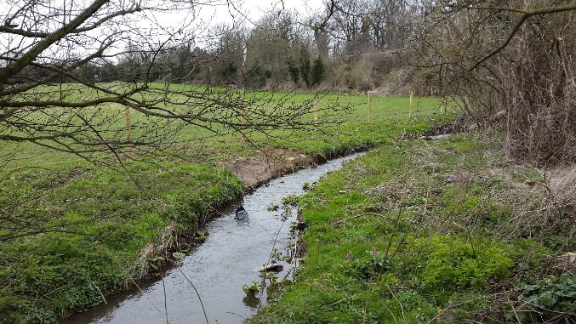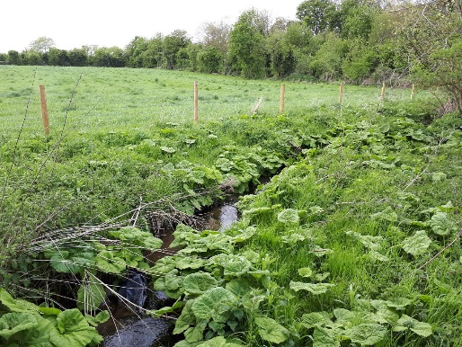
Wider context: The Sandbeck Estate farms and others sit in the waterbody catchment of Ruddle Dyke from source to River Torne, and the overall WFD status is bad in 2014 cycle 2. The reasons for not achieving good Include failings in chemical and ecological status elements including ammonia and invertebrates

Objectives:
- To carry out priority work as identified in the sandbeck estate scoping report
- To engage with 1 farmer to agree habitat enhancements and improve agricultural practices on their land
- Deliver 400m of river habitat restoration
- Install a total of 100m length of fencing to reduce bank degradation by livestock

Outputs:
- Worked with Sandbeck estate and 2 tenant farmers
- Carried out 400m of river habitat restoration
- 0.16ha of wet woodland created – 60 trees planted
- 580m of fencing installed
- 1 limestone spring flush restored
- 0.75ha of floodplain fen restored
- 150m of hedge installed

Benefits:
- Improved farming practices
- Improved community interest
- Reduced livestock poaching, sediment and chemical inputs
- Habitat improvements for wildlife

Tips and lessons learned: We made good use of expertise within the organisation in other regions and river projects to implement innovative ideas from other projects.

Sandall beat wood case study 2015/2016
Project CPAF2901HP – Rewetting Sandall Beat Wood
Who: Yorkshire Wildlife Trust When: 2015/2016 Cost: £15500 + £4000 from Wren BAF partner project
Quote: “So nice to see Sandall beat wood looking like it used to all those years ago, brings back great memories for so many locals and a big thank you to all the volunteers. Now it’s the public’s turn to keep the woods clean and report people who litter and damage this lovely nature reserve.” – Adrian Barker (Woodland user)
Where: Intake, Doncaster NGR: SE 61489 03261
What: A report commissioned by Doncaster Metropolitan Borough Council in 2013 analysed water levels in the drains of Sandall Beat and Cantley Park. With the exception of the two main drainage channels, Mains Drain and Fore’s Drain, the report stated that none of the drains were found to have any water present at any time. This has an impact on the sites SSSI status. Water quality issues were also noted, with road and roof drainage discharged at the pumping station at the head of Fore’s Drain likely to be the cause. The report indicated that cross connection of domestic waste water into roof gulleys could account for some of the water quality issues. The Yorkshire Wildlife Trust subsequently co-funded a report in 2014/15 to identify potential measures that could be taken to address these issues at the site.
This project as a result of these reports aimed to address urban diffuse pollution at Sandall Beat and Cantley Park by improving water flow and creating new wetland habitat to the benefit of water quality in Fores drain. The project also aimed to engage local communities, highlighting urban diffuse pollution issues and solutions, through a volunteer survey programme and an interpretation project delivered by local schools.
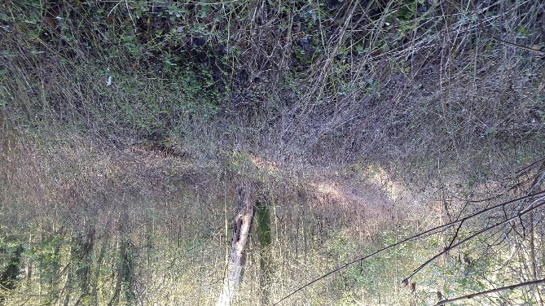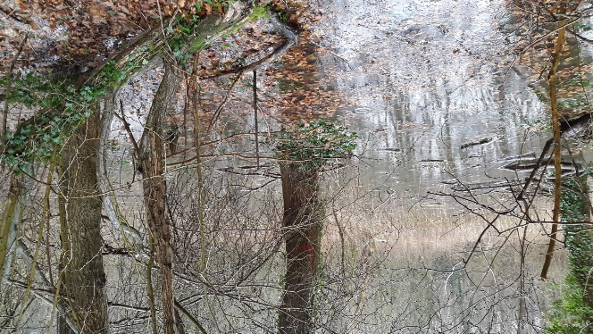

Wider context: Sandall Beat and Cantley Park are located to the east of Doncaster, within the water body catchment of Hatfield Waste Drain (GB104028064330). Despite its urban setting Sandall Beat is designated as a SSSI. The overall WFD status of Hatfield Waste Drain at Cycle 2 is moderate. Whilst the Chemical Status is good overall, the Ecological Status is moderate, due to the impacts of physico-chemical quality issues and biological quality elements. Phosphate levels and dissolved oxygen levels are classified as poor, whilst ammonia levels and fish assessments are moderate. Urban diffuse pollution and poor water flow conditions are largely responsible for the WFD classification.
Objectives:
- Deliver 1ha of wetland habitat with macrophyte planting at Sandall Beat and Cantley Park
- Deliver 150m river habitat restoration, including de-silting of ditches and installation of coir rolls with marginal planting, at Sandall Beat and Cantley Park
- Deliver in channel improvements on Fores drain
- Engage and train at least 10 volunteers
- Engage at least one class from 1 school to produce an interpretation project

Outputs:
- Restoration of 2 hectares of SSSI wet woodland
- 150m of stream habitat improvements on Fores drain
- 110m of pre-planted coir rolls
- 22 volunteers were engaged
- Totalling 201 hours of volunteering time
- The project engaged with 71 schools children from 3 classes

Benefits:
- This has enthused local members of the public in an urban SSSI, encouraged volunteering and a sense of ownership in the woodland at Sandall beat
- Improved water quality
- Creation of ~718m³ of flood storage
- 2 ha of SSSI habitat improved

Tips and lessons learned: The project has been a fantastic example of delivering a project in partnership. Aligning our objectives with Doncaster Metropolitan Borough Council and other Yorkshire Wildlife Trust ‘Living Landscapes’ projects means the project has been able to draw significant additional resource and benefits. Additionally delivering a project in a busy community area has been a fantastic way of engaging the community in the project and the catchment. We have delivered a project that has restored a valued place back to the way many people remember it and it has encouraged a fantastic amount of support whilst delivering the catchment message and engaging people in the Torne catchment.

Iwait case study 2016/2017
Who: Torne Catchment Partnership / East Midlands Environment Program Team
When: 2016/17
What: Partnership project with multiple outcomes including restoration of 46.5ha of wet woodland, natural flood risk benefits, education and community engagement.
Quote: ‘That’s the first time in over forty years that piece of woodland has had any water in it.’ (Local resident referring to Sandall Beat SSSI)
Where (site, catchment, river basin): Sites include Sandall Beat SSSI; Holme Carr Wood; Bog Wood; Tickhill Low Common; Bessacarr Bank; Piper Marsh SSSI; and Rossington Brick Pond. All sites are within the Torne Catchment in the Trent River Basin.
NGR: Various
Wider context: The iWAIT project builds on work delivered in 2015/16 when the Torne Catchment Partnership worked to reconnect up to 2000m3 of floodplain storage at Sandall Beat SSSI in Doncaster. The project also delivered multiple benefits including restoration of 2ha of wet woodland, water quality improvements, engagement with local communities and volunteer groups, education around water issues with schoolchildren. By working with Yorkshire Wildlife Trust (YWT), Doncaster Metropolitan Borough Council (DMBC), Natural England (NE) and the local community the project was able to deliver excellent outcomes and value for money. For 2016/17 the partnership identified further potential works at Sandall Beat and six other woodland sites within the catchment that could be delivered to realise multiple benefits.Funding has been secured through; Local Levy from Trent RFCC; WFD GiA from the Environment Agency; and from YWT sources. In addition all partners have supported the project with further time-in-kind contributions.The River Torne is heavily modified and large areas of the catchment are near to, or below, sea level. Water levels in the catchment are managed intensively for flood risk and land management. The terminus of this system is Keadby Pumping Station, which pumps water from the Torne system into the River Trent.By targeting natural flood risk management techniques and providing additional flood storage in the upstream part of the catchment we will be able to help attenuate both peak and flood flows from rainfall events.This provides dual benefits, firstly that flood risk to property and agricultural land within the catchment is reduced by making more space for water. Secondly, it will reduce both the financial and carbon cost of pumping water from the Torne catchment into the River Trent.Using desk top analysis (including reviewing LIDAR data), the project objective is to deliver a minimum of 46.5ha of wet woodland recreation or restoration that delivers over 4,000m3 of additional flood storage capacity.
Other benefits: Alongside this work funding is being used to engage with seven schools. Each of the schools will be linked to a woodland site. Each school will have a series of lessons and other activities delivered by a dedicated educational project officer. Sessions will cover a variety of water related themes including flood risk, water quality, water availability and biodiversity. At three schools a Suds feature is being retro-fitted within the school grounds. This will provide an additional means of engaging with the schoolchildren, and will also further help support efforts to slow the flow in the catchment. Each of the woodland sites is also being linked to a local community group. As well as providing health and wellbeing benefits to what, in some cases, are deprived and disconnected communities this also helps to ensure legacy and sustainability benefits. Local groups of volunteers have helped to deliver some of the lower risk capital works. This investment of their time has helped to secure a greater sense of local ownership of the sites. Support has also been given to the local groups in developing site management plans, thereby ensuring that the projects gains are secured in to the long term. By using these methods, the project will create, restore or improve a minimum 46.5ha of wet woodland which is a priority habitat; deliver in class improvements in WFD status classification; contribute to SSSI remediation; and provide support for priority species such as the Willow Tit (Poecile montanus subsp kleinschmidti).
Outputs:
- Priority habitat created = 46.5ha
- Flood storage volume realised = 4,078m3
- Schools engaged with = 7
- Number of pupils engaged with project = 600
- Suds schemes retrofitted = 3
- Community groups supported = 5
- Volunteer hours realised = 1200
- NFM Regional Conference delivered
- SSSI’s improved = 2
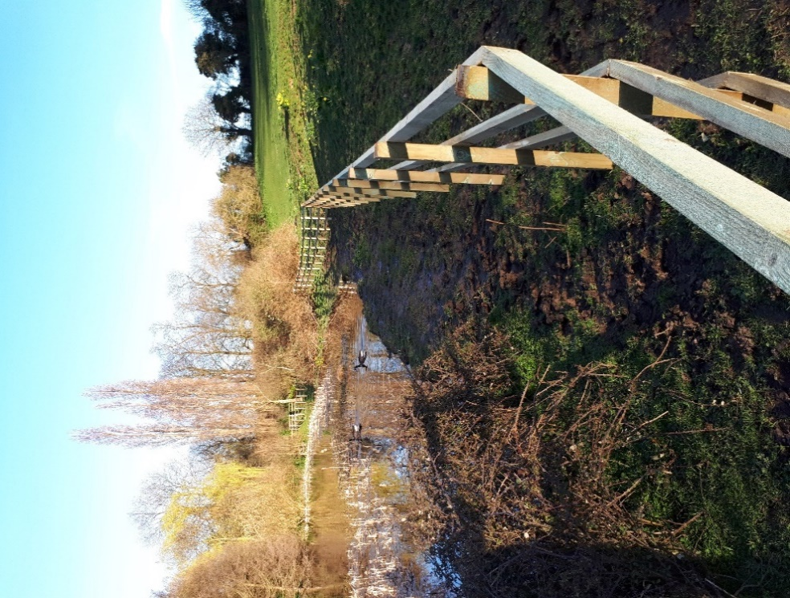
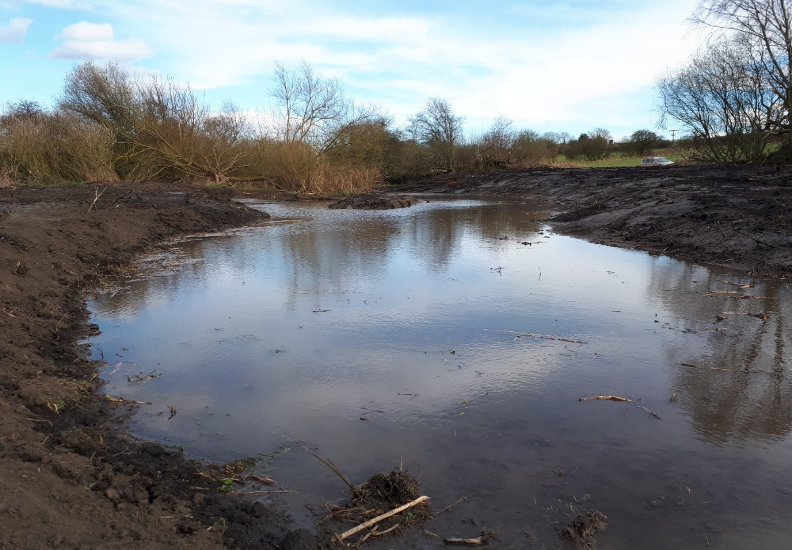
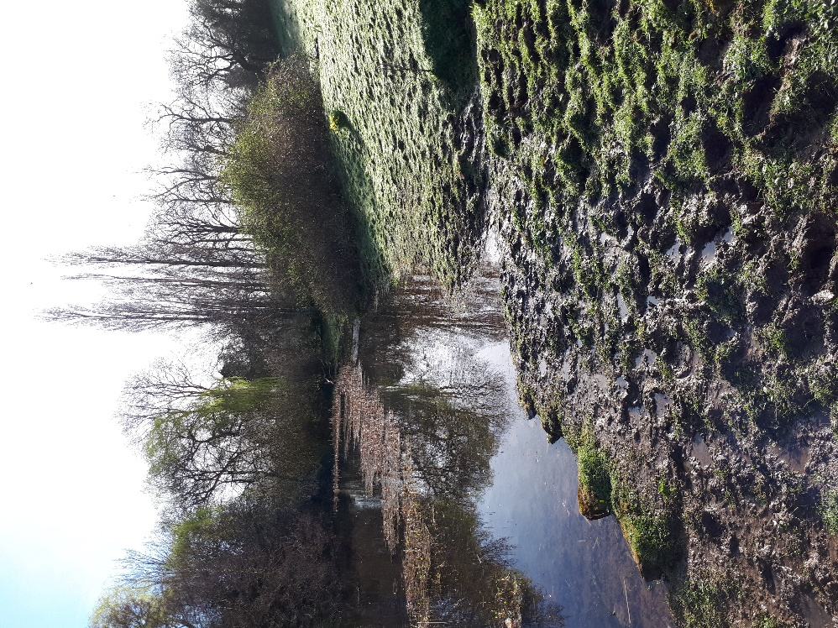
Reducing Rural Diffuse Pollution on Papermill Dyke: Limstone farm and Tickhill friary

SuDS in schools – PG/1718/WEIF/EMD/0005
When: 2017/18/19
What: A large scale engagement project within the Torne Catchment educating and engaging the primary and secondary schools around the Torne’s heritage and the water environment. The project aimed to retro-fit 6 SUDS schemes to further engage school children whilst providing a green learning environment and flood and water quality benefits.
Outcomes:
- Build on previous engagement within the Torne catchment around the local water environment.
- Deliver SuDS on a larger scale to schools within the catchment
- Improve water quality and flood resilience within the catchment
- Increase awareness of the heritage of the Torne, past and present

Quote: “Last we went pond dipping and back to the education centre, it was a lot of fun.” Blake – Wroot travis primary school.

Where (site, catchment, river basin): Sites included Potteric Carr nature reserve, Grange lane, Tornedale infants, Wroot travis, Hungerhill, St Marys primary Tickhill, Maltby Redwood Academy. All within the River Torne Catchment.
NGR: Various
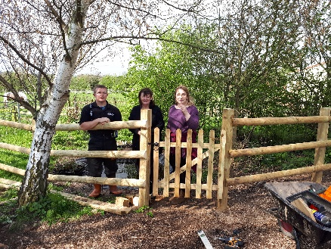

Wider context: This project addresses a need for a better overall understanding of the river and how it has changed. The River Torne has been modified over time in order to serve the communities that live in the catchment and that has had a significant impact on local wildlife and water quality. The River Torne catchment partnership has worked towards revitalising this river for the last three years and delivered a number of projects with the communities in the catchment. Despite the Torne Catchment protecting over 20000 properties from flooding overwhelmingly whilst working within the community we recognised that this important water course passes through the landscape relatively unnoticed. In the design of this project we have attended seven local events with a survey to better understand the community’s relationship with the river. Despite all of these events being held no more than 2km from the river 63% of survey respondents had not heard of the River Torne before we had spoken to them. With the water quality and wildlife on the river suffering from these alterations it’s increasingly important that the communities living on the Torne better understand the changes that have happened for their benefit, the negative impacts these changes have had on the natural heritage of the Torne and how we can restore some of these natural process to create habitat and improve our rivers.

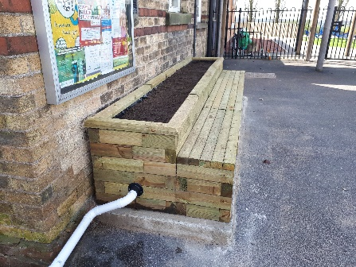
SuDS: 6 SUDS schemes were implemented in the catchment with 12 individual interventions. These were a mix of interventions designed to create and sustain better places for people and wildlife whilst controlling the flow of run off and the quality of the water leaving the site. Interventions included formal raised planters. Sunken rain gardens, water butts, woodland planting and ponds as well as the creation of 0.2 ha of woodland created in Tornedale infant school.
Education: A total of 44 sessions on the River Torne and water environment were delivered with 1537 school children engaged in the water cycle, their local river and the wildlife reliant on it.
Community events and volunteering: 225 adults were also engaged through community talks and presentations to groups such as Tickhill horticultural society, Doncaster Naturalists and Doncaster Rotary club.
The project also received contributions of 856 volunteer hours from family and friends of the schools involved as well as young people from National citizen service and the Wildlife trusts tomorrow natural leaders project. A project trainee also made a significant contribution to the project in terms of volunteer hours and engagement with local communities.
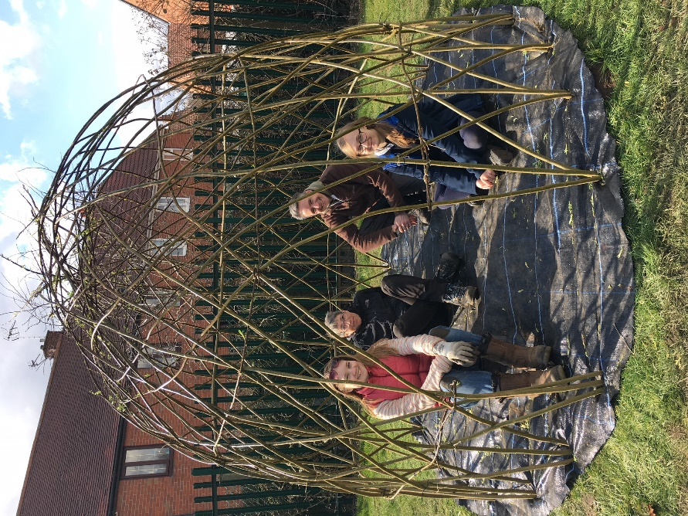

Summary: Overall an excellent engagement project with some great examples of retrofitting SuDS interventions in schools and the potential to connect people with their local water course. Building on the success of this project and the learning from this year a pilot Yorkshire Wide SuDS in schools project with Yorkshire water ‘Soak it up’ has been rolled out this year. https://www.yorkshirewater.com/soakitup

Papermill Dyke (WEIF) - PG/1718/WEIF/EMD/0006
When: 2017/18
What: The project aimed to restore 2 hectares of wet woodland to flow from the surrounding drainage and create an offline wetland scrape capable of storing river water during high flow and creating a significant area of wetland habitat in the process.
Quote: “You have done a great job with Snipe Bog - it should develop into an excellent habitat. I do hope you can manage something like it near the A1 (M).” Tony Sheridan – Tickhill countryside group.
Where (site, catchment, river basin): Papermill Dyke GB104028058370
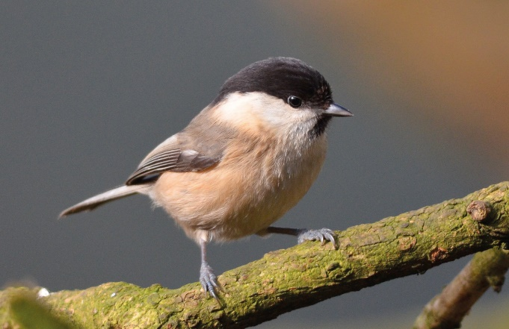
Wider context: The Sandbeck Estate owns a large amount of land within the Papermill Dyke catchment boundary of the River Torne, which is predominantly tenanted farming. There is evidence from multiple sources that rural diffuse pollution from these farms and others in the area is entering the River Torne and its tributaries. As a result the Torne Catchment Partnership commissioned a scoping report and has focused on the most negatively affected waterbody in this location, Ruddle (Papermill) Dyke from source to River Torne. This catchment includes the Sandbeck Estate farms as well as neighbouring tenanted farms.
The objective of this scoping report was to identify suitable locations for future work that will minimise the impact on riverine ecology by diffuse pollution. A report made recommendations for improved farming practices along with small scale habitat creation interventions which have been delivered in this catchment with the Sandbeck estate and local land owners over the last 2 years through the Catchment partnership.
This project was identified by a Tickhill community group and delivered under the Torne catchment partnership plan to connect small groups and the aim to deliver a project put forward by a small group through the catchment partnership to improve the River Torne’s water environment. Connecting small groups allows small specific interest groups to bring their ideas and issues to the people who can help to make it happen. It also builds capacity in the catchment where small groups are able to help deliver catchment aims and messages. This project was designed in partnership with the Tickhill countryside group who have an extensive knowledge of Papermill dyke (one of the Torne’s priority water bodies). The project also contributes to a larger natural flood risk measures project in this catchment which aims to lessen the risk of flooding in Tick

2 ha of wet woodland: 2 hectares of wet woodland was reconnected with flow from the stream. Work also included some coppicing of old willow stands to add to the age structure of the woodland and the creation of standing deadwood to benefit the rapidly declining willow tit recorded at adjacent sites. Monitoring of the long term benefits of willow tit habitat creation will be completed through the NFM project carried out on Papermill Dyke and by the volunteers trained through local landscape monitoring volunteers in the humberhead levels.
Volunteering: Only 83 volunteer hours were realised through the project through two volunteer tasks days. This was lower than the 200 originally planned due to lack of attendance locally. Work was suggested and carried out in consultation with the Tickhill countryside group who were closely involved in the project however they have less -capacity for practical tasks.
Offline wetland scrape: In addition a 0.6ha offline scrape was created, designed to take flow from the river during heavy rainfall events and create a significant wetland habitat in the area.
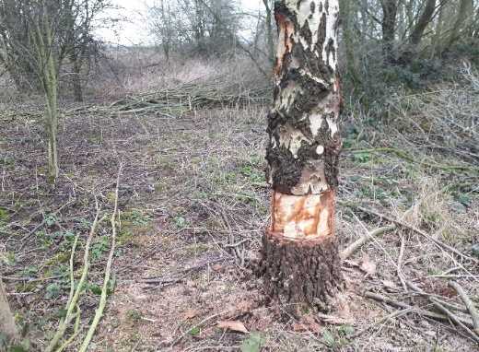
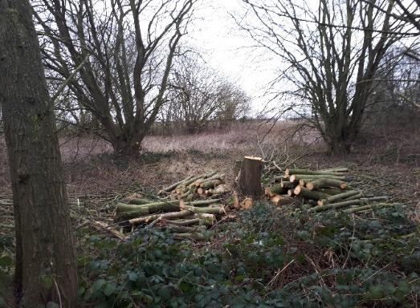

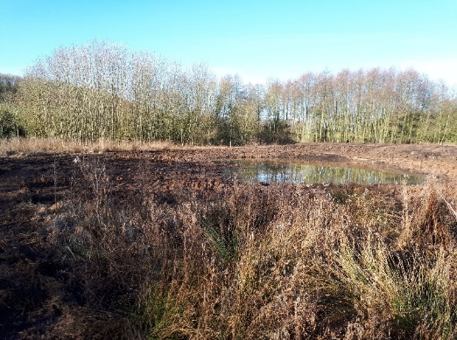
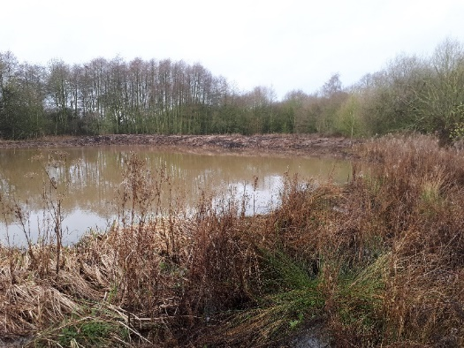

Floodplain Reconnection PG/2021/WEIF/EMD/009

When: 2020/2021
What: A floodplain reconnection on a piece of DMBC owned land from the Mother drain.
Where (site, catchment, river basin): Motherdrain at Rossington/Bessacarr, SK6151399299
Wider context:
Capital - restore 5 hectares of fen and wetland habitat through the creation of shallow scrapes and the installation of a culvert to improve connectivity and whole water body (element) status by March 2021.

By installing a culvert water can enter the floodplain from the Motherdrain during high flows, mimicking the natural processes that would have allowed the floodplain to wet before the bank was raised. The floodplain has a large water capacity, allowing extra storage and cleansing during large flood events. There are two existing culverts on site shown with Yellow arrows. A 30cm dual walled 10m long culvert was implemented on site at 80cm depth (see diagram below). Culverts will allow us to control the amount of water entering the flood plain. A lockable penstock will allow control over the abstraction from the Motherdrain onto the floodplain.
Outputs:
- Scrapes and pools were created making space for wildlife and the implementation of a culvert from the Motherdrain to the floodplain will allow a more natural hydrology and connectivity in the floodplain. This will allow wet grassland fen vegetation to recover and have additional water quality benefits through the interaction with the floodplain and marginal vegetation.
- The restoration of the wetlands within the floodplain will provide the opportunity during flood conditions for water quality improvements. An established wetland will help to treat flows, removing phosphates, ammonia, and deposition on heavy metals present in the Motherdrain. The cleansed flows will re-enter the Motherdrain via an outflow.
- The wetland will provide up to 2.5 million litres of additional flood water storage within the catchment (based on an average depth of 10cm over half of the site). This will reduce pressure on Auckley Pumping station and reduce risk downstream, including to The Warren golf course.
- The site is on valley peat, therefore we expect a degree of groundwater re-charge through the washing over land and temporary storage process, although it is not possible to quantify this now. Groundwater monitoring equipment will be installed on the site to gather data on the water table depth and hydrologic continuity.

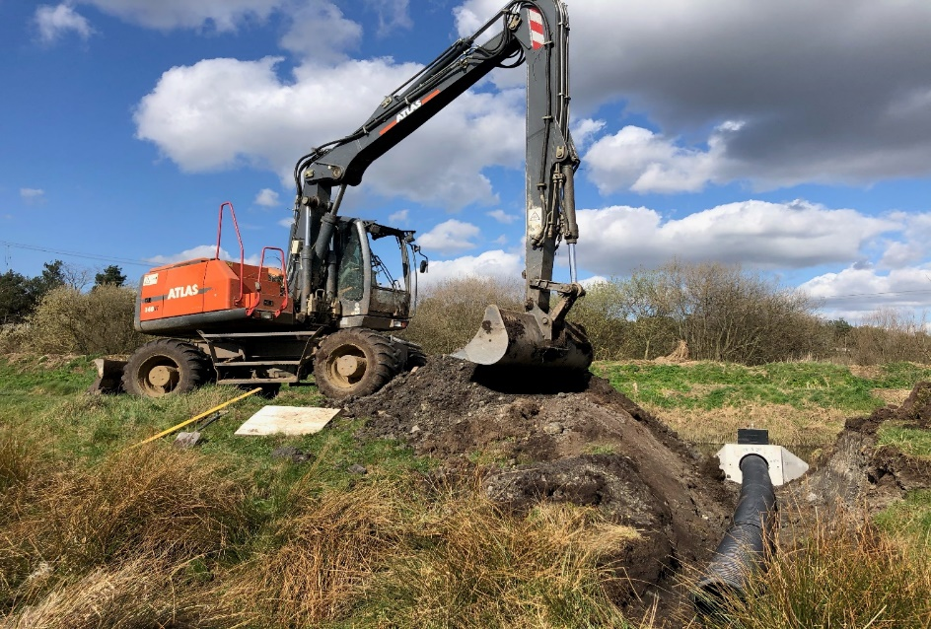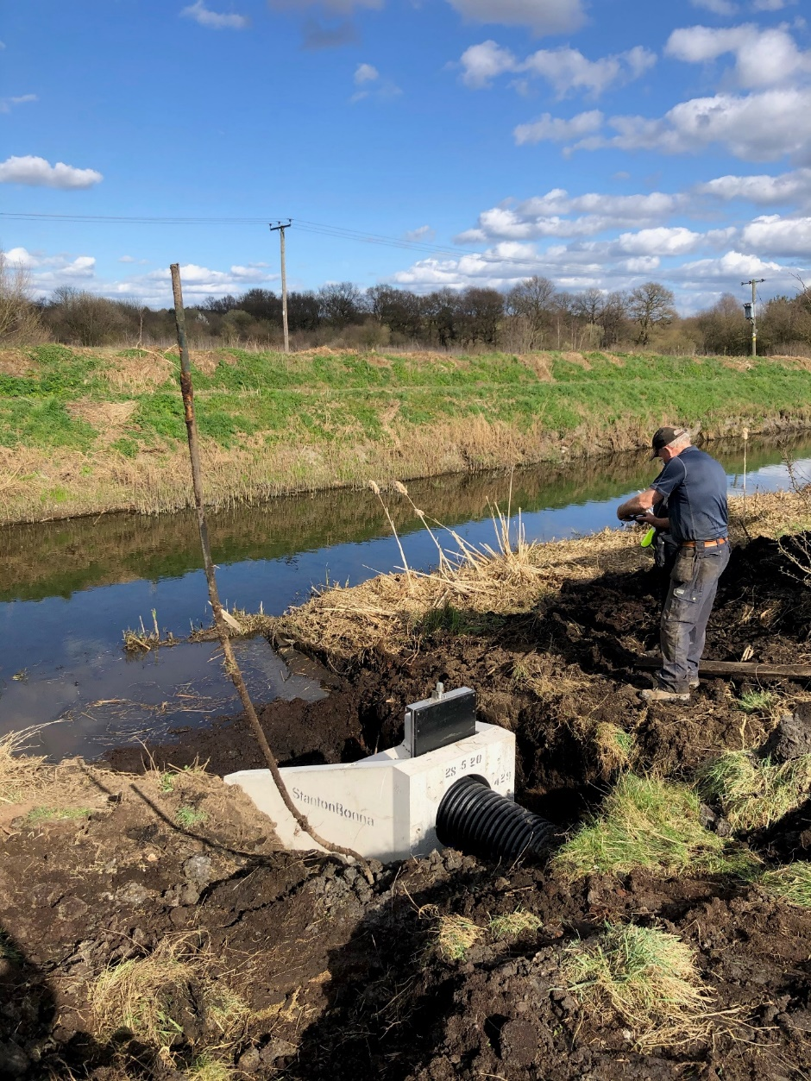

Funded projects
The projects listed below are projects that are currently in progress.

Torne Feasibility Study (WEG)
YWT have commissioned environmental specialist group CBEC to undertake a desk top study report which will select areas/sections of the Torne that have potential to, though not restricted to, reduce flood risk to neighboring land and properties, improve water quality, restore functionality to the river, enhance wildlife potential within the river and on adjacent land. Options put forward at this stage will be discussed by all interested parties, an agreement by partners will be required before further development of any options is pursued. If the study finds any options to be viable and has agreement of partners, we require further survey of the sites and options for up to four proposed sites.

Let’s be Fens!
The ‘Let’s be Fens’ project is a partnership between Yorkshire Wildlife Trust (YWT) - lead partner, the Environment Agency and Doncaster Metropolitan Borough Council. The partnership aims to deliver multiple river restoration works and create or restore wetland habitats next to the River Torne and Mother Drain over the next 3 years.
Over the next 3 years, YWT will deliver a targeted program of habitat restoration work, focusing on diversifying river habitats and restoring wetlands. The project aims to improve water quality for the river Torne and Mother Drain; create areas of wetland habitat with flood storage capacity, which will provide habitat for numerous wetland species; decrease river uniformity and provide diverse instream habitats. It will; restore unused poor grassland to wetland/fen and create habitat on a landscape scale approach that provides habitat corridors and connectivity to the Potteric Carr SSSI. The project will also have a community engagement element, working with five primary schools who will participate in the Eco Water Warriors scheme, educating primary schools on the importance of river restoration and conservation.

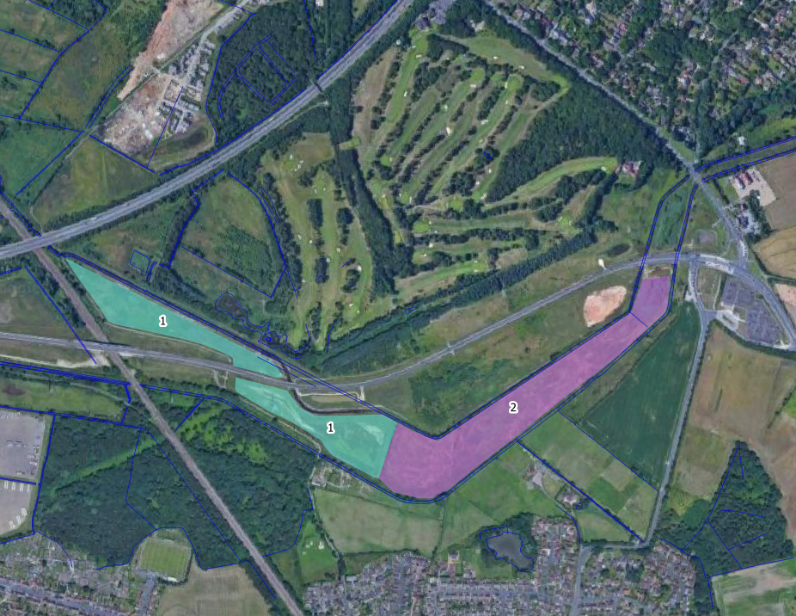
Figure 1. the blue parcel (1) is dmbc owned land, the purple parcel (2) is currently owned by the golf course but soon to be purchased by ywt. the combination of both parcels of land will become ‘the betwixt fen’ upon completion of works.

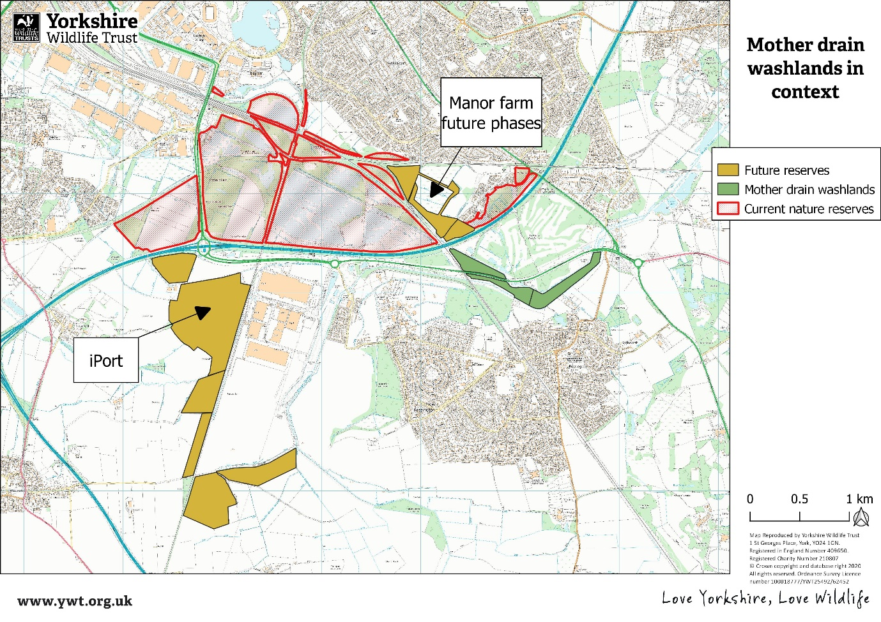
Figure 2. betwixt fen (labelled mother drain washlands in this diagram) in relation to current reserves and future acquisitions.

Appendices

About this document

The general principles used to identify these projects are listed below:
- Identify, discuss, and refine. The initial list of 'Aspirational Projects' should be discussed and refined by the partnership. This will ensure that the limited resources of the CaBA partnership are used to develop projects which attract the most support from the group.
- The approach is all about direction of travel, rather than achieving a threshold water quality or ecological status. This is making the use of evidence much simpler and easier to understand.
- The rivers in the catchment are highly modified and influenced by urban and rural pollution. Catchment scale water quality and overall habitat are likely to be very difficult to bring back in a way that will deliver a status of Good. Therefore, the focus of the projects is on waterbodies where we can aim towards Moderate status whilst delivering multiple benefits for local access, habitat, and recreation.
- Projects should provide evidence that justifies their contribution to the Catchment partnership aims whilst identifying possible funding streams and additional multiple benefits.
- The Catchment Aims have been used to select opportunities which should move the Torne catchment forward in all the areas prioritised by the catchment steering group.
- Preference is given to opportunities in areas where there is already some activity which can be built on; it is easier to make progress when activity has already started on the ground.
- The summary table could be used to change or refine the suggested projects, in consultation with the steering group, to better deliver the catchment strategy.
- All 'Aspirational projects' should deliver benefits for WFD as well as CaBA if they are to be supported by the Environment Agency.
- Each project should incorporate Environment Agency measures from the list of cost beneficial measures where possible.
- Each project should have an 'owner' to drive it forward.
- Priority 1 projects have agreement. Priority 2 projects have an 'owner' who will proceed when there is an opportunity. Priority 3 projects need an owner to progress and Priority 4 projects are blue sky.
- Projects progress when the opportunity arises. Once a project is 'agreed' by the delivery group as a priority 2 (it has an owner). It is the responsibility of the owner to move the project forward.
- The owner of a project will report progress at partnership meetings on a quarterly basis and identify the next steps in moving the project forward to provide the partnership with the opportunity to offer support were possible.

How to add a project and put forward project ideas

Additional projects for inclusion in this document are encouraged and a template project page is included in Appendix 2.

New project ideas should be submitted in the form of a completed project template to the Catchment host to be discussed at the steering group before being added to the integrated catchment plan.

A project overview needs to be filled in to provide the required general information for the project.

The projects are numbered as they are added and are listed in no priority order. As such new projects should be numbered accordingly in the list.

Project status refers to the project’s activity. It is a ‘potential project’ if it is not yet funded. A ‘funded project’ if it has received funding. And a ‘completed project’ if it has been completed.

A projects priority status refers to its priority status within the partnership. Priority 1 projects have agreement. Priority 2 projects have an 'owner' who will proceed when there is an opportunity. Priority 3 projects need an owner to progress and Priority 4 projects are blue sky.
A projects funding status is either ‘Funded’ or ‘Not Funded.’

Each project should be assigned an owner which will be the organisation the project sits with. A projects owner could change as the project develops for example when it moves from development to delivery.

A project manager is the individual responsible for progressing the project as such it can also change as the project develops.

A projects’ location should be indicated by its waterbody number and its waterbody Name.

It should also have a grid reference.

Project progress should be reviewed on a quarterly basis and the date of last review recorded.

A projects main aims and costs should be completed indicating the main rational behind the project and which aims of the catchment partnership the project meets.

✓✓✓ indicates the main rational behind a project, it does not mean that the project will deliver big improvements.
✓✓ indicates secondary benefits from the project.
✓ indicates minor benefits from the project.
Which of the partnership aims that the project contributes towards should be indicated by the relevant symbols.
A cost and ease of delivery should be included.
A project description accompanied by maps and photographs should provide evidence to justify the project against the funding streams selected. It should also say how it contributes to the indicated partnership aims and any other multiple benefits. For example, if reducing rural diffuse pollution is the main rational behind the project then a description of how the proposed work will achieve that should be included as well as justifying any secondary or minor benefits identified. Where possible the next steps in progressing, this project should be identified in the form of tasks. This will allow partners to contribute and identify where they can lend support to the project.

Blank project template guide

Torne Project X
- | Project Status |  | Priority status | Funding status |  | Project Owner |  | Project Manager |  | Waterbody Number |  | Waterbody Name: |  | Location |  | Last Reviewed
x
Aims |  | Urban |  |  | Rural |  | Ecology |  | Hydro  morphology |  | Engagement |  | Cost  (£K) |  | Ease of  Delivery

Project description:

Maps / Photos:

Next steps:
Task 1
Task 2:
Task 3:
Tas

