Potteric Carr Highlights
December 2019
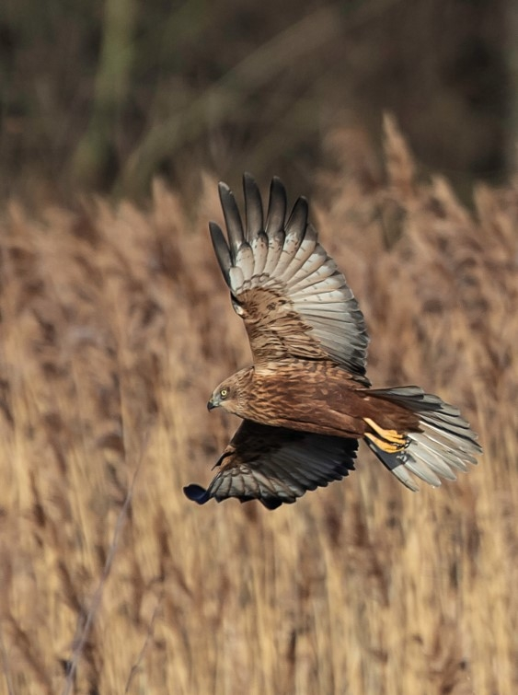

Marsh Harrier © Barry Wardley.

Starlings © Allen Holmes
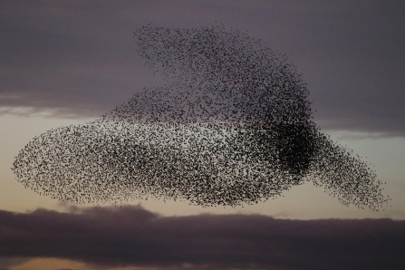

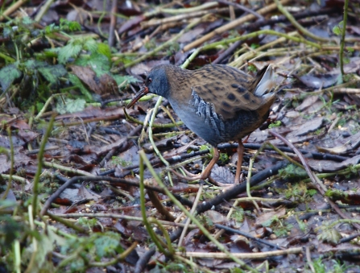
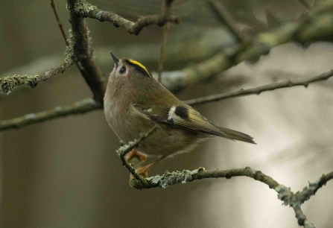
Water rail ©Michael Short. Goldcrest ©Keith Horton

The staring murmuration continued to put on an n impressive display, slowly moving nearer to Hawthorn Bank as the month progressed. A minimum of 100,000 birds were involved at its peak during mid-month.

The gull roost continued to build also during December almost going unnoticed by those admiring the starlings, although several hundred herring. black headed and great black backed gulls arrived most evenings.

Chiffchaff was recorded again during the month completing a full twelve months of records on site. As expected lesser spotted woodpecker was also seen on a few occasions- the next three months being the best time of year to catch up with Potteric’ s most elusive resident bird. Winter visitors were represented this month with an increase in recorded woodcock, golden plover (55 were seen on the 1st) fieldfare and redwing.

The year ended with a very respectful list of 166 species seen within the recording area. This was up on 2018’s total of 163 but 2 species short of the all-time record of 168. Of the total seen, 157 species were solely recorded on Potteric Carr itself.

Sixty-three species bred this year, with bearded tit undoubtable being the highlight. This represents the last target species to bread on Huxter Well Marsh since its creation back in the early 2000’s, complementing the breeding bittern and marsh harrier the reserve holds.

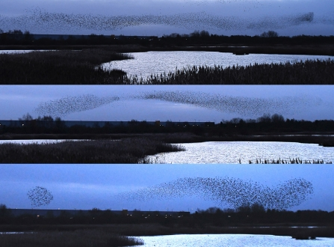

©Ian Parnell

LIST OF BIRDS |  |  | RECORDED IN 2019
 | Jan | Feb | Mar | Apr | May | Jun | Jul | Aug | Sep | Oct | Nov | Dec
Mute Swan
Whooper Swan |  |  |  | IP |  |  |  |  | IP
Pink-footed Goose
Greylag Goose
Canada Goose
Barnacle Goose
Egyptian Goose | IP | IP |  |  |  |  |  |  |  | IP |  | IP
Shelduck
Mandarin Duck
Wigeon
Gadwall
Teal
Mallard
Pintail
Garganey |  |  |  |  | IP
Shoveler
Red-crested Pochard
Pochard
Tufted Duck
Goldeneye |  | IP
Goosander | IP
Red-legged Partridge
Grey Partridge |  |  | IP |  | IP | IP |  | IP
Pheasant
Gannet
Cormorant
Bittern
Little Egret
Great White Egret
Grey Heron
Spoonbill
Little Grebe
Great Crested Grebe
Slavonian Grebe
Black-necked Grebe |  |  |  |  |  |  | IP
Red Kite
Marsh Harrier
Hen Harrier
Sparrowhawk
Buzzard
Osprey
Kestrel
Merlin |  |  |  |  |  |  |  |  |  | IP
Hobby
Peregrine
Water Rail
Spotted Crake
Moorhen
Coot
Crane
Avocet
Oystercatcher
Golden Plover
Grey Plover
Lapwing
Little Ringed Plover
Ringed Plover |  | IP | IP |  | IP
Whimbrel |  |  |  |  | IP |  | IP
Curlew
Black-tailed Godwit
Bar-tailed Godwit |  |  |  | IP
Turnstone |  |  |  |  | IP |  |  | IP
Knot
Ruff
Sanderling |  |  |  |  | IP
Dunlin |  | IP
Common Sandpiper |  |  |  |  |  |  |  | IP
Green Sandpiper | IP | IP | IP
Spotted Redshank
Greenshank
Wood Sandpiper
Redshank | IP | IP
Jack Snipe | IP |  |  |  |  |  |  |  |  |  |  | IP
Woodcock
Snipe
Black Tern |  |  |  |  | IP |  |  | IP
Common Tern
Arctic Tern |  |  |  |  | IP
Kittiwake |  |  |  |  | IP
Black-headed Gull
Little Gull |  |  |  | IP
Mediterranean Gull
Common Gull
Lesser Black-backed Gull
Herring Gull
Yellow-legged Gull |  |  |  |  |  |  | IP
Caspian Gull
Iceland Gull
Glaucous Gull
Great Black-backed Gull
Rock Dove / Feral Pigeon
Stock Dove
Woodpigeon
Collared Dove
Turtle Dove
Ring-necked Parakeet
Cuckoo
Barn Owl
Tawny Owl
Long-eared Owl
Swift
Kingfisher
Green Woodpecker
Great Spotted Woodpecker
Lesser Spotted Woodpecker
Magpie
Jay
Jackdaw
Rook
Carrion Crow
Raven |  |  |  |  | IP |  | IP
Goldcrest
Firecrest
Blue Tit
Great Tit
Coal Tit
Willow Tit
Marsh Tit
Bearded Tit
Skylark | IP |  |  |  |  |  | IP | IP
Sand Martin
Swallow
House Martin
Cetti’s Warbler
Long-tailed Tit
Chiffchaff
Willow Warbler
Blackcap
Garden Warbler
Lesser Whitethroat
Whitethroat
Grasshopper Warbler
Sedge Warbler
Reed Warbler
Nuthatch
Treecreeper
Wren
Starling
Ring Ouzel
Blackbird
Fieldfare |  |  | IP
Song Thrush
Redwing
Mistle Thrush |  |  |  |  |  |  | IP
Spotted Flycatcher
Robin
Pied Flycatcher
Redstart
Whinchat |  |  |  |  |  |  |  | IP
Stonechat
Wheatear |  |  | IP |  | IP
Dunnock
House Sparrow
Tree Sparrow
Yellow Wagtail |  |  |  |  |  | IP | IP
Grey Wagtail |  | IP
Pied Wagtail
Meadow Pipit |  |  |  |  | IP | IP
Rock Pipit |  |  |  |  |  |  |  |  |  | IP
Water Pipit |  | IP | IP |  |  |  |  |  |  |  |  | IP
Chaffinch
Brambling
Greenfinch
Goldfinch
Siskin
Linnet | IP |  |  |  |  |  |  |  |  | IP | IP
Twite |  |  |  | IP
Lesser Redpoll
Common/Mealy Redpoll
Bullfinch
Yellowhammer |  | IP | IP |  | IP | IP | IP | IP |  |  | IP
Reed Bunting
Total species recorded
Month | 95 | 102 | 108 | 128 | 120 | 94 | 106 | 110 | 110 | 92 | 89 | 82
year to date 2019 | 95 | 104 | 120 | 146 | 154 | 154 | 156 | 160 | 162 | 164 | 166 | 166
year to date for 2018 | 84 | 98 | 111 | 134 | 144 | 145 | 148 | 153 | 157 | 159 | 162 | 163

