Pond Dipping: Incorporates working scientifically, habitats, animals and living things.
The safest and best way to enjoy pond dipping is to visit reserves such as Potteric Carr in Doncaster that offer pond dipping sessions.
Aim: To develop an understanding and have respect for all living things
After booking ensure the group have been informed of the correct clothing, wellies, waterproofs, sun cream, drinking water and ask for a copy of the risk assessment.
Whenever going to new sites please also use these simple guidelines.

Check Clean Dry
The Check Clean Dry procedure should be followed at all times as the bare minimum.

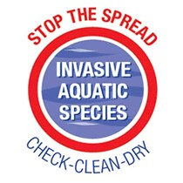

CHECK - Check your equipment and clothing (including the soles of footwear). Remove any organisms and plant material (look very carefully for any small organisms and plant fragments) before entering and leaving each site.

CLEAN - Clean and wash all equipment, footwear and clothing thoroughly.
If you do come across any organisms, leave them at the site where you found them.

DRY - Aim to dry all kit for 48 hours prior to reuse in a different watercourse

Introduce the group to ponds before attending the session
State we all live in an ecosystem. A pond is an ecosystem this is an area that has a community of living things (plants, animals) and non-living things (air, water, soil). Many species depend on ponds to survive.
Explain ponds can be natural but many ponds are man-made (can anyone tell me what I mean by man-made?) over 50% of UK ponds have been lost in the 20th century, 80% of the remaining ponds are not in a good condition.
Fingers can be used to show percentage get the children to hold up both hands fingers outstretched explain each finger is 10% giving them a visual understanding of loss.
Ponds were often created to provide water for livestock such as the dew ponds on the Yorkshire Wolds or created from the result of quarrying or for ornamental purposes.
How can humans affect a pond habitat?
Filling them in. Chemicals from treating plants in the garden or farmers’ fields, litter, bringing plants or other animals from another pond. Allowing plants to take over and dry out the pond. Climate change.
Can you tell me what lives in a pond?
Discuss (see food chain table below for examples)
Below are activity sheets that can be used either before or after the pond dipping event. You could print a recording sheet to take with you.

Pond Food chains and food webs
All animals need to be able to move and feed.
Animals that eat plants are called herbivores.
Animals that eat plants and animals are omnivores.
Animals that eat other animals are called carnivores.
Animals that eat dead plants and animals are detritivores.
A food chain is a simple feeding connection between species in a habitat. Often this is more complex with other species involved within this chain becoming a food web.
Foods chains often start with the sun, green plants use the the sun to convert into energy this process is called photosynthesis. Ask to the children to repeat the word photosynthesis. This is why pond weed is on the surface as it requires the sun.
Consumers
Consumers are animals that get their energy directly or indirectly from plants.
Primary consumers or herbivores eat plant matter to provide energy.
Animals that eat other animals are called carnivores (secondary consumers)
Tertiary consumer will eat a secondary consumer.
An example of a food chain would be a tadpole eating algae (primary consumer) then is eaten by a dragon fly nymph (secondary consumer) then the dragon fly nymph is eaten by a fish (tertiary consumer).
Pond Food Chains
Vertebrates | Feeding/Trophic level
Frog | Carnivore
Toad | Carnivore
Newt | Carnivore
Tadpole | Start out as herbivores and become carnivores (16 weeks they grow legs)

Invertebrate | Feeding/Trophic level
Pond snail | Herbivore/Detritivore
Midge larva | Herbivore
Leech | Carnivore
Rat-tailed maggot | Detritivore
Mayfly nymph | Herbivore
Dragonfly nymph | Carnivore (worms, tadpoles, water fleas, larvae)
Diving beetle | Carnivore
Water mite | Carnivore
Freshwater hog louse | Detritivore
Freshwater shrimp | Detritivore
Water flea | Herbivore
Greater water boatman/Common back swimmer (will nip) | Carnivore
Lesser water boatman | Herbivore
Mosquito larva | Herbivore
Damselfly nymph | Carnivore
Water scorpion | Carnivore

Fun Facts and Adaptations (Explain adaptations are a feature that enables the animal to survive in its habitat).
The skin left behind after a dragon fly emerges is an exuvia.
To travel faster dragonfly nymphs squirt water out of their bottoms.
The tail on a rat-tailed maggot allows them to take in oxygen from the surface of a pond.
True water spiders carrying a bubble of oxygen, so they can travel around the bottom of the pond.
Lesser Water Boatman use the hairs on their legs to suck up and sieve through algae.
Toads can live up to 40 years old but usually around 12 years old
Pond skaters have hairy feet which traps air allowing them to skate on the water’s surface.
Caddis flies have soft bodies mean they use things around them to become camouflaged and have some protection (sticks, leaves, stones, depending on species).
Explain how sensitive frogs and toads (amphibians) skin is? Frogs especially need to be near water and moisture as they have thin skin which loses moisture. Respiratory capillaries are in the skin for gas exchange.
Whirly gig beetles swim on the surface of the water their eyes are placed to be able to look above and below the surface keeping an eye out for predators.

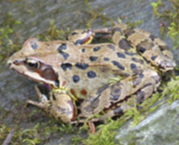

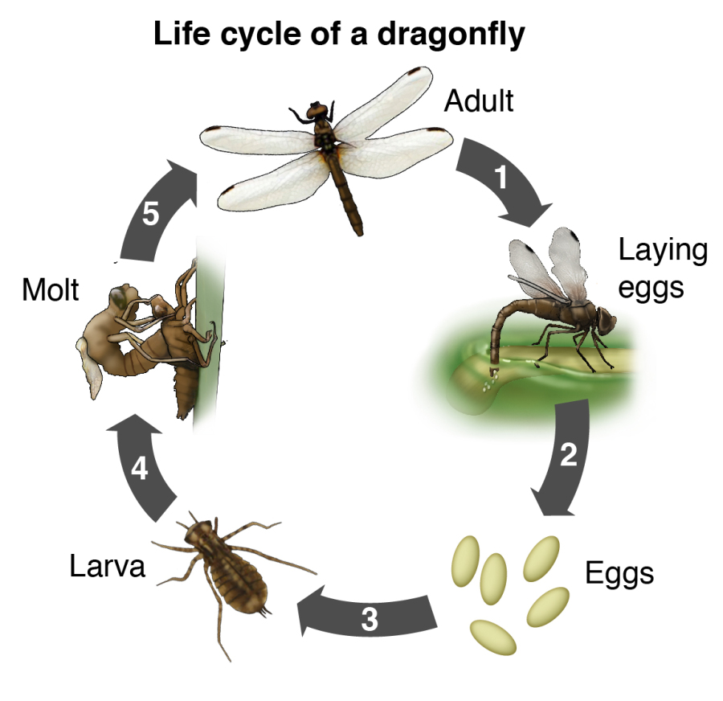

Life Cycle of a frog. Can you put the pictures in order?

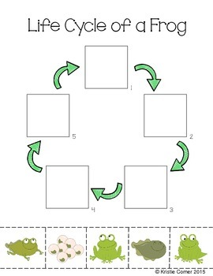

Print and cut out the pictures below to complete the frog’s lifecycle template above.

Recording Sheet
Pond animal | Tally | Total

References

Chumchal, M, and Drenner, R, (no date) The Aquatic Ecology Research Lab at TCU, Life Cycle of a dragonfly [online image] Available at: https://themercurysite.com/bird-health/bugs-spiders-and-songbirds/
Hall, Paddy, Common Frog Photograph X drive
Immediate media company (2018) Spawn picture [online Image] Available at: http://www.countryfile.com/blog-post/top-facts-about-frog-spawn
123RF Limited (2005-2018) Cartoon tadpole pictures [online Image] Available at: https://www.123rf.com/photo_64560820_stock-vector-the-life-cycle-of-a-frog.html
Amphibian and Reptile Group (no date) Educational resources [online] Available at: https://www.arguk.org/info-advice/educational-resources/ks1-ks2-resources/222-the-pond-pack/file
Holland Park Ecology Centre, The Royal Borough of Kensington and Chelsea (2010) [online] Available at: https://www.rbkc.gov.uk/pdf/pond_pack_2010.pdf
The Wildlife Trust Wales, (no date) KS2 Pond Creatures Lesson Plan [online] Available at: https://www.welshwildlife.org/wp-content/uploads/2011/08/pond-lesson-plan.pdf

